The data on the screen provides details of the voyages undertaken by a man named John Holford over a 5 year period. Use this data to plot Holford’s voyages on the map below. You can indicate multiple voyages on the same route with thicker lines or by labelling your lines.
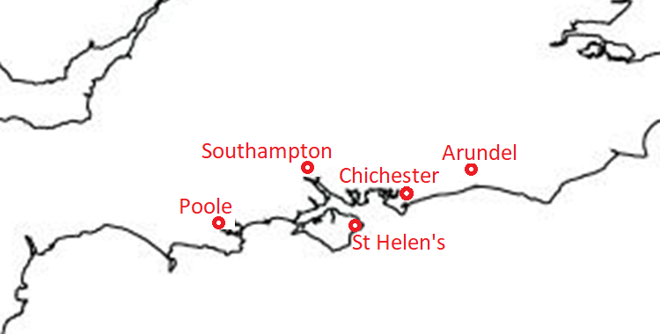

We know that John Holford was a fisherman from Southampton, but no other information about him has been found. Consider the following questions:
- What can this data add to our understanding of how John Holford ran his business? What does this suggest about his position in the town?
- What does this data tell us about how individuals engaged in coastal commerce?

