Accessibility Allies Team Charter

Purpose:
The purpose of the Team Charter is to outline the expectations we have of each other and our leadership throughout the internship. It is also a place where we can state our values and goals as a team (as they develop).
Accessibility Allies 'Mission Statement':
We aim to support members of staff in creating a more inclusive, accessible University of Southampton. We believe that a more accessible university is beneficial to all.
Our values and beliefs:
We all have expectations of ourselves and others - how we work, how we behave and how we are treated by colleagues and leaders.
Vevox Team Values word cloud: most submitted words were: respect, support and understanding, teamwork and collaboration, positivity, and inclusivity.
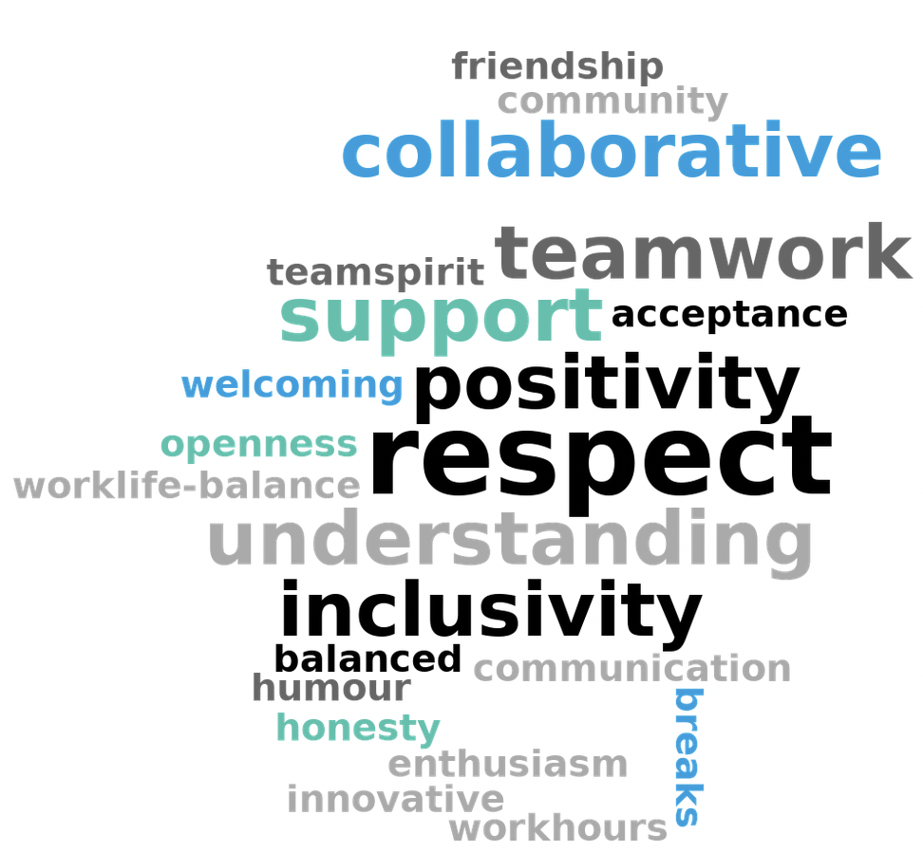

Our expectations around team etiquette:
- Limit meetings to 45 minutes or include regular breaks in longer meetings
- Keep meetings organized with a clear goal in mind
- Schedule a minimum 15-minute break between adjacent meetings
- That when we are meetings, we make sure everyone is listened to and not talked over
- To be empowered to set a period of focus undisturbed work each day (up to an hour in the day)
- This must be indicated on your status of availability in Teams
- To be mindful and respectful of each other in general (but particularly if you feel that someone is struggling).
- That we are empowered to decline meeting requests when:
  - They fall outside our normal working hours (including 'breaks')
  - They are scheduled at short notice
  - They conflict with other plans (including non-working days)
  - They conflict with existing 'No meeting/focus time' slots in people's calendars
  - That meetings are kept to the necessary participants
  - That we try and use alternatives to a meeting (such as the use of asynchronous documents, emails, announcements, Teams group chats, etc.)
- To be respectful and supportive of each other in a positive manner

Our expectations of each other:
Continuing from the final sentiments in the last section:
- That people can feel they can ask for help (both work-related and personal)
- To be sensitive to others situations (both work-related and personal)
  - To reach out to people privately if you feel someone is in need and to respect the reply
  - We will not always know each other's situations, so to just be kind and patient with each other
- We are unique in our own way and all respect that
- To be open to new approaches suggested by others
- To have open and honest communication with each other
- To be flexible with other schedules (especially during covid)
- To respect any existing 'no meetings/focus time' entries to ensure people are not overloaded with appointments.
  - Respect the informal mention of 'no meetings Fridays' within iSolutions
Our expectations from our leaders:
- To provide support and training as required
- To provide a clear assignments list
- Give feedback in a timely and respectful manner
- To have information written down
  - This includes sending out a summary of agreed covered information after meetings, task lists, important conversations etc. (and allow people to amend/comment on that account for accuracy and understanding)
- To be open, transparent, and willing to give an additional explanation if needed
- To delegate tasks to others
  - And for that person who has a task delegated to decline if they are unable to take it
- Be a conduit for information (up/down/sideways) and share what you can so that people feel up to date and aware of the changing environment
- To be open to discussions around directives and to be willing to be flexible with changes of direction
- To be understanding of circumstances affecting our availability and working hour preferences
- To be supportive of all above statements

