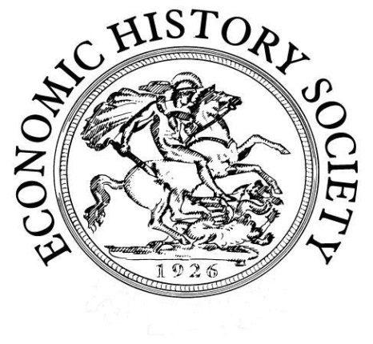
Economic History Society
Women’s Committee 29th Annual Workshop
Women and Financial Advice
Saturday, 3rd November 2018
The Guildhall, Winchester
Provisional programme

10:30 Registration and Coffee in the Walton Suite (3rd floor Guildhall)

11:00-12:00 Session 1
Helen Paul (Southampton)
Welcome and introduction to the ‘History of Financial Advice’ project
Anne Murphy (Hertfordshire)
‘Ill-advised and dangerous for women’: advice for female investors in Thomas Mortimer’s Every Man His Own Broker
Alison Daniell (Southampton)
Training Session: Law, Equity and the Doctrine of Coverture

12:30 Lunch

13:30-15:00 Session 2
Sheryllynne Haggerty (Nottingham)
Female credit networks in eighteenth-century Jamaica
D’Maris Coffman (UCL)
tbc
Jasper Kunstreich (Max Planck Institute for European Legal History)
What kind of experience was bankruptcy for women? Evidence from Germany 1815-70

15:00-15:30 Tea break

15:30-17:00 Session 3
Nicky Marsh (Southampton)
tbc: History of Financial Advice Project
Janette Rutterford (Open)
tbc
Lucy Newton (Henley)
The introduction of ‘personal bankers’ at Barclay’s Bank: women, customer service and the advent of the modern business uniform

17:00 End of workshop

Drinks (pay your own way)

18:30 Dinner (pay your own way and book in advance with Helen Paul)
The Gurkha’s Inn Restaurant
(Nepalese restaurant only 5 mins walk from the train station)

Further details on the conference website: http://generic.wordpress.soton.ac.uk/womenandfinancialadviceehs/

Book via conference website or via Eventbrite:
https://www.eventbrite.co.uk/e/women-and-financial-advice-economic-history-society-uk-tickets-45138629857

Booking Form for the 29th Annual Women’s Committee Workshop

Workshop fees inclusive of all refreshments: £30 non-members; £25 members of the Economic History Society; £17 unwaged.

Ten free places are available for postgraduate students on a first-come first-served basis; please provide evidence of status with your booking form. Please note: a cheque for £17 is required to secure the free place. This will be returned at the workshop and will not be cashed unless the student fails to attend or cancels later than 7 working days before the workshop.

Name
Institution
Postal address
Email
Dietary or other requirements
After workshop drink | Yes No
After workshop dinner | Yes No
Cheque amount* | £

* Cheques should be made payable to ‘Economic History Society’ and returned with the booking form to:

Dr Helen Paul (local organiser)
Economics Department
University of Southampton
Southampton SO17 1BJ

Please send an email to confirm postage of the booking form and cheque to: hjp@soton.ac.uk

