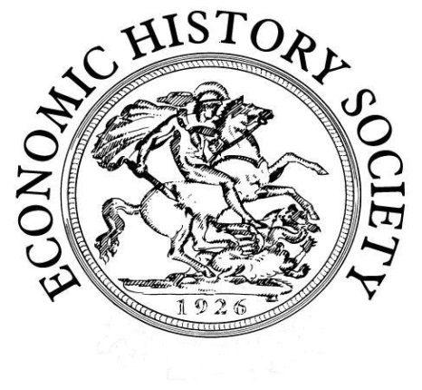
Economic History Society
Women’s Committee 29th Annual Workshop
Women and Financial Advice
Saturday, 3rd November 2018
The Guildhall, Winchester

Programme

10:30 Registration and Coffee in the Walton Suite (3rd floor Guildhall)

11:00-12:30 Session 1 (Chair: Sheryllynne Haggerty)
Helen Paul (Southampton)
Welcome
Peter Knight (Manchester), Paul Crosthwaite (Edinburgh), James Taylor (Lancaster) and Helen Paul
Overview of the Financial Advice project: women and financial advice
Alison Daniell (Southampton)
Training Session: Law, Equity and the Doctrine of Coverture

12:30 Lunch

13:30-15:00 Session 2 (Chair: Helen Paul)
Anne Murphy (Hertfordshire)
‘Ill-advised and dangerous for women’: advice for female investors in Thomas Mortimer’s Every Man His Own Broker
Sheryllynne Haggerty (Nottingham)
Female credit networks in eighteenth-century Jamaica
D’Maris Coffman (UCL)
tbc
15:00-15:30 Tea break

15:30-17:00 Session 3 (Chair: Anne Murphy)
Janette Rutterford (Open)
Women investors, advice and risk: then and now
Jasper Kunstreich (Max Planck Institute for European Legal History)
What kind of experience was bankruptcy for women? Evidence from Germany 1815-70
Lucy Newton (Henley)
The introduction of ‘personal bankers’ at Barclay’s Bank: women, customer service and the advent of the modern business uniform

17:00 End of workshop

Drinks (pay your own way)

18:30 Dinner (pay your own way and book in advance with Helen Paul)
The Gurkha’s Inn Restaurant
(Nepalese restaurant only 5 mins walk from the train station)

