**Name __________________**

CSI School Name Year

Hospital heist

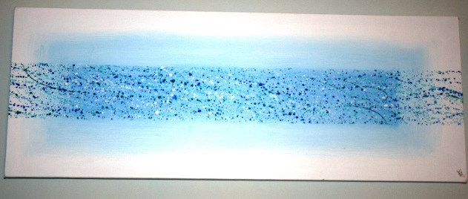

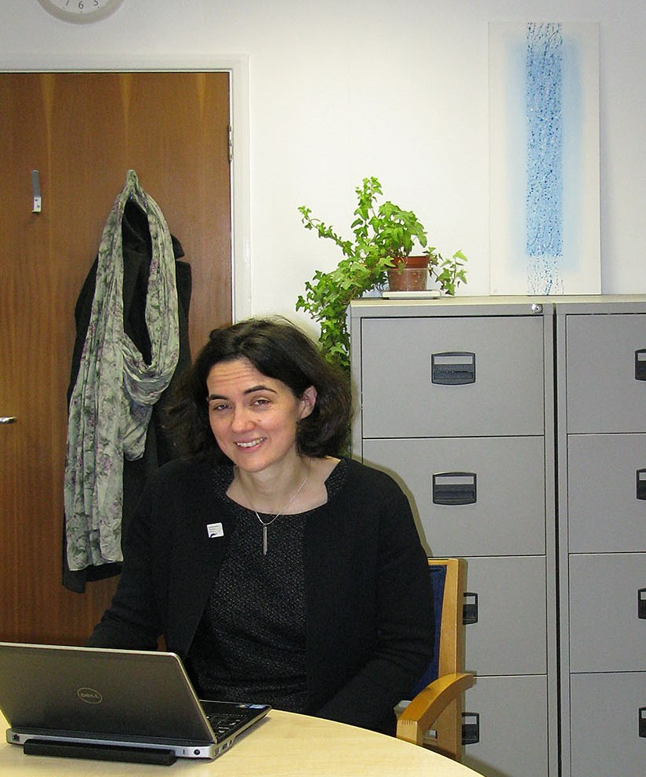

**Biomedical Imaging Unit**

**The Suspects**

|  |  |  |
| --- | --- | --- |
| A | Amanda Oldfield  Specialist Senior Nurse | Works and shares office with Tom Leary. Member of the athletics club so access to starter pistol |
| B | Andrea Jackson  Departmental receptionist | Attended meeting with Catherine Johnston in CEO’s office. Her son is a security guard. |
| C | Janice Angus  Research Scientist | Qualified vet and has access to a human gun as she works with animals. |
| D | Tom Leary  Physiotherapist | Signed the starting pistol in and out of the athletics club. Seen near the CEO office with a large bag |
| E | Catherine Johnston  Microscopist  Biomedical Imaging Unit | Attended CEO meeting with Andrea Jackson. Also a keen member of the athletics club. |
| F | Prof Norman Page  Consultant Pathologist | Rather absent minded but he is a top professor at the hospital. Owner of a O.22 calibre rifle. |
| E:\Forensics\CSI day\Photos\Raegan McNeil - operating theatre assistant\Joanne McNeil - operating theatre assistant.jpgG | Regan McNeil  Operating Theatre Assistant | Another committed member of the athletics club and close friend of Catherine Johnston. |
| H | Balfour Jones  Hospital Cleaner | He has several pets that he cleans in between hospital shifts. He has a lot of access around the hospital as part of his job |

**Initial Police findings**

The call to attend was received at 02:38 am on 10th March 2017, reporting a forced entry to the CEO’s office at Southampton General Hospital and possible use of a firearm. Police arrived on scene at 03:08am.

The CEO’s office is on the second floor at the centre of a U shaped corridor at Centre Block of the hospital building. The only access to the CEO’s office is through an outer office / reception area occupied by her secretary. The outer door is self-closing but is routinely wedged open during the day.

The corridor contains the hospital management offices and is carpeted.

The ends of the corridor have security doors on them, to prevent the general public from wandering behind the scenes, but the door codes are not changed often and known to many hospital staff.

There is no CCTV coverage within the corridor, but CCTV does cover the area of corridor leading to the doors at both ends of the corridor, although not the actual doors themselves.

A routine hospital security patrol in the early hours of the morning had found the door of the outer office “unlocked” but closed. Closer inspection by the security guard had revealed that there was a single gunshot impact on the door of the outer, secretary’s office / reception area where the door lock had been shot out. The door handles themselves remained intact. The guard radioed his office (the call was logged at 2:32 am) to report the break in. The police were called and arrived shortly to secure the scene.

The CEO and her secretary both confirm that the door of the outer office opening onto the corridor was always locked at night, the internal door was never locked.

The CEO’s secretary left work at 5:15 pm. This was independently verified by both the CEO and various other members of hospital staff working on the corridor to whom she had said “good night”. All other staff known to be working on the corridor, except the CEO left by 5:30. CCTV verifies this.

The CEO worked late, leaving at 7:15 pm, locking the door of the outer office behind her. CCTV verifies her leaving the area shortly and shows that she could not have been carrying the painting.

The security guard admits to having gripped the outer door handle when checking the lock. He did touch the inner door handle or enter the CEO’s office.

Police recovered a single cartridge case from the scene, it was found under the door of the room directly opposite the outer office leading to the CEO’s office.

Police recovered a scrunched up piece of A4 paper, showing a colour printed map of the hospital site with the area where the CEO’s office was located circled round and with handwriting saying “*Remember the door code is 1657* ” from behind a display banner by the northern-most entrance to the U shaped corridor.

Police also recovered some unidentified “fluff / fibres” from the floor of the CEO’s office close to where the picture had been temporarily stored on top of a filing cabinet.

A search of the other offices within the corridor failed to locate the painting.

Fingerprints need to be taken from the inner door handle on the corridor door of the outer office leading to the CEO’s room and from around the CEO’s office.

**Crime scene location sketch by police**

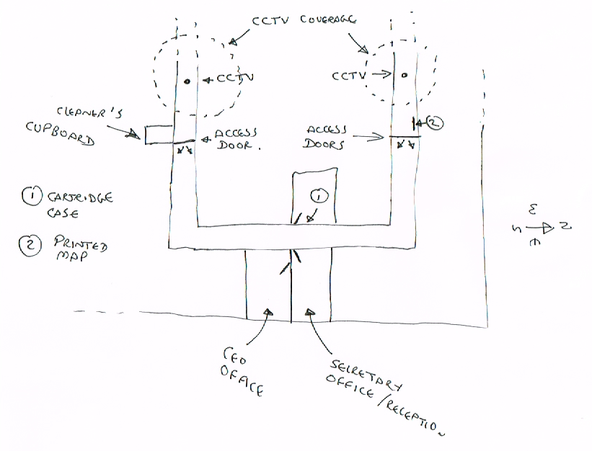

CCTV analysis has identified 8 members of hospital staff as having approached the corridor from either direction between 7:15 pm and 02:30 am. They were all interviewed later that day 10th march 2017. Fingerprints and handwriting samples were taken from all suspects and clothes worn the previous day and skin was swabbed for gunshot residue.

**Suspect Interviews**

**Suspect A: Amanda Oldfield**

Amanda Oldfield has worked as a Specialist Senior Nurse Practitioner in Child Health at Southampton General Hospital for 12 years.

She works alongside Mr Tom Leary as part of a team specialising in respiratory problems in young children. They share an office (room LF57) with other team members. The office contains a single computer and printer used by all team members.

She was working a late shift to cover for a colleague who was away on annual leave.

She claims to have used the corridor on her way home after the shift as a short cut to the hospital records office to drop off some files for a patient who was discharged that day.

She has no pets and is allergic to animal fur.

She is a committee member of the hospital’s Athletics Club, which owns a 0.22 calibre pistol used as a starting pistol. The pistol is stored in a safe at the hospital, to which only Committee members have access. Because of her shift work, she had not attended club training the previous evening, where the pistol had been used

**Suspect B: Andrea Jackson**

Andrea Jackson is the departmental receptionist in the hospital’s Pathology Department. She has worked there for 20 years, having worked her way up from office assistant.

She is a trade union representative for the Hospital’s clerical staff and she and Catherine Johnston had attended a joint Union / management meeting in the CEO’s office in the afternoon of the previous day to discuss the effects of council tax rises announced by the local authority on hospital funding and jobs.

All pathology staff have access to a single, shared, networked printer located in LB62.

She was working overtime to try to rearrange the staff rota to cover for staff sickness.

Her son, Barry, works for the security firm which was contracted to collect the painting from the CEO’s office.

She has a cat.

**Suspect C: Janice Angus**

Dr. Janice Angus works as a research scientist in the Faculty of Medicine of the University of Southampton. Many of the faculty offices and laboratories are located at Southampton General Hospital. She has worked for the University for 8 years and holds a lecturing position. Her research involves the effect of maternal diet on the health of the offspring, linking experimental work on mice, with observational work on human patients at the Princess Anne Maternity Hospital.

She is also a qualified vet with responsibility for the welfare of all animals housed in the Faculty’s animal facility. As such she has access to a 0.22 calibre pistol occasionally used as a human killer. She claims that it was not used on the previous day.

She claims to have been working late to finishing writing a scientific paper and had used the corridor on her way out as her normal route was closed due to hospital maintenance.

CCTV shows here wearing a loose and baggy coat.

**Suspect D: Tom Leary**

Tom Leary is a registered Physiotherapist who has worked at the hospital for 3 years after graduating from University with a degree in Sports Science and Physiotherapy. He works in the Child Health team alongside Mrs Amanda Oldfield, providing physiotherapy to children with respiratory problems and shares office space in room LF57 with other team members.

A keen runner, he is chair of the Hospital’s Athletics Club. He attended their training session the previous day and was responsible for taking and returning the pistol. During the training, he shared responsibility for starting races with Regan McNeil and Catherine Johnston.

He claims to have used the corridor when returning the pistol after training. The CCTV shows him carrying a large sports bag.

**Suspect E: Catherine Johnston**

Catherine Johnston is a microscopist in the Biomedical Imaging Unit which is part of the Pathology Department. She has worked there for 2 years and her job involves electron microscopy of patient samples to support diagnosis by the consultants.

She has access to the single, shared, Pathology Department printer located in LB62.

She is a trade union representative for the Hospital’s laboratory staff and is passionately against any cuts to NHS services. She and Andrea Jackson had both attended yesterday’s union / management meeting in the CEO’s office

Another committee member of the hospital’s Athletics Club, she had attended last night’s training and also used the starting pistol.

CCTV shows her wearing a baggy laboratory coat.

She claims that she was working late the previous evening to complete the analysis of an urgent patient sample, and had used the corridor as a short cut to pathology reception to drop off the report, before returning to the BIU to pick up her sports bag and leave work.

She owns a cat.

**Suspect F: Norman Page**

Professor Norman Page, FRCP is a consultant pathologist at the Hospital and honorary professor at the University, spending part of his time teaching for the University and part of his time as a clinical pathologist for the hospital. He has worked at the hospital for 17 years.

He claims to have accessed the corridor later that evening, having stayed late to finish preparing a lecture, in the off chance that the CEO was also working late, to drop off some information to her concerning the pathology department’s budget and the urgent need to find funds to replace ageing and increasingly unreliable automated processing systems. Having seen the outer door closed, he just carried on and out of the building.

He has access to the single, shared, Pathology Department printer located in LB62.

CCTV shows him wearing a baggy lab coat; he claims that, being an absent minded professor, he just forgot to take it off.

He owns a large, old and expensive to maintain house in the country north of Southampton with a large ornamental garden and vegetable plot, both of which suffer from rabbit damage. He owns a 0.22 calibre rifle which he uses for rabbit control and claims to have shot a few for the pot the previous evening and again that morning. He also has several dogs.

**Suspect G: Regan McNeil**

Regan McNeil has worked as an operating theatre assistant at the hospital for 4 years. Like Tom, Catherine and Amanda she is on the committee of the hospital athletic club and she attended the training session on the previous night, where she used the starting pistol before starting a night time shift.

She only has access to the laser printer in the operating theatre suite office (AB74).

The CCTV shows her wearing loose, baggy surgical scrubs. She claims that she used the corridor as a shortcut whilst taking a sample of tissue from a patient in theatre to specimen reception in Pathology, as it needed urgent processing. Pathology reception confirm that Regan did drop a sample off to them, but did not enter the department itself, as only authorised pathology staff have access. CCTV records her returning through the corridor some minutes later.

She has no pets.

**Suspect H: Balfour Jones**

Mr. Jones has worked as a shift cleaner at the hospital for over 10 years. He works a split shift, 4 hours in the morning and 4 hours at evening, normally finishing at 08:00 pm. His duties include cleaning the offices on this corridor on his morning shift, working elsewhere on site in the evening shift. He is responsible for hovering the CEO’s office every morning.

He claims that he often chats with the CEO, who is also an early starter, and that he was told about the presentation of the painting on the morning that it was scheduled to happen.

CCTV shows him wearing a baggy lab coat.

He claims that in the evening he did not enter the corridor but simply visited his cleaning cupboard just outside the access door to check stocks of paper towels in preparation for the following day.

Mr Jones keeps rabbits and claims to have cleaned them out between his shifts. He does not have access to a computer printer.

**Note: the CEO also has pet dogs.**

**Lab 1 – Fingerprint analysis**

**Activity 1**

Prepare a set of your fingerprints from each of your hands.

Remember it is important to roll, not stamp, your finger and to not load it up with too much ink.

**RIGHT HAND**

|  |  |  |  |  |
| --- | --- | --- | --- | --- |
| Right Thumb | Right Forefinger | Right Middle Finger | Right Ring Finger | Right Little Finger |
|  |  |  |  |  |

**LEFT HAND**

|  |  |  |  |  |
| --- | --- | --- | --- | --- |
| Left Thumb | Left Forefinger | Left Middle Finger | Left Ring Finger | Left Little Finger |
|  |  |  |  |  |

Examine your fingerprint using a hand lens, identify the major pattern seen and record it on the next page.

|  |  |  |  |
| --- | --- | --- | --- |
| Left hand | | Right hand | |
| Thumb |  | Thumb |  |
| Fore finger |  | Fore finger |  |
| Middle finger |  | Middle finger |  |
| Ring finger |  | Ring finger |  |
| Little finger |  | Little finger |  |

Within your group, collate the basic fingerprint type data (whorl (W), loop (L), arch (A) or mixed (M))

|  |  |  |  |  |  |  |  |  |
| --- | --- | --- | --- | --- | --- | --- | --- | --- |
|  | Name | | | | | | | |
|  | |  | |  | |  | |
| L | R | L | R | L | R | L | R |
| Thumb |  |  |  |  |  |  |  |  |
| Fore |  |  |  |  |  |  |  |  |
| Middle |  |  |  |  |  |  |  |  |
| Ring |  |  |  |  |  |  |  |  |
| Little |  |  |  |  |  |  |  |  |

What is the most common pattern in your group?____________________________

How many fingers and thumbs was it found on?_____________________________

What is the least common pattern? ___________________________________

How many fingers and thumbs was it found on?_____________________________



Which powder is best for lifting finger prints?

Mount the lifted print it in the space on the next page as a permanent record

Aluminium Fingerprint Talcum Powder Fingerprint Black Fingerprint powder

I think the best powder for lifting prints is _____________________.

Crime scene fingerprint comparison

Compare the fingerprint from the crime scene to the suspect’s fingerprints.



Use any evidence obtained to help you in your quest to work out who stole the painting.

**Lab 2 – Fibre analysis**

**Activity 1**

Prepare a slide with a strand of your own hair. Draw what it looks like under medium power.



My hair My friend’s hair

**Activity 2**

Carefully examine the crime hair sample under **medium power**. Draw what they look like and use the identification key to help you decide which animals they came from.

Fill in the first column of the table below.



Slide 1 Slide 2 Slide 3

|  |  |  |
| --- | --- | --- |
| Sample Number | Possible identification | Scanning Electron microscope identification |
| 1 |  |  |
| 2 |  |  |
| 3 |  |  |

It is hard to identify the animal fibre under a light microscope because _____________________

___________________________________________________________________________

**Activity 2**

Carefully examine the scanning electron microscope images sent from the Biomedical Imaging department of Southampton General Hospital. Use the second identification key to help you decide which animals they came from.

Fill in the second column of the table above.

The scanning electron microscope is more accurate because ______________________________

___________________________________________________________________________

___________________________________________________________________________

Use any evidence obtained to help you in your quest to work out who stole the painting.

**Lab 3 – Document analysis**

**Activity 1**

Use the instructions to analyse the crime scene document. Cut out and stick any tracking code you find on a scan of the document below.

The document matches the following printer _____________________________

**Activity 2**

Paper can also be different quality. You will be provided with 4 different samples of paper. Work out the area of each piece of A4 paper and its mass so you can work out the paper quality. You can then compare the paper quality with its strength.

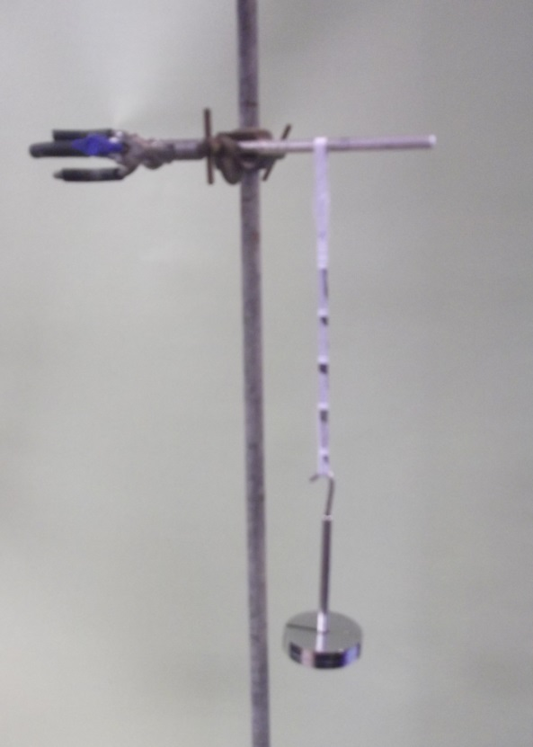

**Don’t forget to calculate the area and mass of your paper strip.**

Make a loop with sellotape to hook over a clamp.

Make a loop with sellotape for the mass hanger.

|  |  |  |  |  |  |
| --- | --- | --- | --- | --- | --- |
| Paper sample | A4 Sheet area in cm²  (*length x width)* | Sheet area in m²  *(÷10,000)* | Mass of A4 paper/g | Paper quality g/m² | Mass to tear paper/g |
| 1 (LB62) |  |  |  |  |  |
| 2(LF57) |  |  |  |  |  |
| 3(AB74) |  |  |  |  |  |
| 4(LB72) |  |  |  |  |  |

The sample paper was believed to be 100g/m².

Use any evidence obtained to help you in your quest to work out who stole the painting.



**Lab 4 – Ballistic analysis**

**Activity 1:**

Piecing together the evidence. The cartridges have been studied in close detail. You need to reassmble the images of the three casings.

Draw a picture of the firing pin patterns left on the cartridge case and label anything you think is important.

Cartridge 3 – Suspect F’s rifle

Cartridge 1 – Starting pistol

Cartridge 2 – Humane gun

Now examine the base of the cartridge case recovered from the crime scene.

Does it match either of the suspect weapons? Explain your answer:_________________________

___________________________________________________________________________

___________________________________________________________________________

**Activity 2: Gunpowder residue analysis**

Items of clothing were removed as soon as the suspects were identified. All clothing has been swabbed and you now need to carry out a chemical identification reaction to determine if their clothing has been contaminated with residue.

Fill in the table below.

|  |  |  |  |  |  |  |  |  |
| --- | --- | --- | --- | --- | --- | --- | --- | --- |
| **Suspect** | **A** | **B** | **C** | **D** | **E** | **F** | **G** | **H** |
| **Colour test** |  |  |  |  |  |  |  |  |

Why is it essential to wear gloves and an apron for this activity? ___________________________

___________________________________________________________________________

___________________________________________________________________________

Use any evidence obtained to help you in your quest to work out who stole the painting.



|  |  |  |  |  |  |  |
| --- | --- | --- | --- | --- | --- | --- |
| Suspect | Laser Printer | Paper quality | Fingerprints at scene | Hair/Fur | Gun access | Gunshot residue |
| A  AMANDA |  |  |  |  |  |  |
| B  ANDREA |  |  |  |  |  |  |
| C  JANICE |  |  |  |  |  |  |
| D  TOM |  |  |  |  |  |  |
| E  CATHERINE |  |  |  |  |  |  |
| F  NORMAN |  |  |  |  |  |  |
| G  REGAN |  |  |  |  |  |  |
| H  BALFOUR |  |  |  |  |  |  |

**Putting together your findings!**