Instructions for Laser Document Scanning
You will find a picture of the map on the student resource area of the network.
It has been stored in the science area in a file called CSI day.
- Save the photo in your documents.
- Open the image in Adobe Photoshop. You can find this by typing in “Adobe Photoshop” in the search bar.
- Once the program has opened then open the image by clicking on the file tab (top left)

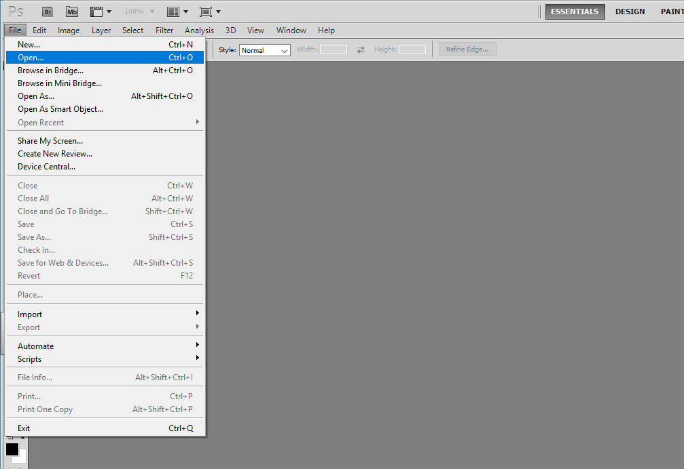
- Go to the student resource folder, Science ,CSI day
- Click on the evidence image and open it as a TIF file.
- Once the image appears in Photoshop, click on the Image tab.
- Scroll down to adjustments and then black and white.
- Use the slider to move the yellow hue to the left
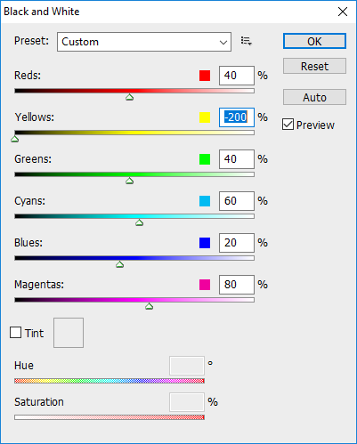
- Click on O.K to save it.
- Save the image in your documents and then print one for every person in your group.

