Hampshire Constabulary

Forensic Evidence Assessment Sheet
Handwriting Analysis

Suspect | Sample
A
B
C
D
E
F
G | 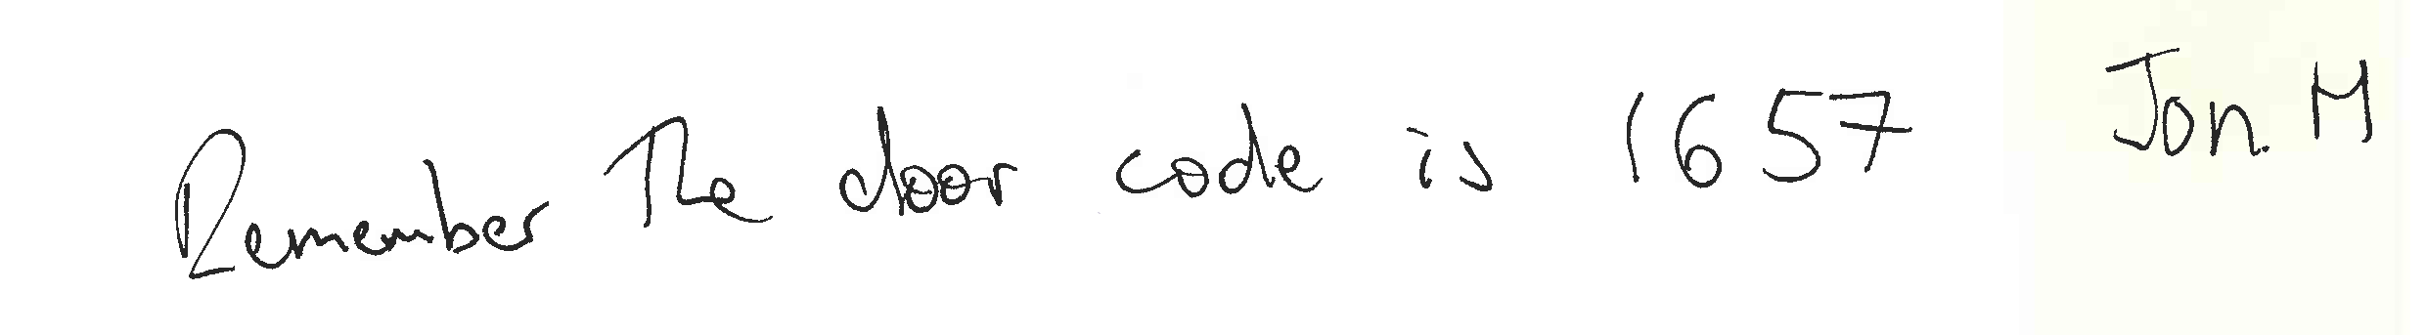
H

Key: Top to bottom:

Ava
Clair
Claire
Gordon
Gemma
Ian
Jon M
Victoria

