FRM4Veg Overview and Metrological Principles

National Physical Laboratory
University of Southampton
EOLab

05 June 2020
This document was produced as part of the ESA-funded project “Fiducial Reference Measurements for Vegetation Phase 2 (FRM4VEG 2)” under ESA contract number: 4000129823/20/I-NS

Signatures

 | Name | Organisation | Date
Written by | Joanne Nightingale | NPL | 05/06/2020
 | Rosalinda Morrone | NPL
 | Niall Origo | NPL
 | Luke Brown | University of Southampton
 | Jadu Dash | University of Southampton
 | Fernando Camacho | EOLab
 | Vicent Garcia | EOLab
Reviewed by (consortium)
Approved by (ESA)

Version History

Version | Date | Publicly available or private to consortium
1.0 | 05/06/2020 | Private Consortium

Table of Contents

Signatures 2
Version History 2
Table of Contents 3
List of Figures 4
Acronyms 4
1 Introduction 6
1.1 Fiducial Reference Measurements (FRM) Concepts and Requirements 6
1.2 Satellite Product Validation and Conformity Testing 8
1.3 FRM4Veg 9
1.3.1 FRM4Veg Documentation 10
2 Metrological concepts and uncertainty in measurement 11
2.1 Useful definitions from the JCGM Guide to the expression of uncertainty in measurement 16
2.2 Uncertainty propagation 18
3 References 20

List of Figures

Figure 1: The sequence of scientific output needed to underpin satellite observation [4]. FRM data will play a vital role in both the post-launch calibration and validation of satellite observations. 7
Figure 2: An illustration of error and uncertainty. [23] 13
Figure 3: Graphical illustration of value, error and uncertainty [7] 14
Figure 4: Graphical illustration of evaluating the standards uncertainty of an input quantity from repeated observations of the temperature t [8] 15
Figure 5: Measurement function [24] 18
Figure 6: A summary of the uncertainty analysis [24] 19

Acronyms

Abbreviation | Stands for
AERONET | Aerosol Robotic Network
CCC | Canopy Chlorophyll Content
CEOS | Committee on Earth Observation Satellites
CIP | Campaign Implementation Plan
DOAS | Dedicated Outdoors Air System
EOLAB | Earth Observation Laboratory
EO | Earth Observation
ESA | European Spatial Agency
EU | European Union
FAPAR | Fraction of absorbed photosynthetically active radiation
FLUXNET | Flux measurement network
FPP | FRM Protocols and Procedures
FRM | Fiducial Reference Measurements
FRM4ALT | Fiducial Reference Measurements for Altimetry
FRM-BOUSSOLE | Buoy for the acquisition of long-term optical time series
FRM4DOAS | Fiducial Reference Measurements for Ground-Based DOAS Air-Quality Observations
FRM4GHG | Fiducial Reference Measurements for Ground-Based FTIR Greenhouse Gas Observations
FRM4STS | Fiducial Reference Measurements for Validation of Surface Temperatures from Satellites
FRM4SOC | Fiducial Reference Measurements for Satellite Ocean Colour
FRM4VEG | Fiducial Reference Measurements for Vegetation
FTIR | Fourier Transform Infrared Spectroscopy
GCOS | Global Climate Observing System
GUM | Guide to the Expression of Uncertainty in Measurement
ICOS | Integrated Carbon Observing System
ISO | International Organisation for Standardisation
JCGM | Joint Committee for Guides in Metrology
LAI | Leaf Area Index
LCC | Leaf chlorophyll concentration
LPV | Land Product Validation
LUT | Look-Up Table
MAG | Mission Advisory Group
NEON | National Ecological Observatory Network
NPL | National Physical Laboratory
RadCalNet | Radiometric Calibration Network
ROI | Return on Investment
SI | International System of Units
SR | Surface Reflectance
SRIX4Veg | Surface Reflectance Inter-Comparison Exercise for Vegetation
TERN | Terrestrial Ecosystem Research Network, Australia
UOS | University of Southampton
VALERI | Validation of European Land Remote Sensing Instruments
VIM | International Vocabulary of Metrology
VM | FRM Validation Methodology
WGCV | Working Group on Calibration and Validation

Introduction

Data from Earth observation (EO) satellites are increasingly used to map, monitor and inform decision making on environmental management and climate mitigation and adaptation strategies. Copernicus is the European Union’s Earth Observation programme that aims at achieving global, continuous, high quality Earth Observation capacity through both spaceborne satellites and in situ (ground and airborne) assets [1]. Fundamental to the basic provision of these data streams is the need for comprehensive metadata on the quality of the data to enable users to judge the fitness for use and ensure confidence in the information used to support decision making processes [2].

Fiducial Reference Measurements (FRM) Concepts and Requirements

The Copernicus programme provides data and services that can be exploited by end users for a wide range of applications in a variety of areas. The ESA sponsored Fiducial Reference Measurement (FRM) programme was formed with the goal to provide the post-launch calibration and validation data to demonstrate whether the Copernicus infrastructure’s mission performance requirements are met (Figure 1). The FRM concept was originally proposed for in situ radiometric measurements of sea surface temperature but has since been generalised to provide a set of guidelines that are more broadly applicable. FRMs are:
‘the suite of independent ground measurements that provide the maximum Return On Investment (ROI) for a satellite mission by delivering, to users, the required confidence in data products, in the form of independent validation results and satellite measurement uncertainty estimation, over the entire end-to-end duration of a satellite mission.’ [3]

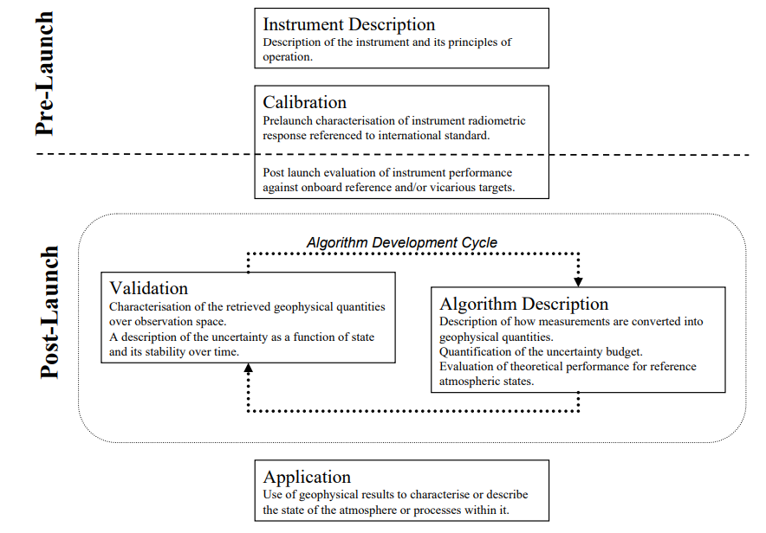
Figure 1: The sequence of scientific output needed to underpin satellite observation [4]. FRM data will play a vital role in both the post-launch calibration and validation of satellite observations.

In simple terms, the Fiducial Reference Measurement (FRM) programme aims to provide a suite of reference measurements (of land, ocean and atmosphere variables) with an associated uncertainty that can be used to conduct satellite product calibration and/or validation through conformity testing. That is, the process that determines whether the estimated target quantity (i.e. the satellite estimate) falls within the range of tolerable values (i.e. the reference estimate), or not [4].
FRMs must:
- Have documented SI traceability (or conform to appropriate international community standards), utilising instruments that have been characterised using metrological standards, both pre-deployment and evaluated regularly post-deployment [5],[6].
- Be independent from the satellite geophysical retrieval process.
- Be accompanied by an uncertainty budget for all instruments, derived measurements and validation methods [7].
- Adhere to community-agreed, published and openly available measurement protocols/ procedures and management practices.
- Provide long-term sustainable mission validation information.
- Be accessible to other researchers allowing independent verification of processing systems.

A number of FRM projects have been initiated and currently include:
- FRM4VEG: Fiducial Reference Measurements for Vegetation [8]
- FRM4SOC: Fiducial Reference Measurements for Satellite Ocean Colour [9]
- FRM4ALT: Fiducial Reference Measurements for Altimetry [10]
- FRM-BOUSSOLE: Buoy for the acquisition of long-term optical time series [11]
- FRM4DOAS: Fiducial Reference Measurements for Ground-Based DOAS Air-Quality Observations [12]
- FRM4GHG: Fiducial Reference Measurements for Ground-Based FTIR Greenhouse Gas Observations [13]
- FRM4STS: Fiducial Reference Measurements for Validation of Surface Temperatures from Satellites [14]
- Pandonia FRM: Fiducial Reference Measurements for Ground-Based Direct-Sun Air-Quality Observations [15]

Satellite Product Validation and Conformity Testing

Validation is the process of assessing, by independent means, the quality of the data products derived from system outputs [16] . Common approaches involve comparison with independent in situ, aircraft and satellite sensor data of known or better quality. However, the Earth Observation Community faces many issues in the validation of satellite derived data products including: disparity between satellite algorithm representation and ground-measured target quantities; lack of long-term monitoring sites suitable for satellite product validation activities due to access and costs associated with deployment and maintenance; inadequate attention to measurement uncertainties; and the protracted compilation of internationally agreed protocols to ensure consistency in field measurements and validation methodologies.

Quantitative EO products can be compared against calibrated in situ measurements such as those from reference networks (e.g. RadCalNet [17], AERONET [18]), through intensive field campaigns (e.g. BigFoot [19], VALERI [20]), or ecological research networks (e.g. TERN [21], NEON[22]). However, in most cases (excluding RadCalNet) the field campaigns or networks were not implemented with the primary purpose of satellite product validation studies, but rather only to understand local or continental-scale ecological processes and land-atmosphere interactions. Consistency of measurements of the same parameter taken at individual sites by different teams cannot be guaranteed (i.e. spatial sampling and measurement equipment may differ, and operator and post-processing errors are not typically quantified). Further, the array of satellite-derived data products being validated are often created with multiple sources of EO data using different retrieval algorithms and assumptions. These confounding issues mean that estimating a meaningful bias between the in situ “validation” measurements and the satellite observations is challenging. Reliable compliance information of quantitative EO products will become even more critical as satellite-derived data are increasingly driving the information and knowledge required for decision making.

Compliance and quality information will serve to solve issues that may arise around: (1) regulatory initiatives; (2) liability debates between customers and providers of value-added (quantitative) EO products and services; and (3) auditing efforts and/or contractual negotiations for the operational exploitation of EO data [4]. Irrespective of context, the conformity of a data product can only be established with respect to permissible deviations from an agreed reference (in situ or drone-based estimate of the satellite derived variable). Ideally this reference should be SI traceable (or community agreed) and the uncertainty of the reference will be smaller than that of the candidate item. While these considerations are an integral part of conformity testing in metrology, they are not yet included in validation efforts of satellite-derived quantitative surface information [4].

FRM4Veg

The FRM4Veg programme of work aims to address many of these fundamental issues by iteratively developing the methods and guidance documentation which should be followed when a) collecting both campaign and permanent FRMs, and b) performing validation of satellite derived products, over the vegetated land surface. The methods and guidance will be developed based, where appropriate, on currently available international good practice vetted through the Committee on Earth Observation Satellites (CEOS) Working Group on Calibration and Validation (WGCV) Land Product Validation (LPV) Sub-group. Most importantly, liaison with the international EO community will be conducted through several channels including CEOS; other ESA mission advisory groups (MAGs); non-ESA mission groups where possible; with ground-based network such as ICOS, TERN, NEON; and with independent groups conducing validation studies. FRM4Veg will ensure the data collection and validation methods are state of the art and practical to implement by conducting an international round-robin exercise (SRIX4Veg) that utilises the developed methodology and is further improved based on community feedback.

FRM4Veg Documentation

FRM Protocols and Procedures (FPP)
Two living documents will be iteratively updated that detail the Fiducial Reference Measurement (FRM) protocols and procedures for both surface reflectance (FPP-SR) and FAPAR and Canopy Chlorophyll Content (FPP-FC) over vegetated field sites. The FRM Protocols and Procedures documents are manuals for calibrating field instrumentation, conducting field measurements in relation to both campaign and permanent field acquisitions, as well as describing how those measurements should be treated for upscaling to represent satellite pixels. The FPP documents are accompanied by supporting Technical handbooks for the individual instruments that are used in both field campaigns and for deployment at permanent FRM field sites. Their purpose is to provide an instrument technical description, together with information about maintenance and calibration history, pre-deployment uncertainties estimates, and steps required to achieve the FRM status.

FRM Validation Methodology (VM)
Two living documents will be iteratively updated that detail the Fiducial Reference Measurement (FRM) validation methodology for both surface reflectance (VM-SR) and FAPAR and Canopy Chlorophyll Content (VM-FC) over vegetated field sites. The VM documents will provide an overview of methodology for validating Copernicus land surface reflectance, LAI, fAPAR and CCC data products over vegetated FRM-compliant field sites.

Campaign Implementation Plans
The campaign implementation plans (CIPs) detail the field site characteristics, campaign aims and objectives, provide an overview of the in-situ sampling strategy and instrumentation to be adopted within the campaigns, as well as the logistical details to implement successful campaign execution. The CIPs will utilise detail from the FPP and VM documentation and may be used as a field work execution template for the international community to implement in the future.

Round Robin Inter-Comparison Exercise Plans
The round robin inter-comparison exercise for surface reflectance (SRIX4Veg) will enable practical implementation of and test for user-based differences in the interpretation of the FRM4Veg FPP-SR.

ESA LPV Supersites Framework
The ESA Supersites Framework document will scope the requirements for both campaign and permanently equipped sites for validation of satellite derived land surface parameters that shall be considered to become part of the network of CEOS WGCV LPV supersites. The document will outline for key vegetation parameters, the measurements required, current and future instrumentation, field and laboratory calibrations as well as the frequency of calibrations required, infrastructure, temporal and spatial sampling, as well as the data processing and delivery of FRM compliant validation information.

Metrological concepts and uncertainty in measurement

When reporting the result of a measurement of a physical quantity, it is obligatory that some quantitative indication of the quality of the result be given so that those who use it can assess its reliability. Without such an indication, measurement results cannot be compared, either among themselves or with reference values given in a specification or standard. It is therefore necessary that there be a readily implemented, easily understood and generally accepted procedure for characterising the quality or a result of a measurement, that is, for evaluating and expressing its uncertainty. The ideal method for evaluating and expressing the uncertainty of the result of a measurement should be [7]:
- Universal: the method should be applicable to all kinds of measurements and to all types of input data used in measurements.
The actual quantity used to express uncertainty should be:
- Internally consistent: it should be directly derivable from the other components that contribute to it, as well as independent of how these components are grouped and of the decomposition of the components into subcomponents.
- Transferable: it should be possible to use directly the uncertainty evaluated for one result as a component in evaluating the uncertainty of another measurement in which the first result is used.
All measurements are subject to error that represents the difference between the value obtained and the theoretical true value (or measurand).
Five classifications of error by source are proposed in [23]:
- Measurement errors: result from statistical variation in the measurand or random fluctuations in the detector and electronics. To assess these accurately, it is important that a measurement is traceable to a well-documented standard.
- Parameter errors: retrievals using satellite observations virtually always require auxiliary information as there is insufficient information available to retrieve all parameters of the atmosphere and the surface simultaneously.
- Approximation errors: it is not always practical to evaluate the most precise formulation of a forward model. For example, the atmosphere may be approximated as plane parallel to simplify the equations or look-up tables (LUTs) may be used rather than solving the equations of radiative transfer.
- Resolution errors: Resolution errors are a function of the pixel size and the variability of the measured quantity.
- System errors: results from the difference between the assumed system and reality.

Measurement and parameter errors are both intrinsic sources of uncertainty in a retrieval. Measurement errors affect the quantities measured and analysed by the retrieval. Parameter errors are propagated from auxiliary inputs, such as meteorological data or empirical constants. Resolution errors result from finite sampling of a constantly varying system; these can be especially important as satellites do not sample the environment randomly but with a systematic bias due to the satellite’s orbit and quality control or filtering.

The exact error of a result of a measurement is, in general, unknown and unknowable. All one can do is estimate the values of input quantities, including corrections for recognized systematic effects, together with their standard uncertainties, either from unknown probability distributions that are sampled by means of repeated observations, or from subjective or a priori distributions based on the pool of available information; and then calculate the measurement result from the estimated values of the input quantities and the combined standard uncertainty of that result from the standard uncertainties of those estimated values.
The uncertainty on a measurement describes the dispersion of the values that could reasonably be attributed to the measurand and it may be, for example, a standard deviation or the half-width of an interval having a stated level of confidence.
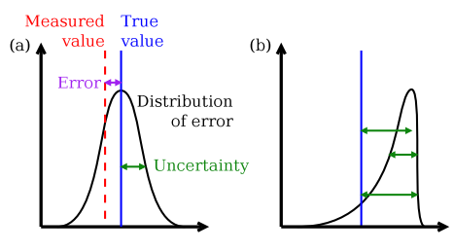
Figure 2: An illustration of error and uncertainty. The error (purple arrow) is the difference between the true value of the measurand (solid blue) and the value measured (dashed red). The black line shows the frequency distribution of values that would be obtained if the measurement were infinitely repeated, referred to as the distribution of an error. (a) A conventional random error. b) An error with a systematic component. This cannot be characterised with a single value. [23]

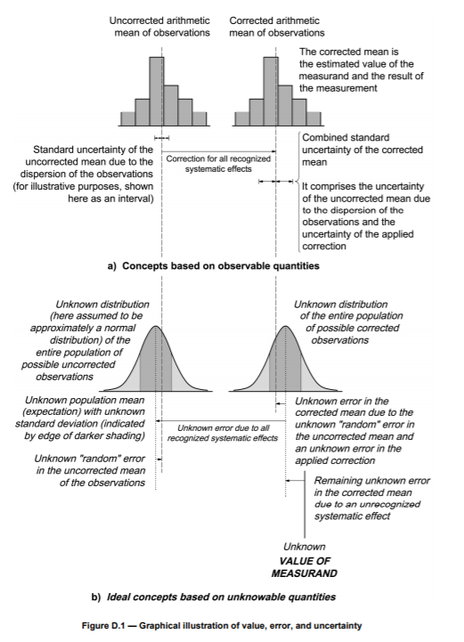
Figure 3: Graphical illustration of value, error and uncertainty [7]

In practice, there are many possible sources of uncertainty in a measurement, including [7]:
- Incomplete or imperfect definition of the measurand
- Non-representative sampling
- Inadequate knowledge of the effects of environmental conditions on the measurement
- Personal bias in reading analogue instruments
- Finite instrument resolution or discrimination threshold
- Inexact values of measurement standards and reference materials
- Inexact values of constants and other parameters obtained from external sources and used in the data-reduction algorithm
- Approximations and assumptions in the measurement method
- Variations in repeated observations of the measurand under apparently identical conditions.

The classification of an uncertainty is based on probability distributions and quantified by variances or standard deviations. The estimated standard deviation is calculated from series of repeated observations (Type A standard uncertainty obtained from a probability density function derived from an observed frequency distribution, it focuses on the repeatability and on the reproducibility of measurements) or using available knowledge (Type B standard uncertainty obtained from an assumed probability density function based on the degree of belief that an event will occur and it involves the use of other means, e.g. previous measurement data, data provided in calibration or other certificates). Once all influential uncertainty components have been evaluated, the general procedure to derive the combined standard uncertainty of the in-situ measurement involves propagating these components through the associated measurement equation. For more information about this see [7].
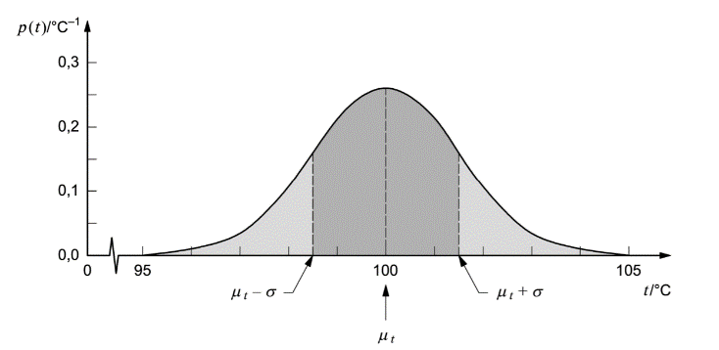
Figure 4: Graphical illustration of evaluating the standards uncertainty of an input quantity from repeated observations of the temperature t [8]

Summary of procedure for evaluating and expressing uncertainty as presented in[7]:
- Express mathematically the relationship between the measurand Y and the input quantities X_{i} on which Y depends: Y=f (X_{1 ,}X₂ ,…,X_{N}). The function f should contain every quantity, including all corrections and correction factors that can contribute a significant component of uncertainty to the result of the measurement.
- Determine x_{i}, the estimate value of the input quantity X_{i}, either on the basis of the statistical analysis of series of observations or by other means.
- Evaluate the standard uncertainty u(x_{i}) of each input estimate x_{i}. For an input estimate obtained from the statistical analysis of series of observations, the standard uncertainty is evaluated as Type A. For an input estimate obtained by other means, the standard uncertainty is evaluated as Type B.
- Evaluate the covariances associated with any input estimates that are correlated.
- Calculate the result of the measurement, that is, the estimate y of the measurand Y from the functional relationship f using for the input quantities X_{i} the estimates x_{i} obtained in step 2.
- Determine the combined standard uncertainty u_{c}(y) of the measurement result y from the standard uncertainties and covariances associated with the input estimates. If the measurement determines simultaneously more than one output quantity, calculate the covariances.
- If it is necessary to give an expanded uncertainty U, whose purpose is to provide an interval y-U to y+U that may be expected to encompass a large fraction of the distribution of values that could reasonably be attributed to the measurand Y, multiply the combined standard uncertainty u_{c}(y) by a coverage factor k, typically in the range 2 to 3. Select k on the basis of the level of confidence required of the interval.
- Report the result of the measurement y together with its combined standard uncertainty u_{c}(y) or expanded uncertainty U and discuss how they were obtained.

Useful definitions from the JCGM Guide to the expression of uncertainty in measurement

- Measurable quantity: attribute of a phenomenon, body or substance that may be distinguished qualitatively and determined quantitatively.
- Value of a quantity: magnitude of a particular quantity generally expressed as a unit of measurement multiplied by a number
- True value of a quantity: value consistent with the definition of a given particular quantity
- Conventional true value of a quantity: value attributed to a particular quantity and accepted, sometimes by convention, as having an uncertainty appropriate for a given purpose
- Measurement: set of operations having the object of determining a value of a quantity
- Principle of measurement: scientific basis of a measurement
- Method of measurement: logical sequence of operations, described generically, used in the performance of measurements
- Measurement procedure: set of operations, described specifically, used in the performance of particular measurements according to a given method
- Measurand: particular quantity subject to measurement
- Influence quantity: quantity that is not the measurand but that affects the result of the measurement
- Result of a measurement: value attributed to a measurand, obtained by measurement
- Uncorrected result: result of a measurement before correction for systematic error
- Corrected result: result of a measurement after correction for systematic error
- Accuracy of measurement: closeness of the agreement between the result of a measurement and a true value of the measurement
- Repeatability of results of measurements: closeness of the agreement between the results of successive measurements of the same measurand carried out under the same conditions of measurement
- Reproducibility of results of measurements: closeness of the agreement between the results of measurements of the same measurand carried out under changed conditions of measurement
- Experimental standard deviation: for a series of n measurements of the same measurand, the quantity $s\left(q_{k}\right)$characterizing the dispersion of the results and given by the formula:
$$s\left(q_{k}\right)= \sqrt{\frac{\sum_{j=1}^{n}{{(q_{j}-\overline{q})}^{2}}}{n-1}}$$
$q_{k}$ being the result of the kth measurement and$\overline{ q}$ being the arithmetic mean of the n results considered.
- Uncertainty of measurement: parameter, associated with the result of a measurement, that characterizes the dispersion of the values that could reasonably be attributed to the measurand
- Error of a measurement: result of a measurement minus a true value of the measurand
- Relative error: error of measurement divided by a true value of the measurand
- Random error: result of a measurement minus the mean that would result from an infinite number of measurements of the same measurand carried out under repeatability conditions
- Systematic error: mean that would result from an infinite number of measurements of the same measurand carried out under repeatability conditions minus a true value of the measurand
- Correction: value added algebraically to the uncorrected result of a measurement to compensate for systematic error
- Correction factor: numerical factor by which the uncorrected result of a measurement is multiplied to compensate for systematic error.
Additional guidance on evaluating and expressing uncertainty components and definitions may be found in [7].

Uncertainty propagation

The uncertainty associated with a measured value can generally be attributed to many components: the measuring instrument, the item being measured, the measurement procedure, operator skills, sampling issues, the ambient conditions, etc. Some of these components may be evaluated from the statistical distribution of the results of series of measurements and can be characterized by experimental standard deviations. All components of uncertainty, including those arising from systematic effects, such as components associated with corrections and reference standards, contribute to the dispersion.
Once all influential uncertainty components have been evaluated, the general procedure to derive the combined standard uncertainty of the in-situ measurement involves propagating these components through the associated measurement equation (and any subsequent treatment of the data). In [7] a combined standard uncertainty is defined as “a standard uncertainty of the result of a measurement when that result is obtained from the values of a number of other quantities, equal to the positive square root of a sum of terms, the terms being the variances of covariances of these other quantities weighted according to how the measurement result varies with changes in these quantities”. This is achieved using the law of propagation of uncertainty [7], which states that for the measurement equation:
$$y=f\left(x_{1},x_{2},…,x_{n}\right)$$
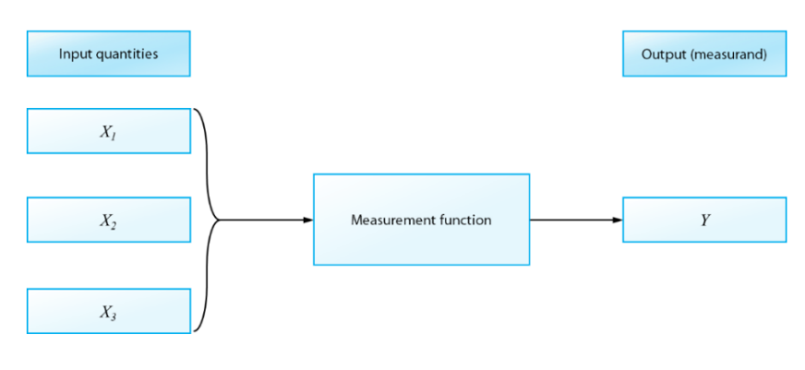
Figure 5: Measurement function [24]

The combined standard uncertainty can be obtained as:
$$u\left(y\right)=\sqrt{\sum_{i=1}^{n}{{\left[\frac{∂f}{{∂x}_{i}} u(x_{i})\right]}^{2}+2\sum_{i=1}^{n-1}{\sum_{j=i+1}^{n}{\frac{∂f}{∂x_{i}} \frac{∂f}{∂x_{j}} u(x_{i},x_{j})}}}}$$
where $y$ is the output quantity, whilst $x_{i}$ represents an input quantity, and $u(x_{i})$ its standard uncertainty.
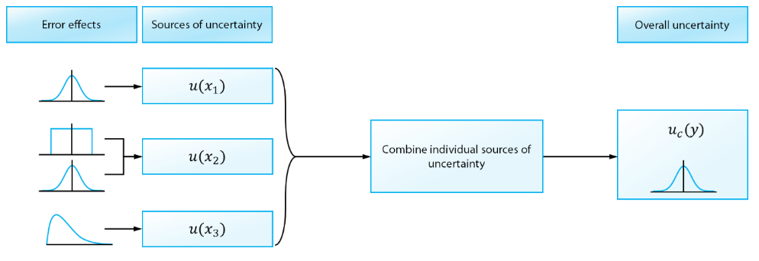
Figure 6: A summary of the uncertainty analysis [24]

The result of the measurement is obtained by using different input estimates x₁, x₂, … x_{N} for the values of the N quantities. The combined standard uncertainty is determined from the estimated standard deviation associated with each input estimate x_{i}, termed the standard uncertainty and denoted by u(x_{i}). Alternatively, [25] presents a work undertaken within the project FIDUCEO and it defines the result of uncertainty analysis by taking into account various encapsulated matrices in a covariance matrix with all the effects in the sum of the individual error covariances:
$$S= C U R U^{T}C^{T}$$

Where C represents a matrix of sensitivity coefficients (along diagonal); U is the uncertainty matrix where the diagonal elements are the uncertainty contributions; R represents the correlation matrix; T denotes the transpose operation. This approach separates the correlation and the uncertainty allowing both to be set accordingly and propagated through the equations as required [26].
This approach allows, for example, to individuate the variability in uncertainty across an image, even if, compared to the analytical approach previously presented, this operation can be practically challenging because of the size and number of dimensions of the arrays involved.

References

[1] Copernicus, “Copernicus, Europe’s eyes on Earth: About Copernicus.” https://www.copernicus.eu/en/about-copernicus (accessed Jun. 01, 2020).
[2] J. Nightingale et al., “Ten Priority Science Gaps in Assessing Climate Data Record Quality,” Remote Sens., vol. 11, no. 8, p. 986, 2019, doi: 10.3390/rs11080986.
[3] ESA, “Fiducial Reference Measurements: FRM,” 2019. https://earth.esa.int/web/sppa/activities/frm (accessed Mar. 08, 2019).
[4] J. L. Widlowski, “Conformity testing of satellite-derived quantitative surface variables,” Environ. Sci. Policy, vol. 51, pp. 149–169, Aug. 2015, doi: 10.1016/j.envsci.2015.03.018.
[5] N. Fox and M.-C. Greening, “QA4EO: A guide to comparisons – organisation, operation and analysis to establish measurement equivalence to underpin the Quality Assurance requirements of GEO (QA4EO-QAEO-GEN-DQK-004) Version 4.0.” QA4EO, 2010.
[6] E.Theocharous, E.Usadi, and N.P.Fox, “CEOS comparison of IR brightness temperature measurements in support of satellite validation. Part I: Laboratory and ocean surface temperature comparison of radiation thermometers.,” London, United Kingdom, Hampton Road, Teddington, TW11 0LW. doi: 10.1016/s1474-4422(10)70234-9.
[7] Working Group 1 of the Joint Committee for Guides in Metrology, Evaluation of measurement data — Guide to the expression of uncertainty in measurement. Paris, France: Bureau International des Poids et Mesures, 2008.
[8] ESA, “FRM4VEG – Fiducial Reference Measurements for Vegetation.” https://frm4veg.org/ (accessed Apr. 15, 2020).
[9] ESA, “FRM4SOC - Fiducial Reference Measurements for Satellite Ocean Colour.” https://frm4soc.org/ (accessed Jun. 01, 2020).
[10] ESA, “FRM4ALT - Fiducial Reference Measurements for altimetry.” https://www.frm4alt.eu/ (accessed Jun. 01, 2020).
[11] ESA, “BOUSSOLE.” http://www.obs-vlfr.fr/Boussole/html/project/strategy.php (accessed Jun. 01, 2020).
[12] ESA, “FRM4DOAS - Fiducial Reference Measurements for Ground-Based DOAS Air-Quality Observations.” https://frm4doas.aeronomie.be/ (accessed Jun. 01, 2020).
[13] ESA, “FRM4GHG - Reference Measurements for Ground-Based FTIR Greenhouse Gas Observations.” http://frm4ghg.aeronomie.be/ (accessed Jun. 01, 2020).
[14] ESA, “FRM4STS - Fiducial Reference Measurements for validation of Surface Temperatures from Satellites.” http://www.frm4sts.org/ (accessed Jun. 01, 2020).
[15] ESA, “Pandonia Global Network – Reference Measurements of Atmospheric Composition.” https://www.pandonia-global-network.org/ (accessed Jun. 01, 2020).
[16] C. Justice, A. Belward, P. Lewis, J. Privette, and F. Baret, “Developments in the ‘validation’ of satellite sensor products for the study of the land surface,” int. j. Remote Sens., vol. 21, no. 17, pp. 3383–3390, 2000.
[17] CEOS - Committee on Earth Observation Satellites, “RadCalNet Portal.” https://www.radcalnet.org/#!/ (accessed Apr. 09, 2020).
[18] B. N. Holben et al., “AERONET—A Federated Instrument Network and Data Archive for Aerosol Characterization,” Remote Sens. Environ., vol. 66, no. 1, pp. 1–16, Oct. 1998, doi: 10.1016/S0034-4257(98)00031-5.
[19] W. B. Cohen and C. O. Justice, “Validating MODIS Terrestrial Ecology Products: Linking In Situ and Satellite Measurements,” Remote Sens. Environ., vol. 70, 1999.
[20] J. Baret, F., Schaaf, C., Morisette, Privette, and J., “Report on the Second International Workshop on Albedo Product Validation,” Earth Obs., pp. 13–17, 2005.
[21] M. Karan et al., “The Australian SuperSite Network: A continental, long-term terrestrial ecosystem observatory,” Sci. Total Environ., vol. 568, pp. 1263–1274, Oct. 2016, doi: 10.1016/j.scitotenv.2016.05.170.
[22] M. Keller, D. S. Schimel, W. W. Hargrove, and F. M. Hoffman, “A continental strategy for the National Ecological Observatory Network,” Front. Ecol. Environ., vol. 6, no. 5, pp. 282–284, Jun. 2008, doi: 10.1890/1540-9295(2008)6[282:ACSFTN]2.0.CO;2.
[23] A. C. Povey and R. G. Grainger, “Known and unknown unknowns: Uncertainty estimation in satellite remote sensing,” Atmos. Meas. Tech., vol. 8, no. 11, pp. 4699–4718, 2015, doi: 10.5194/amt-8-4699-2015.
[24] FIDUCEO, “Introducing the measurement function.” http://www.fiduceo.eu/tutorial/introducing-measurement-function (accessed Jun. 04, 2020).
[25] C. Merchant, G. Holl, J. Mittaz, and E. Woolliams, “Radiance Uncertainty Characterisation to Facilitate Climate Data Record Creation,” Remote Sens., vol. 11, no. 5, p. 474, Feb. 2019, doi: 10.3390/rs11050474.
[26] N. Origo, J. Gorroño, J. Ryder, J. Nightingale, and A. Bialek, “Fiducial Reference Measurements for validation of Sentinel-2 and Proba-V surface reflectance products,” Remote Sens. Environ., vol. 241, no. November 2019, p. 111690, 2020, doi: 10.1016/j.rse.2020.111690.

