|  |  |
| --- | --- |
|  | **FRM Protocols and Procedures for Fraction of Absorbed Photosynthetically Active Radiation (FAPAR) and Canopy Chlorophyll Content (FPP)**  VERSION 1.0  University of Southampton  EOLAB  National Physical Laboratory  17 June 2020 |
| [Related image](https://www.google.co.uk/url?sa=i&rct=j&q=&esrc=s&source=images&cd=&cad=rja&uact=8&ved=0ahUKEwjRx6alu5PYAhXL1xQKHcWbBx4QjRwIBw&url=https://www.bodet.co.uk/news/269-the-national-physical-laboratory-selects-bodet-to-provide-a-wireless-time-solution.html&psig=AOvVaw3HTJAk3pVRL7SYyC5vdX23&ust=1513683146214264) | This document was produced as part of the ESA-funded project “Fiducial Reference Measurements for Vegetation Phase 2 (FRM4VEG 2)” under ESA contract number: 4000129823/20/I-NS |

##### Authors

|  |  |  |  |
| --- | --- | --- | --- |
|  | **Name** | **Organisation** | **Date** |
| **Written by** | Luke Brown | University of Southampton | 17/06/2020 |
|  | Jadunandan Dash | University of Southampton |  |
|  | Fernando Camacho | EOLAB |  |
|  | Vicente García-Santos | EOLAB |  |
|  | Joanne Nightingale | NPL |  |
|  | Niall Origo | NPL |  |
|  | Rosalinda Morrone | NPL |  |
| **Reviewed by (consortium)** |  |  |  |
| **Approved by (ESA)** |  |  |  |

##### Version History

|  |  |  |
| --- | --- | --- |
| **Version** | **Date** | **Publicly available or private to consortium** |
| 1.0 | 17/06/2020 | Private Consortium |

##### Table of Contents

Authors 2

Version History 2

Table of Contents 3

List of Figures 5

List of Tables 5

Acronyms 6

1 Introduction 8

1.1 Purpose and Scope 8

1.2 Overview of FRM Requirements 8

2 FAPAR and CCC Terminology 10

2.1 FAPAR 10

2.1.1 FAPAR Principles of Measurement 10

2.1.2 The Two Flux Approach: FIPAR 12

2.1.3 Multi-angular Measurements of Canopy Transmittance/Gap Fraction 13

2.2 CCC 15

2.2.1 LAI Principles of Measurement 15

2.2.2 LCC Principles of Measurement 18

3 Measurement Instrumentation 21

3.1 LI-COR LAI-2200C Plant Canopy Analyser 21

3.2 DSLR Camera and Fisheye Lens for DHP 22

3.3 Konica Minolta SPAD-502 Chlorophyll Meter 22

3.4 SQ-110 PAR Sensor 23

3.5 AccuPAR PAR/LAI Ceptometer LP-80 23

4 Instrument Calibration 25

4.1 Quantum Sensor Calibration 25

4.2 LAI-2200C Calibration 27

4.3 DHP Calibration 27

4.4 Optical Chlorophyll Meter Calibration 28

4.5 AccuPAR LP-80 Calibration 30

5 Criteria for FRMs 31

5.1 Criteria for Field Campaigns 31

5.1.1 Selection of Field Sites 31

5.1.2 Sampling Strategy 32

5.1.3 Timing of Field Data Collection 33

5.2 Permanent Field Sites 33

6 Traceability, Uncertainty Sources and Propagation 34

6.1 Uncertainty Sources and Propagation for FAPAR 34

6.2 Uncertainty Sources and Propagation for CCC 38

7 References 45

A Appendix 48

A.1 FRM4VEG Phase 1 FAPAR and CCC Campaign at Wytham Woods 48

A.1.1 Measurement Instrumentation 48

A.1.2 Instrument Calibration 48

A.1.3 Selection of the Field Site 48

A.1.4 Field Sampling Strategy 49

A.1.5 Timing of the Field Campaign 50

A.1.6 Field Data Uncertainty Propagation 51

##### List of Figures

Figure 1: The PAR balance as measured with quantum sensors facing upwards and downwards at the top and the bottom of the canopy. 11

Figure 2: Angular sampling provided by the optical sensor of the LI-COR LAI-2200C [12]. 14

Figure 3: LI-COR LAI-2200C Plant Canopy Analyser [12]. 22

Figure 4: Canon EOS 6D DSLR camera [23]. 22

Figure 5: Konica Minolta SPAD-502 [25]. 23

Figure 6: Apogee SQ-110 PAR Sensor [26]. 23

Figure 7: AccuPAR model LP-80 PAR/LAI Ceptometer [15]. 24

Figure 8: PAR sensors set up on the spectral response facility at NPL. 26

Figure 9: Alignment of PAR sensors before measuring a broadband source. 26

Figure 10: Example of the setup used to determine the lens projection function according the method implemented in CAN-EYE [35]. 28

Figure 11: Pigment extraction from a leaf disc in DMSO (left). The solution is transferred to a cuvette to facilitate spectrophotometric determination of LCC (right). 29

Figure 12: Systematic within-ESU sampling strategy. 32

Figure 13: Fish-bone diagram illustrating the components contributing to uncertainty in the SPAD values provided by the optical chlorophyll meter. 41

Figure 14: Fish-bone diagram illustrating the components contributing to uncertainty in the spectrophotometric determination of LCC. Greyed out components are not considered due to their minimal influence on overall uncertainty. 42

Figure 15: Example SPAD calibration function for Hazel, derived using ODR. Error bars represent expanded uncertainties (k = 2). 43

Figure 16: Fish-bone diagram illustrating how the uncertainty in an individual in situ LCC measurement is derived. 44

Figure 17: Wytham Woods canopy walkway (a) and during leaf-on (b) and leaf-off (c) conditions. 49

Figure 18: Map of Wytham Woods, indicating the locations of selected ESUs. High spatial resolution image acquired in May 2017. The red points represent ESUs containing nodes of the permanent wireless FAPAR sensor network. 50

##### List of Tables

Table 1: Typical values of x for different crops [15]. 17

Table 2: Spectrophotometric equations to convert absorption values to the concentrations of chlorophyll-a and -b for different solvents and spectrophotometer spectral resolutions [20]. 19

Table 3: Uncertainty sources associated with in situ measurements of FAPAR performed using quantum sensors. 34

Table 4: Uncertainty sources associated with in situ measurements of FIPAR derived from multi-angular measurements of gap fraction. 35

Table 5: Cloud-free availability of Sentinel-2 MSI data over Wytham Woods (red to green colour scale represents the minimum to maximum number of available scenes). 51

Table 6: Overpass schedule for the Wytham Woods campaign (all times UTC). 51

##### Acronyms

|  |  |
| --- | --- |
| **Abbreviation** | **Stands For** |
| AOT | Aerosol optical thickness |
| CCC | Canopy chlorophyll content |
| CEOS | Committee on Earth Observation Satellites |
| CIP | Campaign Implementation Plan |
| CORINE | Coordination of Information on the Environment |
| DHP | Digital hemispherical photography |
| DMF | Dimethyl-formamide |
| DMSO | Dimethyl-sulfoxide |
| DPOF | Digital print order format |
| DSLR | Digital single lens reflex |
| EOLAB | Earth Observation Laboratory |
| ECV | Essential climate variable |
| ESA | European Space Agency |
| ESU | Elementary sampling unit |
| FAPAR | Fraction of absorbed photosynthetically active radiation |
| FEL | Free electron laser |
| FIDUCEO | Fidelity and Uncertainty in Climate Data Records from Earth Observation |
| FIPAR | Fraction of intercepted photosynthetically active radiation |
| ForestGEO | Forest Global Earth Observatory Network |
| FPP | FRM Protocols and Procedures |
| FRM | Fiducial Reference Measurements |
| FRM4VEG | Fiducial Reference Measurements for Vegetation |
| GCOS | Global Climate Observing System |
| GLC | Global Land Cover |
| GPS | Global positioning system |
| HDR | High dynamic range |
| JCGM | Joint Committee for Guides in Metrology |
| JPEG | Joint Photographic Experts Group |
| LAD | Leaf angle distribution |
| LAI | Leaf area index |
| LCC | Leaf chlorophyll concentration |
| LPV | Land Product Validation |
| LST | Land surface temperature |
| LUT | Look up table |
| MSI | Multispectral Instrument |
| NCAVEO | Network for Calibration and Validation of Earth Observation |
| NDVI | Normalised difference vegetation index |
| NPL | National Physical Laboratory |
| ODR | Orthogonal distance regression |
| PAI | Plant area index |
| PAR | Photosynthetically active radiation |
| RGB | Red green blue |
| RTM | Radiative transfer model |
| SI | International System of Units |
| SLA | Specific Leaf Area |
| SMF | Spectral mismatch factor |
| SPAD | Special Products Analysis Division |
| SWIR | Shortwave infrared |
| SZA | Solar Zenith Angle |
| TREES | Traceability in Terrestrial Vegetation Sensors and Products |
| TTL | Through the lens |
| UAV | Unmanned aerial vehicle |
| UCLM | University of Castilla-La-Mancha |
| UHS | Ultra-high speed |
| UOS | University of Southampton |
| USB | Universal serial bus |
| UTC | Coordinated universal time |
| UV | Ultraviolet |
| VALERI  VIS | Validation of European Land Remote Sensing Instruments  Visible |
| VNIR | Visible near infrared |
| WGCV | Working Group on Calibration and Validation |

# Introduction

## Purpose and Scope

This document forms deliverable D-20 of the ESA project ‘Fiducial Reference Measurements for Vegetation Phase 2 (FRM4VEG)’. Its purpose is to detail Fiducial Reference Measurement (FRM) protocols and procedures for the fraction of absorbed photosynthetically active radiation (FAPAR) and canopy chlorophyll content (CCC). The FRM Protocols and Procedures for FAPAR and CCC (FFP-FAPAR/CCC) is a manual for calibrating field instrumentation, conducting field measurements in relation to both campaign and permanent field acquisitions, as well as describing how those measurements should be treated for upscaling to represent satellite pixels. The document is organized into 7 main sections:

* **Section 1** provides a summary of the FPP-FC document with an overview of the FRM projects and requirements.
* **Section 2** provides an overview of the terminology for both FAPAR and CCC.
* **Section 3** reviews the instruments which can be used to measure FAPAR and CCC with their role in the supporting calibration and validation of satellite data.
* **Section 4** describes the calibration of the instruments both in laboratory and in the field.
* **Section 5** describes the procedures that should be followed in the field in order to support the systematic collection of in situ data with the goal of satellite product validation to FRM standards, and a description of requirements for permanent field sites.
* **Section 6** underlines the importance of reporting quantitative indication on the quality of the results to assess the reliability of the measurement of the physical quantity.
* **Appendix 1:** provides a practical example of a field campaign from FRM4VEG Phase 1, by summarising the field activities to measure FAPAR and CCC and by describing the processing of field and satellite data.

## Overview of FRM Requirements

The ESA sponsored Fiducial Reference Measurement (FRM) programme aims to provide a suite of reference measurements (of land, ocean and atmosphere variables) with an associated uncertainty that can be used to conduct satellite product validation through conformity testing. That is, the process that determines whether the estimated target quantity (i.e. the satellite estimate) falls within the range of tolerable values (i.e. the reference estimate), or not [1].

All FRMs should:

1. Have documented SI traceability (or conform to appropriate international community standards), utilising instruments that have been characterised using metrological standards, both pre-deployment and evaluated regularly post-deployment [2], [3].
2. Be independent from the satellite geophysical retrieval process.
3. Be accompanied by an uncertainty budget for all instruments, derived measurements and validation methods [4].
4. Adhere to community-agreed, published and openly available measurement protocols/ procedures and management practices.
5. Be accessible to other researchers allowing independent verification of processing systems.

A number of FRM projects have been created for various satellite retrievals [5]:

* FRM4VEG: Fiducial Reference Measurements for Vegetation.
* FRM4SOC: Fiducial Reference Measurements for Satellite Ocean Colour.
* FRM4ALT: Fiducial Reference Measurements for Altimetry.
* FRM-BOUSSOLE: Buoy for the acquisition of long-term optical time series.
* FRM4DOAS: Fiducial Reference Measurements for Ground-Based DOAS Air-Quality Observations.
* FRM4GHG: Fiducial Reference Measurements for Ground-Based FTIR Greenhouse Gas Observations.
* FRM4STS: Fiducial Reference Measurements for Validation of Surface Temperatures from Satellites.
* Pandonia FRM: Fiducial Reference Measurements for Ground-Based Direct-Sun Air-Quality Observations.

FRM4VEG Phase 2 develops the methods and guidance documentation which should be followed by the international validation community when a) collecting campaign and permanent FRMs and b) performing validation of satellite-derived products, over the vegetated land surface.

# 

# FAPAR and CCC Terminology

## FAPAR

The fraction of absorbed photosynthetically active radiation (FAPAR) is recognised as an essential climate variable (ECV) by the Global Climate Observing System (GCOS) as it has a primary role in estimation of the carbon balance. FAPAR is generally defined as the fraction of photosynthetically active radiation (PAR) absorbed by vegetation, where PAR is the solar radiation reaching the vegetation in the wavelength region 400 nm to 700 nm. It is a dimensionless quantity varying from zero (over bare soil) to almost one for the largest amounts of green vegetation. Since FAPAR is mainly used as a descriptor of photosynthesis and evapotranspiration processes, only the green photosynthetic elements (leaves, needles, or other green elements) should be accounted for.

FAPAR depends on the illumination conditions, i.e. the angular position of the sun and the relative contributions of the direct and diffuse illumination. Both black-sky (assuming only direct radiation) and white-sky (assuming that all incoming radiation is in the form of isotropic diffuse radiation) FAPAR values may be considered. FAPAR may also be considered on an instantaneous (at the time of acquisition) or temporally integrated basis.

### FAPAR Principles of Measurement

The fraction of PAR absorbed by a canopy may be directly measured using quantum sensors, or it may be estimated from measurements of transmission or gap fraction, the latter of which is equivalent to transmission if leaves are assumed to be black. Quantum sensors consist of a detector and filter that is sensitive to the PAR region of the electromagnetic spectrum, and typically incorporate cosine correction to provide a measurement integrated over the entire hemisphere. When measured directly, the PAR absorbed by a canopy is determined based on a closure of the PAR balance, considering hemispherical fluxes at the boundaries of the canopy. It is computed as

$${{PAR}_{a}=PAR}_{H}^{↓}-{PAR}_{H}^{↑}-{PAR}_{0}^{↓}+{PAR}_{0}^{↑} \\ where {PAR}^{↓}$$ and ${PAR}^{↑}$ are downward and upward PAR fluxes measured at the bottom (${PAR}_{0}$) and top (${PAR}_{H}$) of the canopy. Thus, the measurement of each term of the PAR balance requires several quantum sensors (Figure 1):

* ${PAR}_{H}^{↓}$- incident PAR at the bottom of the canopy may be measured using upwards facing quantum sensors at the top of the canopy.
* ${PAR}_{H}^{↑}$- reflected PAR may be measured using downwards facing quantum sensors at the top of the canopy
* ${PAR}_{0}^{↓}$- transmitted PAR may be measured using upwards facing quantum sensors at the bottom of the canopy.
* ${PAR}_{0}^{↑}$- PAR reflected by the soil may be measured using downwards facing sensors at the bottom of the canopy.

The number of quantum sensors required to derive representative measurements of a canopy depends on its heterogeneity, in addition to the footprint of the sensor itself. Approximately half of the flux collected by a quantum sensor comes from a circle with a radius equal to the height of the sensor [6]. Between five and fifty sensors are therefore required for the terms measured at the bottom of the canopy, because distances to the soil, top of the canopy and bottom of the canopy are generally limited. Conversely, a smaller number of sensors are typically required to measure the reflected PAR, depending on the distance between the sensor and the top of the canopy. Where possible, these sensors should be positioned at a distance of at least five times the typical size of heterogeneities [6]. In the case of incoming PAR at the top of the canopy, only a single sensor is required because the incident radiation field is rarely locally heterogeneous.



Figure : The PAR balance as measured with quantum sensors facing upwards and downwards at the top and the bottom of the canopy.

When all terms are measured, FAPAR may be derived as

$$FAPAR=1-R_{c}-T_{c}+T_{c} R_{s}=1-R_{c}-T_{c} (1-R_{s})$$

where $R_{c}$ is the reflectance of the canopy, $T_{c}$ is the transmittance of the canopy and $R_{s}$ is the reflectance of the soil, all integrated in the PAR region. Note all correspond to bi-hemispherical reflectance quantities [7], [8].

### The Two Flux Approach: FIPAR

Where very little multiple scattering is expected in the PAR domain, FAPAR may be simplified to

$$FAPAR≈\left(1-T_{c}\right) (1-R_{∞})$$

where $R_{∞}$ is the asymptotic value of canopy reflectance when leaf area index (LAI) tends towards infinity [9]. Values of $R_{∞}$ are generally small (approximately 0.06) in the PAR domain as most photons are absorbed by green leaves [10]. Under these conditions, the PAR balance may be approximated by measuring only the incident (${PAR}_{H}^{↓}$) and transmitted (${PAR}_{0}^{↓}$) terms. This simplification enables potential issues in measuring the soil reflectance term to be avoided: as highlighted earlier, many sensors are required due to the small distance between the soil and the sensor, and the possible effect of the sensor shadow in the footprint. It also avoids issues in the computation of this term from the soil reflectance values that may vary significantly depending on the geometry of the incoming radiation.

Green leaves are characterised by high absorption in the PAR domain, and thus appear almost black. As such, the contribution of multiple scattering to canopy transmittance is negligible, allowing the fraction of PAR intercepted by the canopy (FIPAR) to be determined according to the fraction of PAR transmitted by the canopy:

$$FIPAR≈(1-T_{c})$$

Combining these equations enables FAPAR to be related to FIPAR as

$$FAPAR≈FIPAR (1-R_{∞})$$

An $R_{∞}$ of 0.06 would be expected for a canopy with very high LAI. The validity of this approximation was investigated by [10], [11].

A number of individual sensors are available commercially, with a range of performances in terms of spectral sensitivity, cosine response, and price. Examples include the LI-COR LI-190R, Apogee Instruments SQ-100 series, Delta-T QS5, Kipp and Zonen PQS1, and Skye SKP-215. Several manufacturers also provide a number of sensors aligned on a single support, enabling spatial variability in incoming PAR at the bottom of the canopy to better represented. Such systems are known as ceptometers and can incorporate up to 80 individual sensors along a length of 1 m. Examples include the Decagon Devices AccuPAR LP-80 and Delta-T SunScan.

In all cases, approaches based on the PAR balance asses the quantity of PAR absorbed by the canopy independently of the nature of the elements. As a consequence, when a substantial fraction of canopy elements are non-photosynthetically active (e.g. trunks, branches and senescent leaves), the PAR absorbed by green photosynthetically active elements will be overestimated.

### Multi-angular Measurements of Canopy Transmittance/Gap Fraction

Incoming PAR may be decomposed into the direct component coming from the sun, and the diffuse component due to light scattering in the atmosphere. For each of those components, an FAPAR value can be associated. The total FAPAR can then be determined as

$$FAPAR=FAPAR\left(θ_{s},φ_{s}\right) \left(1-f_{diff}\right)+{FAPAR}_{diff} f_{diff}$$ where $f_{diff}$ is the fraction of diffuse PAR, $FAPAR\left(θ_{s},φ_{s}\right)$ is the direct FAPAR (also known as black-sky FAPAR) from the sun at a given illumination geometry, and ${FAPAR}_{diff}$ is the diffuse FAPAR (also known as white-sky FAPAR). By integrating the direct FAPAR over the whole hemisphere, ${FAPAR}_{diff}$ may be derived as

$${FAPAR}_{diff}=\frac{\int_{0}^{2π}{\int_{0}^{π/2}{E\left(θ_{s},φ_{s}\right)FAPAR\left(θ_{s},φ_{s}\right)\sin{θ_{s}}\cos{θ_{s}}d{θ_{s}}d{φ_{s}}}}}{\int_{0}^{2π}{\int_{0}^{π/2}{E(θ_{s},φ_{s})\sin{θ_{s}}\cos{θ_{s}}d{θ_{s}}d{φ_{s}}}}}$$

where $θ_{s}$ and $φ_{s}$ are the solar zenith and azimuth angles, and $E(θ_{s},φ_{s})$ describes the directional variation of irradiance. When the diffuse fraction is assumed isotropic, then $E\left(θ_{s},φ_{s}\right)$ is a constant.

Several techniques can be used to provide measurements of canopy transmittance/gap fraction at multiple zenith angles. The LI-COR LAI-2200C Plant Canopy Analyser (and previous LAI-2200 and LAI-2000 variants) makes use of an optical sensor to measure incoming radiation in the blue region of the electromagnetic spectrum, within five zenith rings of approximately 15° (Figure 2). Measurements are performed both above and below the canopy, enabling canopy transmittance to be determined within each zenith ring. The same principles can be applied to images collected using digital hemispherical photography (DHP), whereby angular sampling is facilitated by a fisheye lens with a 180° FOV. Images can be divided into any number of angular bins, and the gap fraction can be estimated by classifying pixels as belonging to the canopy or its background (i.e. the soil or sky depending on the direction the camera is facing). In the PAR domain, gap fraction can be considered nearly equal to canopy transmittance due to strong absorption by photosynthetic pigments.

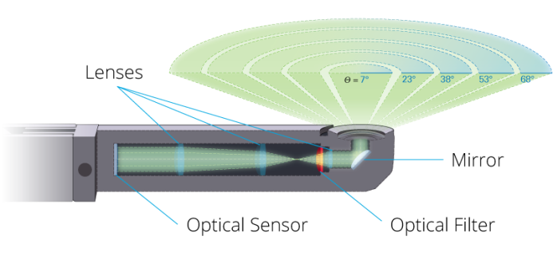

Figure 2: Angular sampling provided by the optical sensor of the LI-COR LAI-2200C [12].

The angular variation in canopy transmittance/gap fraction can be used to reconstruct diurnal variations in FIPAR. These multi-angular techniques are very efficient, facilitating instantaneous measurements that can be replicated multiple times to improve spatial sampling, whilst also enabling diurnal variations in FIPAR to be assessed. Whilst the LAI-2200C cannot distinguish between photosynthetically active and non-photosynthetically active canopy elements, when DHP images are acquired above the canopy, it is possible to distinguish between green leaves and other canopy elements such as stems and branches. Thus, downwards facing DHP can provide an accurate estimate of green FIPAR, which would otherwise be overestimated. Nevertheless, the technique is limited to relatively short canopies for obvious practical reasons.

When DHP is adopted in forest environments, separate measurements of the overstory and understory may be performed using upwards and downwards facing images respectively. In this case, they must be combined to provide a single value. The combination strategy adopted in the FRM4VEG project is equivalent to that used in the Validation of Land European Remote Sensing Instruments (VALERI) project [13], and states that

$$FIPAR={FIPAR}_{up}+\left(1-{FIPAR}_{up}\right) {FIPAR}_{down}$$ where ${FIPAR}_{up}$ and ${FIPAR}_{down}$ are the FIPAR values derived using upwards and downwards facing DHP, respectively. It should be noted that such a combination strategy assumes independence of gaps within the two canopy layers, which may not hold at all scales.

## CCC

As the key photosynthetic pigment within a plant, chlorophyll plays an important role in determining its physiological status. The content of chlorophyll within a vegetation canopy is therefore strongly related to its productivity and is a sensitive indicator of its health. Thus, estimates of canopy chlorophyll content (CCC) are a key input into models of terrestrial primary productivity and carbon exchange. CCC is defined as the product of leaf chlorophyll concentration (LCC) and LAI. LCC is expressed as the mass of chlorophyll per unit leaf area, whist LAI is a dimensionless quantity defined as the one-sided leaf area per unit ground area.

### LAI Principles of Measurement

The direct determination of LAI involves the planimetric measurement of the leaves present within a given area of ground surface (i.e. using a leaf area meter). It is possible to carry out such measurements non-destructively, but because the process is time-consuming, leaves are more typically harvested, allowing the area of a small subset of leaves to be measured. This enables leaf area to be related to dry mass through specific leaf area (SLA). By oven drying and weighing all leaves collected from a given area of ground surface, LAI can then be calculated gravimetrically. In the case of deciduous species, litter traps can be used as an alternative to destructive harvesting.

Given the time-consuming nature of direct LAI determination methods, indirect techniques are more typically adopted, making use of optical instruments to enable larger areas to be covered non-destructively. These techniques include ceptometry, in addition to the use of instruments that exploit multi-angular measurements of canopy transmittance/gap fraction. Because these optical techniques are unable to discriminate between green leaves and other canopy elements such as stems and branches (with the exception of downwards facing DHP), they cannot strictly be considered to measure LAI itself, and instead the term plant area index (PAI) is preferred by some authors.

Using measurements of incoming PAR at the top and bottom of the canopy (i.e. from a ceptometer), LAI can be estimated through inversion of Beer’s law as

$$LAI=\frac{\ln{I/I_{0}}}{k}$$ where $I$ is the incoming PAR below the canopy, $I_{0}$ is the incoming PAR above the canopy, and $k$ is the extinction coefficient. The value of $k$ is a function of the leaf angle distribution (LAD) of the canopy, and the SZA. A spherical LAD, which describes a canopy in which all leaves are oriented randomly, is often assumed. In this case, $k$ can be calculated as

$$k=\frac{1}{2\cos{θ}}$$

where $θ$ is the SZA. A modification of the spherical LAD is the ellipsoidal LAD, in which leaves are arranged so that they would cover the surface of an ellipsoid, as opposed to that of a sphere. The ellipsoid may be elongated upward or sideways, making use of a parameter that describes the ratio of the horizontal to the vertical semi-axis ($x$). Thus, canopies with more planophile or erectophile LAD can be represented. In the case of the ellipsoidal LAD, $k$ is calculated as

$$k=\frac{\sqrt{x^{2}+\tan{θ^{2}}}}{{x+1.744 (x+1.182)}^{-0.733}}$$

Typical values of $x$ are listed in Table 1 for different crops.

An alternative approach involves the use of multi-angular canopy transmittance/gap fraction measurements, which can be obtained using DHP and instruments such as the LAI-2200C (as described in Section 2.1.3). An advantage of this approach is that it does not require prior information on the canopy LAD to be known. Two widely used methods may be adopted. In the first, ‘effective’ LAI is derived according to [14], who states that

$$LAI=2\int_{0}^{π/2}{-\ln{P(θ)}\cos{θ\sin{θ}}}d θ$$

where $P(θ)$ is the gap fraction at zenith angle $θ$. By measuring gap fraction at multiple zenith angles, a discretised version of this integral can be solved as

$$LAI=2\sum_{i=1}^{n}{-\ln{\overline{P\left(θ_{i}\right)}}\cos{θ_{i}\sin{θ_{i}}}d{θ_{i}}}$$

where $\overline{P\left(θ_{i}\right)}$ is the mean gap fraction in zenith ring .

Table : Typical values of x for different crops [15].

|  |  |
| --- | --- |
| **Crop** | $$x$$ |
| Ryegrass | 0.67 to 2.47 |
| Mazie | 0.76 to 2.52 |
| Rye | 0.80 to 1.27 |
| Wheat | 0.96 |
| Barely | 1.20 |
| Timothy | 1.13 |
| Sorghum | 1.43 |
| Lucerne | 1.54 |
| Hyrbrid Swede | 1.29 to 1.81 |
| Sugar Beet | 1.46 to 1.88 |
| Rape | 1.92 to 2.13 |
| Cucumber | 2.17 |
| Tobacco | 1.29 to 2.22 |
| Potato | 1.70 to 2.47 |
| Horse Bean | 1.81 to 2.17 |
| Sunflower | 1.81 to 2.31 |
| White Clover | 2.47 to 3.26 |
| Strawberry | 3.03 |
| Jerusalem Artichoke | 2.16 |

The second method makes use of gap fraction measurements at a single zenith angle. At 57.5°, also known as the hinge angle, the gap fraction can be considered nearly independent of LAD. Thus, LAI can be determined according to [16] as:

$$LAI= \frac{-\ln{\overline{P(θ_{57.5°})}}}{0.93}$$

where $\overline{P(θ_{57.5°})}$ is the mean gap fraction at a zenith angle of 57.5°.

It is important to note that all of the previously described indirect techniques rely on the assumption of randomly distributed foliage, and thus provide an ‘effective’ measurement that is likely to underestimate the ‘true’ LAI as determined by destructive sampling. This is because in a real canopy, varying degrees of foliage clumping are observed. The degree of foliage clumping can be described by the clumping index, which is equal to one when foliage is randomly distributed, but less than one when foliage is clumped.

Where multiple measurements of gap fraction are available at a given zenith angle, [17] propose a method to account for the effects of foliage clumping. The method relies on calculating the mean of the natural logarithm of gap fraction values as opposed to the natural logarithm of mean gap fraction values and enables the ‘true’ LAI to be assessed. The scale of foliage clumping accounted for is dependent on that of the available measurements. For example, when applied to measurements performed with the LAI-2200C, the method can only account for foliage clumping at scales greater than the FOV of the instrument itself. In the case of DHP, because each zenith ring can be divided into a number of small azimuth cells, the effects of foliage clumping can be accounted for at both the within crown and between crown scales.

A range of software packages are available to process DHP images, including the freely available CAN-EYE, DHP-TRACWin, and Gap Light Analyser, in addition to the commercial Hemisfer, HemiView, and WinSCANOPY. CAN-EYE, which was developed within the framework of the VALERI project and is widely used in satellite product validation, is the software package adopted within the FRM4VEG project. In addition to the analysis methods described above, it implements several methods based on look-up-table (LUT) inversion. These are thought better able to handle processing images with a restricted FOV (i.e. to avoid mixed pixels at the edge of the image). Unlike several other software packages, its image classification procedures are well-suited to both upwards and downwards facing images [18].

As is the case for FIPAR, when DHP is adopted in a forest environment, separate measurements of the understory and overstory may be performed using upwards and downwards facing images. In this case, they should be added to provide the total LAI as

$${LAI}_{total}={LAI}_{up}+{LAI}_{down}$$

where ${LAI}_{up}$ and ${LAI}_{down}$ are the LAI values obtained from upwards and downwards facing DHP, respectively.



### LCC Principles of Measurement

The direct determination of LCC necessitates destructive sampling. The procedure involves the removal of a portion of the leaf with a known area (i.e. using a cork borer or hole punch). The sample is then placed in a solvent such as acetone, methanol, chloroform, dimethyl-ether, dimethyl-formamide (DMF) or dimethyl-sulphoxide (DMSO), facilitating the extraction of pigments in solution (Table 2). Solvents such as acetone, methanol and ethanol necessitate grinding of the leaf tissue, whereas complete extraction can be achieved by means of immersion when using DMF and DMSO [19].

Table 2: Spectrophotometric equations to convert absorption values to the concentrations of chlorophyll-a and -b for different solvents and spectrophotometer spectral resolutions [20].

|  |  |  |
| --- | --- | --- |
|  | **Spectral resolution of spectrophotometer** | |
| **Solvent** | **0.1 nm to 0.5 nm** | **1 nm to 4 nm** |
| 80% acetone | $$C_{a}=12.25{ A}_{663.2}-2.79{ A}_{646.8}$$ $$C_{b}=21.5{ A}_{646.8}-5.1{ A}_{663.2}$$ | $$C_{a}=12.21{ A}_{663}-2.81{ A}_{646}$$ $$C_{b}=20.13{ A}_{646}-5.03{ A}_{663}$$ |
| Chloroform | $$C_{a}=11.47{ A}_{665.6}-2{ A}_{647.6}$$ $$C_{b}=21.85{ A}_{647.6}-4.53{ A}_{665.6}$$ | $$C_{a}=10.91{ A}_{666}-1.2{ A}_{648}$$ $$C_{b}=16.38{ A}_{648}-4.57{ A}_{666}$$ |
| Dimethyl-ether | $$C_{a}=10.05 A_{660.6}-0.97{ A}_{642.2}$$ $$C_{b}=16.36{ A}_{642.2}-2.43{ A}_{660.6}$$ | $$C_{a}=10.05 A_{662}-0.77{ A}_{644}$$ $$C_{b}=16.37{ A}_{644}-3.14{ A}_{662}$$ |
| Dimethyl-formamide (DMF) | $$C_{a}=12{ A}_{663.8}-3.11{ A}_{646.8}$$ $$C_{b}=20.78{ A}_{646.8}-4.88{ A}_{663.8}$$ | $$C_{a}=11.65{ A}_{664}-2.69{ A}_{647}$$ $$C_{b}=20.81{ A}_{647}-4.53{ A}_{664}$$ |
| Dimethyl-sulphoxide (DMSO) | $$C_{a}=12.47{ A}_{665.1}-3.62{ A}_{649.1}$$ $$C_{b}=25.06{ A}_{649.1}-6.5{ A}_{665.1}$$ | $$C_{a}=12.19{ A}_{665}-3.45{ A}_{649}$$ $$C_{b}=21.99{ A}_{649}-5.32{ A}_{665}$$ |
| Methanol | $$C_{a}=16.72{ A}_{665.2}-9.16{ A}_{652.4}$$ $$C_{b}=34.09{ A}_{652.4}-15.28{ A}_{665.1}$$ | $$C_{a}=15.65{ A}_{666}-7.34{ A}_{653}$$ $$C_{b}=27.05{ A}_{653}-11.21{ A}_{666}$$ |

Once extracted in solution, the concentrations of chlorophyll-a and -b can be determined spectrophotometrically. [20] provides a series of spectrophotometric equations for converting absorption values to the concentrations of chlorophyll-a and -b (Table 2), emphasising the importance of using an equation derived from extinction coefficients associated with the solvent being used. The importance of matching spectrophotometric equations with instrument type and spectral resolution is also stressed. Those derived with high spectral resolution spectrophotometer are not appropriate for use with lower spectral resolution instruments, whilst those derived using diode-array spectrophotometers are not interchangeable with non-diode array instruments.

As in the case of LAI, indirect techniques for the determination of LCC have been developed, reducing the need for destructive sampling and enabling larger areas to be covered in a shorter space of time. They involve the use of optical chlorophyll meters, which measure leaf transmittance at two wavelengths (red at approximately 650 nm and near-infrared at approximately 930 nm to 940 nm) to provide a relative measure of LCC. Such instruments include the Konica Minolta SPAD-502, Opti-Sciences CCM-200, and Apogee Instruments MC-100. All are based on similar principles, although differ slightly in their exact wavelength specification. Of the available optical chlorophyll meters, the SPAD-502 is the most widely used. By determining transmittance at 650 nm and 940 nm, the instrument calculates a relative value proportional to LCC as

$$M=k\log{\frac{I_{0\left(650\right)}I_{(940)}}{I_{(650)}I_{0(940)}}}+C$$

where $I_{(650)}$, $I_{(940)}$, $I_{0\left(650\right)}$, and $I_{0(940)}$ are the incident and transmitted electromagnetic radiation at 650 nm and 940 nm, respectively, whilst $k$ and $C$ are slope and offset terms undisclosed by the manufacturer.

# Measurement Instrumentation

The following sections provide a brief technical description of the instruments that can be used to measure FAPAR and CCC in the field. Recommendations on the specific instruments that should be employed for campaign and permanent measurements will be discussed in Section 5 and Appendix A. Further details on the manufacturer’s specifications and theory of operation of the instruments can be found in the associated ‘*Technical Handbooks of FRM4VEG Instrumentation*’.

FAPAR can be derived from multi-angular measurements of light interception/gap fraction provided by the LI-COR LAI-2200C Plant Canopy Analyser and digital hemispherical photography (DHP).

CCC is determined as the product of leaf area index (LAI) and leaf chlorophyll concentration (LCC). LAI can be derived from multi-angular measurements of light interception/gap fraction using the same instruments as for FAPAR, whilst LCC will be determined using a Konica Minolta SPAD-502 chlorophyll meter.

## LI-COR LAI-2200C Plant Canopy Analyser

The LAI-2200C is an instrument designed to calculate LAI and other canopy attributes from multi-angular measurements of light interception made with a ‘fish-eye’ optical sensor that has a 148°FOV. It measures interception of diffuse light at five zenith angles simultaneously. If the sensor is level and viewing the sky, detector 1 will measure the brightness straight overhead, while detector 5 will measure the brightness of a ring centred at the 68° zenith angle. A normal measurement with the LAI-2200C consists of a minimum of ten values: five are the readings from the five detectors when the optical sensor was above the canopy, and the remaining five are the readings made with the sensor below the canopy (though in reality multiple below canopy replicates are required to capture spatial variability). Five values of canopy transmittance are calculated from these reading by dividing corresponding pairs.

The technical characteristics of the LAI-2200C (Figure 3) provided by the manufacturer are detailed in [21] and in the ‘*Technical Handbook of FRM4VEG Instrumentation: LAI-2200C’*.

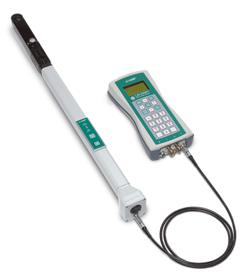

Figure : LI-COR LAI-2200C Plant Canopy Analyser [12].

## DSLR Camera and Fisheye Lens for DHP

As detailed in Section 2.1 and 2.2, DHP provides a means of measuring gap fraction at multiple angles, from which several canopy attributes (including LAI and FAPAR) can be derived. In the FRM4VEG project, a Canon EOS 6D was operated with the Sigma 8 mm F3.5 EX DG fisheye lens for the purposes of DHP. The technical characteristics of the camera and lens (Figure 4) provided by the respective manufacturers are detailed in [22] and in the ‘*Technical Handbook of FRM4VEG Instrumentation: Canon EOS 6D Digital Single Lens Reflex Camera and Sigma 8 mm F3.5 EX DG Fisheye Lens’*.

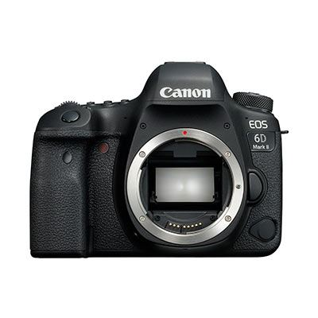

Figure : Canon EOS 6D DSLR camera [23].

## Konica Minolta SPAD-502 Chlorophyll Meter

The SPAD-502 is a compact handheld instrument to quickly and non-destructively provide a relative measure of LCC. The amount of chlorophyll present in plant leaves can serve as an indicator of the overall condition of the plant itself. In general, healthier plants contain more chlorophyll than less healthy ones. The instrument is water resistant and can be used in a variety of environmental conditions, and its measurement area of 2 mm x 3 mm enables even small leaves to be measured.

The technical characteristics of the SPAD-502 (Figure 5) provided by the manufacturer are detailed in [24] and in the ‘*Technical Handbook of FRM4VEG Instrumentation: Konica Minolta SPAD-502 Chlorophyll Meter‘*.

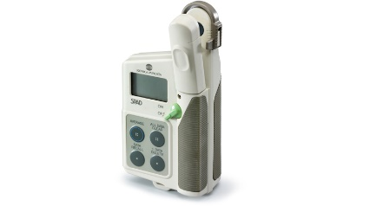

Figure 5: Konica Minolta SPAD-502 [25].

## SQ-110 PAR Sensor

The SQ-110 (Figure 6) is a self-powered quantum sensor that measures photosynthetically active radiation (PAR) and it is calibrated for use in sunlight. The sensor housing design features a fully potted, domed-shaped head making the sensor fully weatherproof and self-cleaning.The technical characteristics of the SQ-110 PAR sensor (Figure 6) provided by the manufacturer are detailed in [26] and in the ‘*Technical Handbook of FRM4VEG Instrumentation: SQ-110 PAR Sensor‘*.

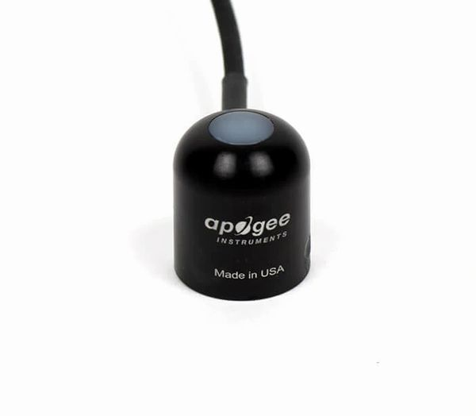

Figure : Apogee SQ-110 PAR Sensor [26].

## AccuPAR PAR/LAI Ceptometer LP-80

The AccuPAR model LP-80 PAR/LAI ceptometer (Figure 7) measures PAR. It is a menu-driven, battery-operated linear PAR ceptometer, used to measure light interception in plant canopies, and to calculate LAI by inverting the PAR readings.

The instrument consists of an integrated microprocessor-driven data logger and probe. The probe contains 80 independent sensors, spaced 1 cm apart. The photosensors measure PAR in the 400 to 700 nm waveband. The AccuPAR displays PAR in units of micromoles per meter squared per second. The instrument is capable of hand-held or unattended measurement [15].

The technical characteristics of the LP-80 provided by the manufacturer are detailed in [15] and in the ‘*Technical Handbook of FRM4VEG Instrumentation: AccuPAR PAR/LAI Ceptometer LP-80‘.*

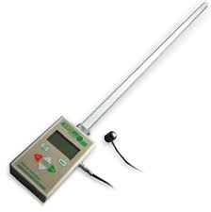

Figure : AccuPAR model LP-80 PAR/LAI Ceptometer [15].

# Instrument Calibration

To calibrate an instrument means to compare it against a more accurate reference in order to provide traceability of the measure by following ISO standards and to ensure global consistency [27]. Calibration is essential for: ensuring an instrument is fit for purpose; quantifying its reliability; and allowing instrument drift to be monitored (through repeated calibrations). When combined with uncertainty analysis, calibration information allows assessment of the uncertainty that an instrument contributes to a measurement. Initial calibration is usually performed by the manufacturer, but it must be performed regularly at appropriate intervals depending on the frequency of usage, susceptibility to drift and to ensure the measurement meets international reporting requirements (i.e. GCOS). When an instrument is calibrated, bias (a constant or predictable difference between the instrument readings) and drift (differences in an instrument’s readings through time) can be accounted for.

## Quantum Sensor Calibration

The quantum sensor calibration procedure adopted in the FRM4VEG project is designed according to the laboratory facilities available at NPL. The calibration coefficient (expressed in μmol m-2 s-1) is derived from a combination of spectral response and broadband irradiance measurements.

The sensor spectral responsivity is measured using a broadband source with a grating that produces monochromatic light that reaches the detector (Figure 8). The signal from the test detectors (in this case the quantum sensors) are compared against reference silicon detectors. At this stage it is possible to produce an absolute spectral response for detectors whose apertures can be overfilled, however, this is not possible with quantum sensors such as the Apogee Instruments SQ-110, due to the large detector area. Underfilling the detector is sufficient to produce a relative spectral response. As a result, a second stage is required and involves calibration against a broadband irradiance source (FEL lamp). In this procedure the detector is aligned at 500 mm from the FEL and records the signal output at a specific current and voltage (Figure 9).

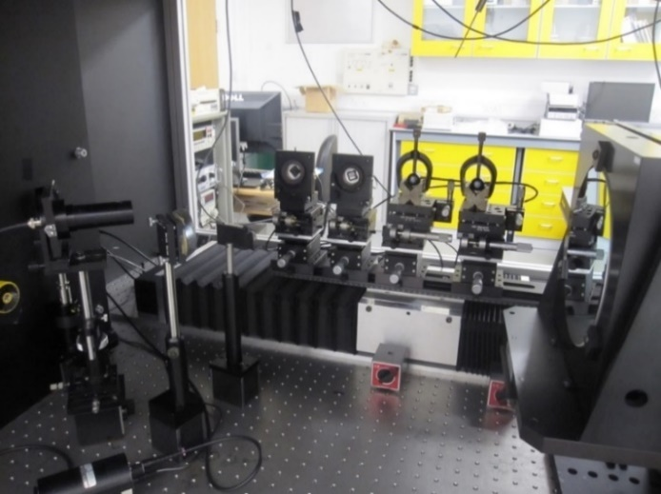

Figure 8: PAR sensors set up on the spectral response facility at NPL.

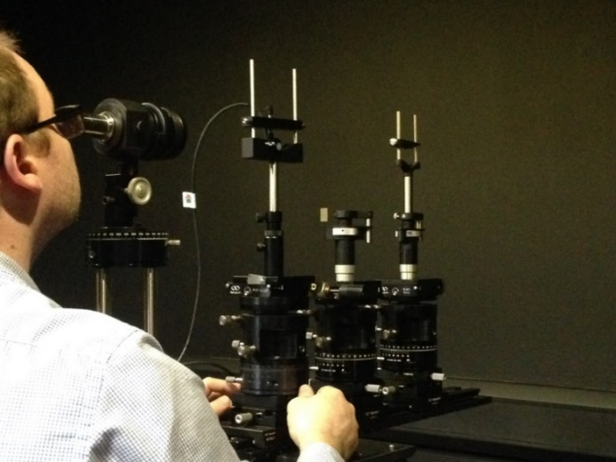

Figure 9: Alignment of PAR sensors before measuring a broadband source.

The information from the relative spectral response measurements is used to decompose the contribution from each wavelength region in order to ascertain the photon irradiance. This procedure applies to illumination sources which are reasonably similar to the spectral shape of the FEL. If this is not the case, a spectral mismatch factor (SMF) is applied to convert the calibration coefficient to the spectral shape of the desired illumination source. A secondary procedure to test the cosine response of the PAR sensors was implemented on a subset of the sensors prior to field deployment. This procedure used a similar setup to the broadband irradiance measurements but with a smaller bulb. This brought the irradiance source closer to the point source assumption required for cosine response characterisation. In this procedure, the detector was rotated ± 90° about the alignment axis, recording the signal at specified angles in between. The signal recorded at each angle was made relative to that produced at 0°. The output response was compared to a theoretical cosine response.

## LAI-2200C Calibration

Prior to shipping, two calibration procedures are performed by the manufacturer of the LAI-2200C. The first is angular calibration, which involves the measurement of a collimated source of light at a range of zenith angles across two planes. This procedure is used to centre the sensor and confirm its relative angular response. The second procedure makes use of an integrating sphere to match the radiometric response of each sensor ring to each other (but not to an absolute standard). Although the sensor may be subject to long-term electronic drift, the manufacturer suggests that such drift will not affect the derived LAI values. Thus, as long as the optics within the sensor remain in place, recalibration is not required before deployment [21].

## DHP Calibration

In order to determine the zenith and azimuth angles of each pixel in an image acquired using DHP, two calibration procedures are required [18]. The first establishes the position of the optical centre (i.e. the position on the imaging sensor that corresponds to the centre of the fisheye lens), whilst the second enables the projection function of the fisheye lens to be determined. Each calibration is specific to a given camera body and fisheye lens.

The position of the optical centre is established by recording the coordinates of a point as it rotates around the central axis of the fisheye lens. This can be achieved, for example, by drilling a hole in the lens cap, and then acquiring images with the hole at several different positions. Using these images, the coordinates of the optical centre can be determined by means of interpolation. Whilst a high-quality fisheye lens can be assumed to have a near-polar projection function, it is desirable to perform calibration to verify this prior to deployment. The projection function can be determined using a dedicated calibration rig, as described by [18]. An example of the measurement setup used to define the lens projection is shown in Figure 10.

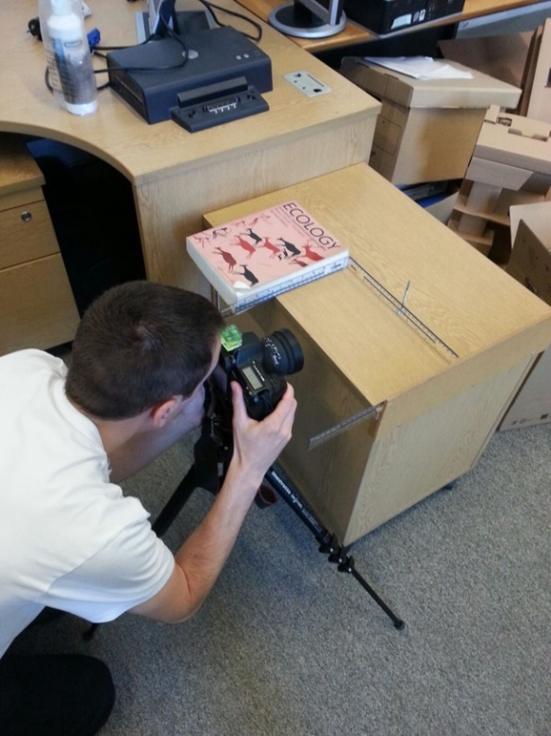

Figure 10: Example of the setup used to determine the lens projection function according the method implemented in CAN-EYE [35].

## Optical Chlorophyll Meter Calibration

The values provided by optical chlorophyll meters are relative measures of LCC only, and are influenced by other leaf properties that vary as a function of vegetation type [19]. To derive LCC in absolute units, laboratory-based calibration is required. This is achieved by determining LCC spectrophotometrically for a subset of samples that have also been measured using the optical chlorophyll meter, enabling an appropriate calibration function to be derived. The calibration function typically takes an exponential form, in which

$${LCC}_{SPAD}=a e^{b M}$$

where $a$ and $b$ are the calibration coefficients.

The calibration procedure adopted in the FRM4VEG Phase 1 project involves the collection of at least 60 leaves for each vegetation type, spanning a range of LCC values (assessed visually in terms of leaf colour). A disc is removed from each leaf using a 6 mm diameter cork borer, and is measured three times using the SPAD-502. The disc is placed in 5 ml of DMSO, which is administered using a calibrated bottle top dispenser with adjustable dosing settings. The sample is then placed in a drying oven set at 65° C overnight to facilitate extraction, which is complete when the disc turns white in colour (Figure 9). Once extracted, a 3 ml aliquot of the solution is transferred to a 10 mm path length polystyrene cuvette using a transfer pipette. The absorbance of the sample is then determined at 665 nm and 649 nm using a spectrophotometer (ThermoFisher Genesys 50 UV-Vis), enabling the concentrations of chlorophyll-a and -b to be derived according to [20] as

$$C_{a}=12.99 A_{665}-3.45 A_{649}$$

$$C_{b}=21.99 A_{649}-5.32 A_{665}$$

where $A_{665}$ and $A_{649}$ are the absorbance values at 665 nm and 649 nm, respectively (Figure 11). The final step is to calculate LCC on a mass per unit area basis as

$${LCC}_{spec}=\frac{{(C}_{a}+C_{b}) V}{A}$$ where $V$ is the volume of DMSO in which the leaf disc was extracted, and $A$ is the area of the leaf disc.

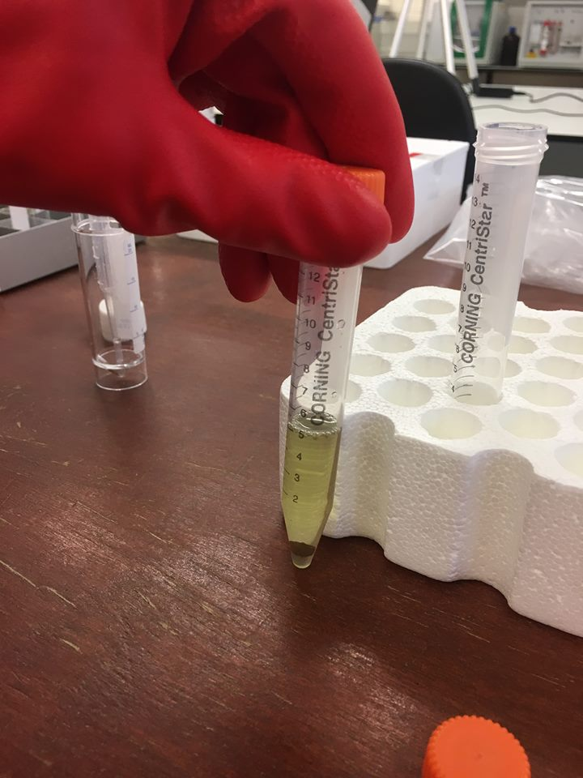 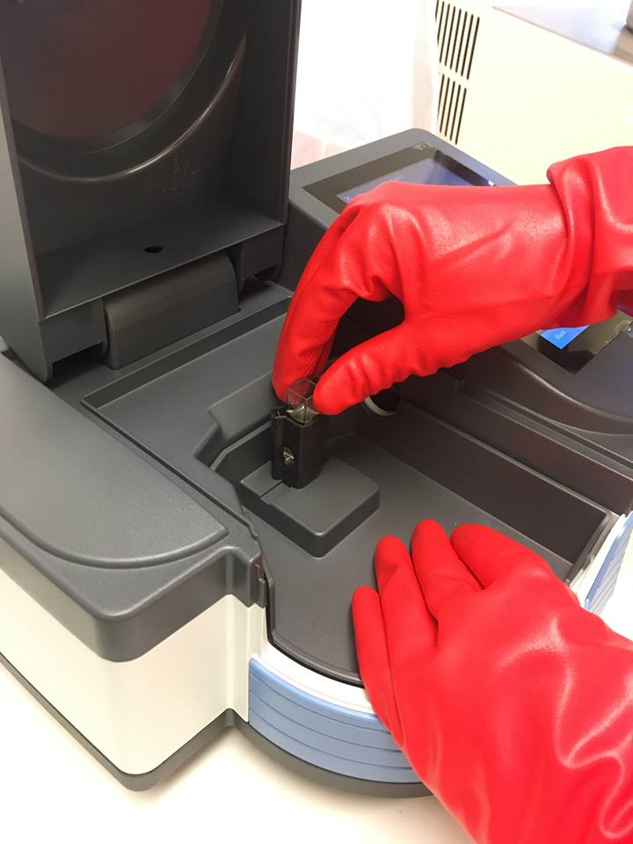

Figure 11: Pigment extraction from a leaf disc in DMSO (left). The solution is transferred to a cuvette to facilitate spectrophotometric determination of LCC (right).

If chlorophyll extraction cannot be conducted within a few hours of collecting the leaves, samples should be stored under freezing conditions until analysis to prevent degradation of the leaf pigments. Where appropriate laboratory facilities are not available near a campaign site, third-party data collected over the same or similar vegetation types may be adopted (as was done in the FRM4VEG project for the Barrax – Las Tiesas campaign). It should follow a similar protocol and incorporate raw measurement values (i.e. absorbance measured by the spectrophotometer as opposed to derived LCC), to enable the same uncertainty evaluation treatment to be applied (see Section 6.2).

## AccuPAR LP-80 Calibration

*This section is pending further development during the course of FRM4VEG Phase 2*

# Criteria for FRMs

## Criteria for Field Campaigns

### Selection of Field Sites

The following criteria can be considered in the selection of sites for field campaigns:

* **Vegetation type**
  + Between them, the selected sites should cover a wide range of structural, biophysical, and biochemical characteristics, as the considered satellite-derived products must be able to perform well over a range of environments and conditions.
* **Representativeness** 
  + The sites should be representative of their respective biomes.
* **Homogeneity**
  + To enable validation of products derived from moderate spatial resolution instruments (i.e. 300 m in the case of Sentinel-3 OLCI), the sites should provide areas of vegetation large enough to encompass multiple moderate spatial resolution product pixels, particularly given positional errors and uncertainties related to the instrument’s point spread function (PSF) [13], [28]. An area of at least 3 x 3 pixels will enable misregistration errors between the moderate spatial resolution product and high spatial resolution imagery used in upscaling to be accounted for.
* **Extent**
  + The extent of the site should be on the order of several square kilometres to balance the need to validate multiple moderate spatial resolution product pixels with efficient in situ sampling [13].
* **Topography**
  + The sites should be located in areas of flat relief to minimise terrain effects [13].
* **Accessibility**
  + The sites should be easily accessible by road to enable access with relevant field equipment.
  + Permission for working at the site should be sought.
* **Maturity**
  + Established and well-characterised sites with a legacy of scientific activity are preferred, particularly where research facilities are available and/or permanent instrumentation is installed, such as flux towers which collect measurements of biophysical variables over extended periods of time.
* **Weather**
  + To maximise data collection and validation opportunities, the sites should have a good probability of clear skies during the timing of the proposed campaigns.

### Sampling Strategy

The sampling strategy for FAPAR and CCC is based on the ‘two-stage’ or ‘bottom-up’ approach proposed by the CEOS WGCV LPV sub-group, which was originally developed for the validation of moderate spatial resolution LAI products [13], [28]. In situ measurements will be conducted within elementary sampling units (ESUs), whose extent corresponds to that of a pixel of the high spatial resolution imagery that will be used for upscaling (i.e. 20 m for Sentinel-2 Multispectral Instrument (MSI) data).

Within each ESU, multiple in situ measurements will be performed following the Validation of Land European Remote Sensing Instruments (VALERI) protocol [13]. The optimal number of in situ measurements is driven by the heterogeneity of the canopy and the measurement footprint. Each ESU will contain thirteen sampling points according to a systematic sampling scheme (Figure 12), enabling within-ESU variability to be characterised. Additionally, measurements will be performed at two randomly distributed sampling points, providing redundancy if there are any non-representative measurements. The centre of each ESU will be located using a handheld global positioning system (GPS) receiver, with an accuracy of a few metres, enabling the ESU to be identified in the high spatial resolution imagery.

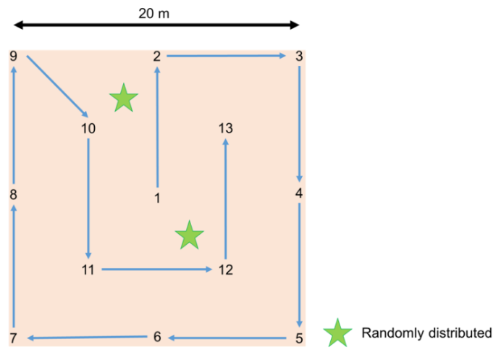

Figure : Systematic within-ESU sampling strategy.

The heterogeneity of the site will determine the required number of ESUs, although a minimum number of twenty to thirty ESUs per site is typically recommended to characterize the site heterogeneity [13], [28]. ESUs will be distributed across the site, stratified by land cover to ensure all dominant vegetation types are represented. In agricultural environments, at least five ESUs per field will be sampled to characterise the intra-field variability. Their placement will be a compromise between being close enough together to maintain efficient in situ sampling, but far enough apart to minimise spatial autocorrelation [28]. To avoid adjacency effects, ESUs will be located at a reasonable distance (at least 50 m) from borders, and will be surrounded by pixels with the same type of vegetation type [13]. At least five additional ESUs will be established over areas with little to no vegetation cover to constrain the lower boundary of the transfer function used for upscaling [13]. Knowledge of land cover characteristics will enable identification of these areas. In agricultural environments, a field survey will be carried out so that up-to-date information on land cover characteristics at the time of the campaign itself is available.

### Timing of Field Data Collection

To minimise the influence of any changes in vegetation condition, field data collection should be conducted within one week of the acquisition of the high spatial resolution imagery used for upscaling. Unlike surface reflectance, simultaneous field data collection is not required, as within this period, mature vegetation is typically considered stable [13], [29]. If in situ data are collected during the start or end of the growing season, when more rapid changes in biophysical or biochemical characteristics may occur, a more restrictive temporal constraint will be required. This will depend on the phenological characteristics of the site itself.

## Permanent Field Sites

*This section is pending further development during the course of FRM4VEG Phase 2*

# 

# Traceability, Uncertainty Sources and Propagation

When a physical quantity is measured, it is mandatory to indicate the quality of the results in order to compare different measurements either among themselves or with reference values or standards. [4] states that the ideal method for expressing uncertainty is based on three characteristics: universality, consistency and transferability. Considering this method, it is possible to evaluate the uncertainty, defined in [4] as *“a parameter, associated with the results of a measurement, that describes the dispersion of the values that could reasonably be attributed to the measurand”*.

Uncertainties related to field activities aregenerally related to: the equipment performance, the methodology of measurement, the sampling strategy, the properties of the surface and the environmental conditions [30].

All the uncertainties associated with the measurement process are then taken into account thanks to the SI traceability, defined as *“the property of the result of a measurement or the value of a standard whereby it can be related to stated references, usually national or international standards, through an unbroken chain of comparisons all having stated uncertainties”* [31]. The unbroken chain of comparisons is called traceability chain.

## Uncertainty Sources and Propagation for FAPAR

Table 3 indicates uncertainty sources associated with in situ PAR measurements performed using quantum sensors. These uncertainties apply to each individual PAR measurement. Once quantified using either ‘Type A’ or ‘Type B’ evaluation, they can be propagated through the measurement equation presented in Section 2.1.1 to derive the resulting combined standard uncertainty in FAPAR.

Table 3: Uncertainty sources associated with in situ measurements of FAPAR performed using quantum sensors.

|  |  |  |  |
| --- | --- | --- | --- |
| **Source** | **Symbol** | **Type** | **Description** |
| Angular response | $$u(angle)$$ | Systematic | Uncertainty in cosine response |
| Levelling | $$u(level)$$ | Usually random, unless mounted continually | Zenith and azimuth uncertainties |
| Calibration | $$u(cal)$$ | Systematic | Uncertainty in the calibration coefficient |
| Radiometric resolution | $$u(rad)$$ | Systematic | Uncertainty due to resolution of data logger to record voltage |
| Spectral | $$u(spec)$$ | Mostly systematic | Uncertainty in the spectral range/response not equating to true PAR response |

The uncertainties associated with in situ measurements of FIPAR derived using multi-angular measurements of gap fraction are a function of several components, including angular response, instrument levelling, sampling, sky uniformity, and in the case of DHP, image classification and exposure settings (Table 4).

Table 4: Uncertainty sources associated with in situ measurements of FIPAR derived from multi-angular measurements of gap fraction.

|  |  |  |  |
| --- | --- | --- | --- |
| **Source** | **Symbol** | **Type** | **Description** |
| Angular response | $$u(angle)$$ | Systematic | Refers to lens angular calibration |
| Levelling | $$u(level)$$ | Random | Zenith and azimuth uncertainties |
| Sampling | $$u(samp)$$ | Random | Uncertainty due to spatial heterogeneity and the sampling performed (i.e. variability in gap fraction) |
| Image classification | $$u(class)$$ | Random | Uncertainty introduced by the operator during image classification in CAN-EYE |
| Exposure settings | $$u(expo)$$ | Systematic and random | Uncertainty in gap fraction due to DHP under or overexposure |
| Sky uniformity | $$u(sky)$$ | Random | Uncertainty due to changes in illumination conditions during measurements |

Within the FRM4VEG project, the uncertainties due to instrument angular response are considered negligible. The influence of the LAI-2200C angular response was investigated using the calibration uncertainties provided in the manufacturer’s calibration certificate. When propagated through the measurement equation, the contribution of these terms to the combined standard uncertainty was less than 0.01. Like the LAI-2200C angular calibration (Section 4.2), the DHP calibration procedures described in Section 4.3 ensure accurate determination of the optical centre and lens projection function.

Unlike the other components, the uncertainty due to instrument levelling is assessed using ‘Type B’ evaluation, based on previous analyses to establish benchmark uncertainty values. For example, in terms of instrument levelling, a relative standard uncertainty of approximately 1% is quoted by [32] in the case of gap fraction derived using hand-levelled DHP. This value is also considered appropriate for the LAI-2200C, given that it is also hand-levelled and operates using similar principles.

The uncertainties due to sampling are assessed for each elementary sampling unit (ESU) as the variability in gap fraction, using ‘Type A’ evaluation. In the case of the LAI-2200C, the instrument reports the standard deviation of the ‘contact number’, which is calculated for each zenith ring over all measurements performed within an ESU. From this, the standard error of the mean gap fraction can be determined and used to derive the resulting standard uncertainty in FIPAR. In the case of DHP, variability in gap fraction can be considered at two distinct scales:

* Within image (computed as the standard error of the mean in each zenith ring over all azimuth cells within an image)
* Between image (computed as the standard error of the mean in each zenith ring over all images)

In this case, the two terms are added in quadrature, such that

$$u\left[P\left(θ_{i}\right)\right]=\sqrt{u{[{P(θ_{i})}_{within}]}^{2}+u{[{P(θ_{i})}_{between}]}^{2}}$$

where $u[{P(θ_{i})}_{within}]$ and $u[{P(θ_{i})}_{between}]$ are the within and between image components for zenith ring $i$, respectively.

In terms of image classification uncertainty, within the project, a series of experiments were carried out on a subset of ESUs to assess the influence of different operator decisions on the classification of green and soil/sky elements. As this classification directly determines gap fraction, which is then used to derive the biophysical variables of interest, the operator’s decisions can result in uncertainties in the final output. Eleven ESUs of different vegetation types were selected from the Barrax – Las Tiesas campaign, whilst five ESUs were selected from the Wytham Woods campaign. The images from each ESU were then classified by three different operators. These experiments yielded a relative standard uncertainty of 4% for FIPAR.

The impact of other terms, including exposure and sky uniformity, was not explicitly assessed during the project. Exposure is defined as the amount of light allowed to fall onto the imaging sensor (measured in lux seconds) and depends on aperture and shutter speed selected by the operator (or by the camera when automatic exposure is used). Several studies have emphasised the importance of correct exposure settings for upwards facing DHP [33], [34]. If automatic exposure is used, photographs are typically overexposed, causing gaps in the canopy to appear larger than in reality, and leading to an overestimation of gap fraction.

Various protocols to determine optimum exposure settings have been proposed in the scientific literature. These include overexposing the image by 2 stops relative to a clear sky reference measured using automatic exposure, acquiring a test image and examining its histogram to determine the appropriate settings [35], or underexposing the image relative to in-canopy automatic exposure by varying degrees [34], [36]. [36] suggest that whilst exposure settings are important for images acquired in the Joint Photographic Experts Group (JPEG) format, they are less critical for those acquired in RAW. In such cases, they recommend underexposing the image by 1 stop relative to automatic in-canopy exposure. It is suggested that exposure settings are less critical for downwards facing images, as the strong contrast between the canopy and its background is reduced, and image classification is based on the identification of green elements rather than a threshold between bright and dark pixels [37], [38].

Sky uniformity is a source of uncertainty that, unfortunately, cannot be controlled by the operator. According to [39], in forest environments, uncertainties in FAPAR will be reduced by working under diffuse illumination conditions as opposed to working under clear skies, when greater variation in shadowed and sunlit areas is experienced. In the case of the LAI-2200C, regular above canopy reference measurements can be used to minimise this source of uncertainty. As such, within the FRM4VEG project, at least one above canopy reference measurement every five below canopy measurements is recommended.

To obtain the combined standard uncertainty in FIPAR, all considered components are added in quadrature, such that

$$u(FIPAR)= \sqrt{{u(level)}^{2}+{u(class)}^{2}+{u(samp)}^{2}}$$

where $u(level)$, $u(class)$, and $u(samp)$ are the standard uncertainties in FIPAR due to instrument levelling, image classification, and sampling, respectively. When derived using both upwards and downwards facing DHP, the standard uncertainty in total FIPAR should be determined as

$$u\left({FIPAR}_{total}\right)=\sqrt{{\left[\left(1-{FIPAR}_{up}\right) u\left({FIPAR}_{down}\right)\right]}^{2}+{\left[\left(1-{FIPAR}_{down}\right) u\left({FIPAR}_{up}\right)\right]}^{2}}$$

where ${FIPAR}_{up}$ and ${FIPAR}_{down}$ are the FIPAR values derived using upwards and downwards facing DHP, whilst $u\left({FIPAR}_{up}\right)$ and $u\left({FIPAR}_{down}\right)$ are their respective standard uncertainties.

Finally, it should be noted that using FIPAR as a proxy of FAPAR can lead to differences in the order of 0 to 0.05 [11]. The intercepted PAR is typically higher than the absorbed PAR, as part of the intercepted radiation is reflected. The differences are a function of background reflectance, SZA, and canopy structure. However, under typical conditions of illumination and background reflectance, the main contribution of FAPAR is given by the intercepted fraction, with respect both to the direct and diffuse illumination [11]. In summary, when using FIPAR as a proxy for FIPAR, we may expect uncertainties in the order of 0 to 0.05 absolute units.

## Uncertainty Sources and Propagation for CCC

Like FIPAR, the uncertainty associated with in situ LAI measurements performed over an ESU can be evaluated as a function of several components, including uncertainties due to instrument levelling, sampling, and in the case of DHP, image classification. An additional source of uncertainty in the case of LAI is differences between analysis methods. The uncertainties due to instrument levelling and image classification are assessed as described in Section 6.1. In terms of instrument levelling, a relative standard uncertainty of approximately 2% is quoted by [32] in the case of LAI, whilst the experiments conducted to assess the influence of different operators on image classification yielded relative standard uncertainties of 11% for ‘effective’ LAI and 12% for ‘true’ LAI.

Uncertainties due to sampling are assessed as the variability in gap fraction, as described in Section 6.1. In the case of DHP, it should be noted that propagating these uncertainties through the LUT inversion-based methods implemented in CAN-EYE is not straightforward. Therefore, the uncertainty quantification approach adopted within the project considers the methods of [14] and [16] only, making use of the method of [17] to account for foliage clumping in the case of ‘true’ LAI. The resulting uncertainties are likely of a similar magnitude to those associated with the CAN-EYE LUT inversion based approaches and represent a good first-order approximation. For ‘effective’ LAI, a combined standard uncertainty is derived by adding the sampling uncertainties obtained using the methods of [49] and [16] in quadrature. For ‘true’ LAI, only the sampling uncertainty obtained using the method of [16] is considered.

For the method of [14], the standard uncertainty in ‘effective’ LAI due to sampling is determined as

$$u\left(samp\right)=2\sqrt{\sum_{i=1}^{n}{{\left(\frac{u[\overline{P(θ_{i})}]}{\overline{P(θ_{i})}}\cos{θ_{i}}\sin{θ_{i}}d{θ_{i}}\right)}^{2}}}$$

where $\overline{P\left(θ_{i}\right)}$ is the mean gap fraction in zenith ring $i$ and $u[\overline{P\left(θ_{i}\right)}]$ is its standard uncertainty. Similarly, for the method of [16], the standard uncertainty in ‘effective’ LAI due to sampling is obtained as

$$u\left(samp\right)=\frac{u[\overline{P(θ_{57.7°})}]/ \overline{P(θ_{57.5°})}}{0.93}$$

where $u[\overline{P(θ_{57.7°})}]$ is the standard uncertainty in the mean gap fraction at 57.5°. In the case of ‘true’ LAI, the standard uncertainty due to sampling is calculated as

$$u\left(samp\right)=\frac{u[\overline{\ln{P(θ_{57.7°})}}]}{0.93}$$

where $u[\overline{\ln{P(θ_{57.7°})}}]$ is the standard uncertainty in the mean of the natural logarithm of gap fraction values at 57.5°.

A final source of uncertainty assessed using ‘Type A’ evaluation is that due to differences between analysis methods. Within the FRM4VEG project, LAI is reported as the mean of several different analysis methods implemented within CAN-EYE (i.e. CE 6.1, CE 5.1 and Miller for ‘effective’ LAI, and CE 6.1 and CE 5.1 only for ‘true’ LAI). To represent this source of uncertainty, the standard error of the mean is calculated over the considered analysis methods.

To obtain the combined standard uncertainty in LAI all considered components are added in quadrature, such that

$$u\left(LAI\right)=\sqrt{{u(level)}^{2}+{u(class)}^{2}+{u(samp)}^{2}+{u(method)}^{2}}$$

where $u(level)$, $u(class)$, $u\left(samp\right)$, and $u(method)$ are the standard uncertainties in LAI due to instrument levelling, image classification, sampling, and differences between analysis methods, respectively. When LAI is derived using both upwards and downwards facing DHP, the standard uncertainty in total LAI should be calculated as

$$u\left({LAI}_{total}\right)=\sqrt{{u({LAI}_{up})}^{2}+{u({LAI}_{down})}^{2}}$$

where $u({LAI}_{up})$ and $u({LAI}_{down})$ are the standard uncertainties in LAI derived using upwards and downwards facing DHP, respectively.

In addition to the uncertainty sources considered above, it should be noted that uncertainty may arise due to differences in the definition of the considered quantity. As discussed in Section 2.2.1, both ‘effective’ and ‘true’ LAI may be defined, and either quantity may refer to all elements of the canopy (i.e. PAI), or in the case of downwards facing DHP, green elements only (i.e. GAI).

The uncertainty in individual in situ LCC measurements includes contributions from two main sources: those uncertainties inherent to the optical chlorophyll meter itself, and those related to the calibration function. The uncertainties inherent to the optical chlorophyll meter are easily assessed using ‘Type B’ evaluation, and include accuracy, repeatability, reproducibility, temperature drift, and resolution (Figure 13). The standard uncertainty in the SPAD values provided by the optical chlorophyll meter can therefore be determined as

$$u\left(M\right)=\sqrt{{u\left(acc\right)}^{2}+{u\left(repeat\right)}^{2}+{u\left(repro\right)}^{2}+ {u\left(temp\right)}^{2}+{u(res)}^{2}}$$

where $u\left(acc\right)$, $u\left(repeat\right)$, $u\left(repro\right)$, $u\left(temp\right)$, and $u(res)$ are the standard uncertainties in SPAD values due to accuracy, repeatability, reproducibility, temperature drift, and resolution, respectively.

In addition to the uncertainties inherent to the optical chlorophyll meter, the uncertainties related to calibration function also incorporate those associated with the instruments and apparatus used to determine LCC spectrophotometrically. These include various uncertainty sources related to the spectrophotometer (i.e. photometric accuracy, repeatability, noise, drift, stray light, baseline flatness, and resolution), in addition to the volume of extraction solvent released by the dispenser, and the area of the leaf disc extracted by the cork borer (Figure 14). With the exception of the latter term, which must be evaluated by ‘Type A’ evaluation, these uncertainties can be assessed using ‘Type B’ evaluation. Within the project, the uncertainty in leaf disc area was assessed by removing discs from a subset of 60 leaves and measuring their area using a flatbed scanner. The uncertainty was determined as the standard error of the mean (0.11 mm2).



Figure 13: Fish-bone diagram illustrating the components contributing to uncertainty in the SPAD values provided by the optical chlorophyll meter.

Taking into account the uncertainty sources related to the spectrophotometer, the standard uncertainty in absorbance measured at a given wavelength can be obtained as

$$u\left(A_{λ}\right)=\sqrt{\begin{aligned}{u\left(acc\right)}^{2}+{u\left(rep\right)}^{2}+{u\left(nosie\right)}^{2}+{u\left(drift\right)}^{2} \\ + {u(stray)}^{2}+{u(flat)}^{2}+{u(res)}^{2}\end{aligned}}$$

where $u\left(acc\right)$, $u\left(rep\right)$, $u\left(noise\right)$, $u\left(drift\right)$, $u(stray)$, $u(flat)$, and $u(res)$ are the standard uncertainties in absorbance at wavelength $λ$ due to photometric accuracy, repeatability, noise, drift, stray light, baseline flatness, and resolution, respectively.

It is worth noting that some terms, such as photometric accuracy, noise, and stray light, are dependent on the measured absorbance itself. For these terms, the corresponding uncertainty is best determined by interpolating between specifications provided by the manufacturer at different absorbance values. An additional source of uncertainty is related to the accuracy and repeatability of wavelength selection. Experiments in which the measured wavelength was adjusted by ± 1 nm were carried out over a range of samples to assess the influence of these components. As the resulting error in absorbance was found to lie within the overall photometric uncertainty, these wavelength related components are not considered further.



Figure 14: Fish-bone diagram illustrating the components contributing to uncertainty in the spectrophotometric determination of LCC. Greyed out components are not considered due to their minimal influence on overall uncertainty.

Using the standard uncertainties in absorbance values, the standard uncertainties in chlorophyll-a and -b values derived using the spectrophotometric equations of [20] can be determined as

$$u\left(C_{a}\right)=\sqrt{{\left[12.19 u\left(A_{665}\right)\right]}^{2}+{\left[3.45 u\left(A_{649}\right)\right]}^{2}} \\ u\left(C_{b}\right)=\sqrt{{\left[21.99 u\left(A_{649}\right)\right]}^{2}+{\left[5.32 u\left(A_{665}\right)\right]}^{2}}$$

where $u\left(A_{665}\right)$ and $u\left(A_{649}\right)$ are the standard uncertainties in absorbance at 665 nm and 649 nm, respectively. Finally, the combined uncertainty in spectrophotometrically determined LCC (expressed on a mass per unit area basis) can be derived as

$$u\left({LCC}_{spec}\right)=\frac{[\left(C_{a}+C_{b}\right) V]}{A}\sqrt{{\left(\frac{\left(C_{a}+C_{b}\right) V\sqrt{{\left[\frac{\sqrt{{u(C_{a})}^{2}+{u(C_{b})}^{2}}}{C_{a}+C_{b}}\right]}^{2}+{\left[\frac{u(V)}{V}\right]}^{2}}}{\left(C_{a}+C_{b}\right) V}\right)}^{2}+{\left[\frac{u(A)}{A}\right]}^{2}}$$

where $u\left(V\right)$ and $u(A)$ are the uncertainties in the volume of solvent dispensed and area of the leaf disc, respectively.

Within the FRM4VEG project, it is recommended that calibration functions are established using orthogonal distance regression (ODR), as unlike other methods, ODR enables uncertainties in both the predictor and response to be accounted for in the fitting procedure. Once the appropriate calibration function is established (Figure 15), LCC can be obtained by applying it to the SPAD values provided by the optical chlorophyll meter. The standard uncertainty is then determined by propagating the uncertainties in both the SPAD values and calibration coefficients through the calibration function (Figure 16). Correlation between the calibration coefficients is accounted for, such that

$$u\left({LCC}_{SPAD}\right)=\sqrt{\begin{aligned}{\left[\frac{∂{LCC}_{SPAD}}{∂a} u\left(a\right)\right]}^{2}+{\left[\frac{∂{LCC}_{SPAD}}{∂M}u\left(M\right)\right]}^{2}+{\left[\frac{∂{LCC}_{SPAD}}{∂b}u\left(b\right)\right]}^{2} \\ +2\left[\begin{aligned}\frac{∂{LCC}_{SPAD}}{∂a} \frac{∂{LCC}_{SPAD}}{∂M} u\left(a, M\right)+\frac{∂{LCC}_{SPAD}}{∂a} \frac{∂{LCC}_{SPAD}}{∂b} u\left(a,b\right) \\ +\frac{∂{LCC}_{SPAD}}{∂M} \frac{∂{LCC}_{SPAD}}{∂b} u(M,b)\end{aligned}\right]\end{aligned}}$$

where $u\left(a\right)$ and $u\left(b\right)$ are the standard uncertainties of the calibration coefficients.

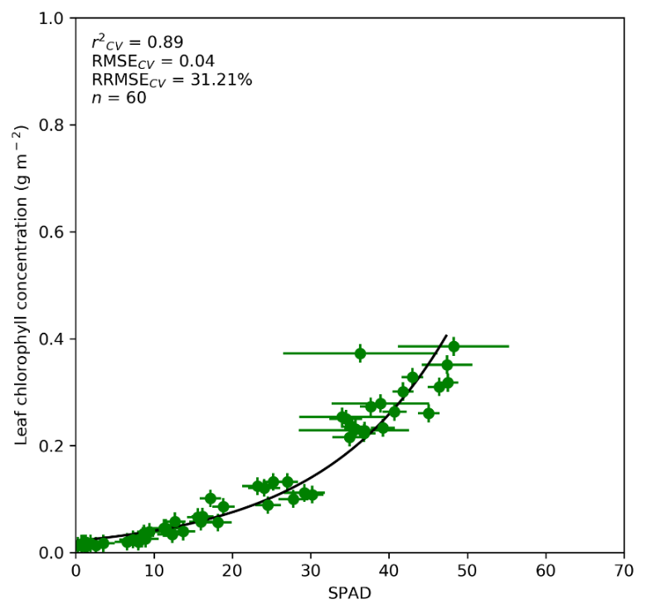

Figure 15: Example SPAD calibration function for Hazel, derived using ODR. Error bars represent expanded uncertainties (k = 2).



Figure 16: Fish-bone diagram illustrating how the uncertainty in an individual in situ LCC measurement is derived.

When the mean of multiple in situ measurements are taken to represent an ESU, their individual uncertainties should be propagated through the calculation of the mean, whilst the standard error of the mean should be calculated to reflect uncertainty due to sampling. The combined standard uncertainty in SPAD derived LCC at the ESU level can then be determined by adding these two terms in quadrature, such that

$$u\left({LCC}_{ESU}\right)=\sqrt{{\left[\frac{\sqrt{\sum_{i=1}^{n}{{u({{LCC}_{SPAD}}_{i})}^{2}}}}{n}\right]}^{2}+{u(samp)}^{2}}$$

# References

[1] J. L. Widlowski *et al.*, “The fourth phase of the radiative transfer model intercomparison (RAMI) exercise: Actual canopy scenarios and conformity testing,” *Remote Sens. Environ.*, vol. 169, pp. 418–437, 2015.

[2] E. Theocharous and N. P. Fox, “NPL REPORT OP 4 CEOS comparison of IR brightness temperature measurements in support of satellite validation. Part II: Laboratory comparison of the brightness temperature of blackbodies,” 2010.

[3] N. Fox, “QA4EO: A guide to comparisons – organisation, operation and analysis to establish measurement equivalence to underpin the Quality Assurance requirements of GEO (QA4EO-QAEO-GEN-DQK-004) Version 4.0,” 2010.

[4] Working Group 1 of the Joint Committee for Guides in Metrology, *Evaluation of measurement data — Guide to the expression of uncertainty in measurement*. Paris, France: Bureau International des Poids et Mesures, 2008.

[5] ESA, “Fiducial Reference Measurements: FRM,” 2019. [Online]. Available: https://earth.esa.int/web/sppa/activities/frm. [Accessed: 08-Mar-2019].

[6] H. P. Schmid, “Experimental design for flux measurements: matching scales of observations and fluxes,” *Agric. For. Meteorol.*, vol. 87, no. 2–3, pp. 179–200, 1997.

[7] G. Schaepman-Strub, M. E. Schaepman, T. H. Painter, S. Dangel, and V. J. Martonchik, “Reflectance quantities in optical remote sensing — definitions and case studies,” *Remote Sens. Environ.*, vol. 103, pp. 27–42, 2006.

[8] F. E. Nicodemus, J. C. Richmond, and J. J. Hsia, *Geometrical considerations and nomenclature for reflectance*. Washington D.C., United States: Department of Commerce National Bureau of Standards, 1977.

[9] F. Baret and R. Fernandes, *VALSE-2 Validation Concept*. Avignon, France: Institut National de la Recherche Agronomique, 2012.

[10] F. Baret and G. Guyot, “Potentials and limits of vegetation indices for LAI and APAR assessment,” *Remote Sens. Environ.*, vol. 35, no. 2–3, pp. 161–173, 1991.

[11] N. Gobron *et al.*, “Evaluation of fraction of absorbed photosynthetically active radiation products for different canopy radiation transfer regimes: Methodology and results using Joint Research Center products derived from SeaWiFS against ground-based estimations,” *J. Geophys. Res.*, vol. 111, no. D13, p. D13110, 2006.

[12] LI-COR, “LAI-2200C Optical Sensor,” 2017. [Online]. Available: https://www.licor.com/env/products/leaf_area/LAI-2200C/optical-sensor.html. [Accessed: 10-May-2017].

[13] F. Baret *et al.*, *VALERI: a network of sites and a methodology for the validation of medium spatial resolution land satellite products*. Avignon, France: Institut National de la Recherche Agronomique, 2005.

[14] J. Miller, “A formula for average foliage density,” *Aust. J. Bot.*, vol. 15, no. 1, pp. 141–144, Apr. 1967.

[15] Meter Group, *AccuPAR PAR/LAI Ceptometer: Model LP-80*. Pullman, Washington, United States: Meter Group, 2018.

[16] J. Warren-Wilson, “Estimation of foliage denseness and foliage angle by inclined point quadrats,” *Aust. J. Bot.*, vol. 11, no. 1, pp. 95–105, 1963.

[17] A. R. G. Lang and X. Yueqin, “Estimation of leaf area index from transmission of direct sunlight in discontinuous canopies,” *Agric. For. Meteorol.*, vol. 37, no. 3, pp. 229–243, 1986.

[18] M. Weiss and F. Baret, *CAN-EYE V6.4.91 User Manual*. Avignon, France: Institut National de la Recherche Agronomique, 2017.

[19] C. Parry, J. M. Blonquist, and B. Bugbee, “In situ measurement of leaf chlorophyll concentration: analysis of the optical/absolute relationship,” *Plant. Cell Environ.*, vol. 37, no. 11, pp. 2508–2520, 2014.

[20] A. R. Wellburn, “The Spectral Determination of Chlorophylls a and b, as well as Total Carotenoids, Using Various Solvents with Spectrophotometers of Different Resolution,” *J. Plant Physiol.*, vol. 144, no. 3, pp. 307–313, 1994.

[21] LI-COR, *LAI-2200C Plant Canopy Analyser Instruction Manual*. Lincoln, Nebraska, United States: LI-COR, 2013.

[22] Canon, “Canon EOS 6D Specification.” [Online]. Available: https://www.canon.co.uk/for_home/product_finder/cameras/digital_slr/eos_6d/specification.aspx. [Accessed: 24-Aug-2018].

[23] Canon, *EOS 6D Instruction Manual*. Tokyo, Japan: Canon, 2017.

[24] Minolta, *Chlorophyll Meter SPAD-502*. Osaka, Japan: Minolta.

[25] Konica Minolta, “Chlorophyll Meter SPAD-502.” [Online]. Available: https://www.konicaminolta.eu/en/measuring-instruments/products/colour-measurement/discontinued-products/spad-502.html. [Accessed: 24-Aug-2018].

[26] Apogee Instruments, “Quantum Sensor Owner’s Manual.” Utah, USA, 2020.

[27] C. D. Ehrlich and S. D. Rasberry, “Metrological timelines in traceability,” *Metrologia*, vol. 34, no. 6, pp. 503–514, 1997.

[28] J. T. Morisette *et al.*, “Validation of global moderate-resolution LAI products: a framework proposed within the CEOS land product validation subgroup,” *IEEE Trans. Geosci. Remote Sens.*, vol. 44, no. 7, pp. 1804–1817, 2006.

[29] M. G. De Kauwe, M. I. Disney, T. Quaife, P. Lewis, and M. Williams, “An assessment of the MODIS collection 5 leaf area index product for a region of mixed coniferous forest,” *Remote Sens. Environ.*, vol. 115, no. 2, pp. 767–780, Feb. 2011.

[30] O. Gutierrez, “Towards a complete spectral reflectance uncertainty model for Field Spectroscopy Towards a complete spectral reflectance uncertainty model for Field Spectroscopy,” no. October, 2018.

[31] Z. Grkov and F. Consultant, “International Vocabulary of Basic and General Terms in Metrology ( VIM ) Skopje , septemvri 1998 Zoran Grkov avtor na makedonskoto izdanie,” no. March, pp. 15–19, 2015.

[32] N. Origo, K. Calders, J. Nightingale, and M. Disney, “Influence of levelling technique on the retrieval of canopy structural parameters from digital hemispherical photography,” *Agric. For. Meteorol.*, vol. 237–238, pp. 143–149, 2017.

[33] Y. Zhang, J. M. Chen, and J. R. Miller, “Determining digital hemispherical photograph exposure for leaf area index estimation,” *Agric. For. Meteorol.*, vol. 133, no. 1–4, pp. 166–181, 2005.

[34] J. M. Chen, T. A. Black, and R. S. Adams, “Evaluation of hemispherical photography for determining plant area index and geometry of a forest stand,” *Agric. For. Meteorol.*, vol. 56, no. 1–2, pp. 129–143, 1991.

[35] P. Beckschäfer, D. Seidel, C. Kleinn, and J. Xu, “On the exposure of hemispherical photographs in forests,” *iForest - Biogeosciences For.*, vol. 6, no. 4, pp. 228–237, 2013.

[36] C. Macfarlane, Y. Ryu, G. N. Ogden, and O. Sonnentag, “Digital canopy photography: Exposed and in the raw,” *Agric. For. Meteorol.*, vol. 197, pp. 244–253, 2014.

[37] V. Demarez, S. Duthoit, F. Baret, M. Weiss, and G. Dedieu, “Estimation of leaf area and clumping indexes of crops with hemispherical photographs,” *Agric. For. Meteorol.*, vol. 148, no. 4, pp. 644–655, 2008.

[38] S. Garrigues, N. V Shabanov, K. Swanson, J. T. Morisette, F. Baret, and R. B. Myneni, “Intercomparison and sensitivity analysis of Leaf Area Index retrievals from LAI-2000, AccuPAR, and digital hemispherical photography over croplands,” *Agric. For. Meteorol.*, vol. 148, no. 8–9, pp. 1193–1209, 2008.

[39] J.-L. Widlowski, “On the bias of instantaneous FAPAR estimates in open-canopy forests,” *Agric. For. Meteorol.*, vol. 150, no. 12, pp. 1501–1522, 2010.

[40] K. Calders *et al.*, “Variability and bias in active and passive ground-based measurements of effective plant, wood and leaf area index,” *Agric. For. Meteorol.*, vol. 252, no. April, pp. 231–240, 2018.

[41] K. Calders *et al.*, “Realistic Forest Stand Reconstruction from Terrestrial LiDAR for Radiative Transfer Modelling,” *Remote Sens.*, vol. 10, no. 6, p. 933, Jun. 2018.

###### Appendix



FRM4VEG Phase 1 FAPAR and CCC Campaign at Wytham Woods

The purpose of the FRM4VEG Phase 1 FAPAR and CCC campaign at Wytham Woods was to validate the Sentinel-3 Ocean and Land Colour Instrument (OLCI) L2 land products over a deciduous broadleaf forest environment. The L2 land products validated were the OLCI Global Vegetation Index (OGVI), which corresponds to FAPAR, and the OLCI Terrestrial Chlorophyll index (OTCI), a surrogate of CCC.

Measurement Instrumentation

The instruments used to collect data were:

* **Canon EOS 6D DLSR camera and Sigma 8 mm F3.5 EX fisheye lens**: for DHP to determine LAI and FAPAR
* **Konica Minolta SPAD-502 optical chlorophyll meter**: for the measurement of LCC

Instrument Calibration

Prior to the campaign, the optical centre and lens projection function of the DSLR camera and fisheye lens was determined by EOLAB, using the procedures outlined in Section 4.3. Post-campaign calibration of the SPAD-502 was conducted in the laboratory by the University of Southampton, following the procedures described in Section 4.4. Separate calibration functions relating the values provided by the SPAD-502 with spectrophotometrically-determined LCC were developed for each species encountered. 60 leaves spanning a range of LCC values (assessed visually in terms of leaf colour) were obtained for each species. Samples were stored under freezing conditions until analysis to prevent degradation of the leaf pigments.

Selection of the Field Site

Wytham Woods (51.774 N, 1.338 W) is a research forest located outside of Oxford, United Kingdom, and is one of the most heavily monitored ecological survey sites in the world. It is a prime example of semi-natural woodland, and ecological studies have been carried out at the site for 75 years. It covers approximately 430 ha across two low hills that rise above the surrounding agricultural land of the Thames Valley: the northern Wytham Hill (164 m) and an unnamed hill to the south (148 m). The site is a CEOS LPV ‘supersite’, and consists of a variety of tree species, the dominant of which include oak, ash, beech, hazel and sycamore. The tree species are randomly distributed across the site. An 18 ha Smithsonian monitoring plot was initiated in 2008 that identified more than 16,000 individual trees. A canopy walkway, 15 m above the ground, is located in the south-western corner of the plot, and a flux tower in the north-western corner allows for direct access to the top of the canopy (Figure 17). The forest also forms part of the Environmental Change Network (ECN), which is coordinated by the Centre for Ecology and Hydrology (CEH).

The site has previously been used for the collection of in situ measurements of various biophysical variables, including LAI and FAPAR [40], as well as to test in situ measurement procedures [32]. In 2015, extensive TLS and spectroradiometric data were collected. This led to the creation of a detailed three-dimensional model [41]. In addition, a permanent four-flux wireless FAPAR sensor network has been installed around the canopy walkway, consisting of 31 pairs of below-canopy sensors, which are spread over a 150 m x 150 m area, and a pair of above-canopy sensors, which are located on the canopy walkway itself. The Traceability in Terrestrial Vegetation Sensors and Biophysical Products (TREES) group at the National Physical Laboratory (NPL) has acquired extensive experience at this site, in collaboration with various partners. In addition to its facilities, instrumentation, and characterisation, the close proximity of the site to Oxford makes it easily accessible by road.

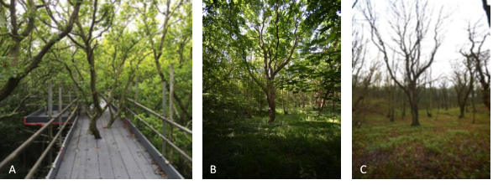

Figure 17: Wytham Woods canopy walkway (a) and during leaf-on (b) and leaf-off (c) conditions.

Field Sampling Strategy

The sampling scheme was driven by the need to capture variability at the scale of the Sentinel-2 MSI data used for upscaling. As a result of its homogeneity, the majority of ESUs were established randomly within the forest at Wytham Woods, driven by accessibility via roads and paths. However, several ESUs were also established in locations containing nodes of the permanent wireless FAPAR sensor network located at the site, to facilitate inter-comparison (Figure 18).

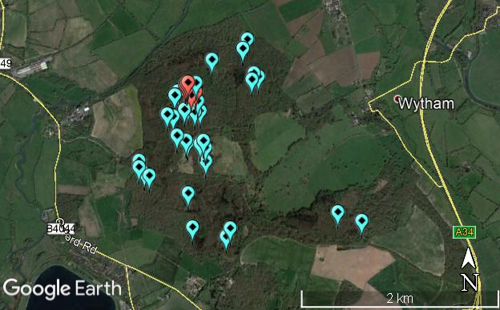

Figure : Map of Wytham Woods, indicating the locations of selected ESUs. High spatial resolution image acquired in May 2017. The red points represent ESUs containing nodes of the permanent wireless FAPAR sensor network.

Within each ESU, the systematic sampling strategy described in Section 5.1.2 was followed. At each sampling point, two DHP images were acquired by the EOLAB team: one facing upwards, and another facing downwards. This enabled both the forest understory and overstory to be characterised. SPAD-502 measurements were conducted by the team from the University of Southampton. To ensure the same locations were characterised by both teams, the coordinates of the central location of each ESU were shared amongst the teams. The number of ESUs at which SPAD-502 measurements were made was reduced as a result of the homogeneity of the forest, in addition to the extra time required to remove leaves from the forest canopy. Measurements were carried out on three leaves at each of the thirteen systematic sampling points, and six measurements were performed per leaf.

Timing of the Field Campaign

Table 5 provides a summary of the cloud-free Sentinel-2 MSI imagery available for Wytham Woods, which was used in order to assess the suitability of the site. Based on this information and other logistical constraints, the campaign was scheduled for 02/07/2018 to 06/07/2018. Due to the higher probability of cloud cover in the United Kingdom, an additional backup period until 13/07/2018 was also put in place. The period offered several opportunities for acquisition of a cloud-free Sentinel-2 MSI image for upscaling, in addition multiple Sentinel-3 overpasses (Table 6).

A meeting was held to discuss forecasts some days prior to the departure date to take into account the short-term forecasts from a) an ensemble of models and b) from the national weather forecaster (e.g. the Met Office), together with a more general assessment of the medium-term conditions (such as the movement and likely projection of low- and high-pressure systems).

Table 5: Cloud-free availability of Sentinel-2 MSI data over Wytham Woods (red to green colour scale represents the minimum to maximum number of available scenes).

|  |  |  |  |  |  |  |  |  |  |  |  |  |  |
| --- | --- | --- | --- | --- | --- | --- | --- | --- | --- | --- | --- | --- | --- |
|  | **Number of scenes with <10% cloud cover over a 3 km x 3 km area** | | | | | | | | | | | | |
|  | **2017** | | | | |  | **2018** | | | | | | |
| **Site** | **A** | **S** | **O** | **N** | **D** |  | **J** | **F** | **M** | **A** | **M** | **J** | **J** |
| Wytham Woods | 3 | 2 | 2 | 7 | 5 |  | 5 | 3 | 3 | 2 | 7 | 7 | 6 |

Table 6: Overpass schedule for the Wytham Woods campaign (all times UTC).

|  |  |  |  |  |
| --- | --- | --- | --- | --- |
| **Date** | **Sentinel-2A** | **Sentinel-2B** | **Sentinel-3A** | **Sentinel-3B** |
| 03/07/2018 | - | - | - | - |
| 04/07/2018 | - | 11:26 | 11:04 | 11:04 |
| 05/07/2018 | - | - | 10:39 | 10:39 |
| 06/07/2018 | 11:16 | - | 10:13 | 10:13 |
| 07/07/2018 | - | - | - | - |
| 08/07/2018 | - | - | 11:01 | 11:01 |
| 09/07/2018 | 11:26 | - | 10:35 | 10:35 |
| 10/07/2018 | - | - | 10:09 | 10:09 |
| 11/07/2018 | - | 11:16 | - | - |
| 12/07/2018 | - | - | 10:57 | 10:57 |
| 13/07/2018 | - | - | 10:31 | 10:31 |
| 14/07/2018 | - | 11:26 | 10:05 | 10:05 |
| 15/07/2018 | - | - | - | - |

Field Data Uncertainty Propagation

The uncertainty evaluation procedures described in Section 6.1 and 6.2 were applied to the raw measurements obtained in the campaign, enabling the various sources of uncertainty to be propagated through each stage of data processing (i.e. derivation of FAPAR and LAI from DHP-derived gap fraction measurements, SPAD-502 calibration, calculation of LCC from SPAD-502 values, averaging of measurements at the ESU level, and determination of CCC) to the final values of FAPAR and CCC per ESU.