FRM Protocols and Procedures for Surface Reflectance (FPP)

version 1.0

National Physical Laboratory
University of Southampton
EOLAB

05 June 2020
This document was produced as part of the ESA-funded project “Fiducial Reference Measurements for Vegetation Phase 2 (FRM4VEG 2)” under ESA contract number: 4000129823/20/I-NS

Authors

 | Name | Organisation | Date
Written by | Niall Origo | NPL | 05/06/2020
 | Rosalinda Morrone | NPL
 | Joanne Nightingale | NPL
 | Luke Brown | University of Southampton
Reviewed by (consortium)
Approved by (ESA)

Version History

Version | Date | Publicly available or private to consortium
1.0 | 05/06/2020 | Private Consortium

Table of Contents

Authors 2
Version History 2
Table of Contents 3
List of Figures 4
List of Tables 4
Acronyms 5
1 Introduction 7
1.1 Purpose and Scope 7
1.2 Overview of FRM Requirements 8
2 Surface Reflectance Terminology 9
2.1 Definitions 9
2.2 Principles of Surface Reflectance Measurement 12
3 Surface Reflectance Measurement Instrumentation 12
3.1 Instrument configurations for in situ observations 13
3.1.1 Analytical Spectral Devices FieldSpec Spectroradiometer 14
3.1.2 Solar Light Company Microtops II Sunphotometer 15
3.1.3 Delta-T Devices BF3 Sunshine Sensor 16
3.1.4 Spectralon Panel 17
3.2 Combination of Field Spectroscopy with Unmanned Aerial Vehicles 18
3.2.1 Headwall Airborne Integrated Solution with DJI Matrice 600 PRO 19
4 Instrument calibration 20
4.1 Calibration of field instruments 20
4.1.1 Spectroradiometer: Radiometric Calibration 21
4.1.2 Spectroradiometer: Spectral Calibration 22
4.1.3 Reference Panel Calibration 24
4.1.4 Sun photometer calibration 25
4.2 Measurement of Atmospheric Properties 26
4.3 Calibration of the UAV-based hyperspectral systems 27
5 Criteria for FRMs 28
5.1 Field Campaigns 28
5.1.1 Selection of field sites 28
5.1.2 Field sampling strategies 30
5.1.3 Timing of field data collection 32
5.2 Permanent field sites 33
6 Traceability, Uncertainty Sources and Propagation 34
7 References 38
8 APPENDIX 1 41
8.1 FRM4VEG Phase 1, Surface Reflectance Campaign at Barrax, Spain 41
8.2 Measurement Instrumentation for the field campaign 41
8.3 Instrument calibration 41
8.4 Field campaign 42
8.4.1 Selection of the field site 42
8.4.2 Field sampling strategy 43
8.4.3 Timing of field data collection 45
8.5 Field data uncertainty propagation 45

List of Figures

Figure 1: Conceptual and measurable reflectance quantities [15] 10
Figure 2: SFOV scheme and DFOV scheme systems [16] 14
Figure 3: ASD FieldSpec 4 Standard-Res [18] 15
Figure 4: Solar Light Company Microtops II sunphotometer [19] 16
Figure 5: Delta-T Devices BF3 Sunshine Sensor [20] 17
Figure 6: Spectralon Diffuse Reflectance Targets produced by Labsphere 17
Figure 7: Headwall VNIW-SWIR Co-Aligned + Internal Data Storage + GPS/IMU + LiDAR [24] 19
Figure 8: Wavelength characterisation setup, with an integrating sphere used to provide a radiance source 23
Figure 9:Illumination/total hemispherical reflectance calibration for a Labsphere Spectralon 99% reference panel 24
Figure 10: Example Langley plot, in which the instrument voltage is determined at different depths of atmosphere[19] 26
Figure 11: Flowchart describing the main steps for the SR retrieval [38] 27
Figure 12: Example of a hyperspectral processing chain [40] 28
Figure 13: Example of sampling strategy for one 300m x 100 m area [44] 31
Figure 14: Example of motion sampling strategy [44] 31
Figure 15: Subset of an uncertainty analysis tree for in situ measurements of HCRF, developed based on the recommendations of the FIDUCEO project [48] 36
Figure 16: Measurements were taken at the alfafa and bare soil sites by Niall Origo, using the portable Analytical Spectral Devices (ASD) FieldSpec 4 instrument. The Spectralon panel is shown in the foreground (left with cover on; right off).[6] 42
Figure 17: Location of Las Tiesas site in Barrax, Spain 43
Figure 18: The location of the field campaign with sample points shown. Las Tiesas farm boundary shown in grey, with the boundaries and sample points of the Alfalfa and bare soil shown in green and red, respectively [49] 44
Figure 19: Distribution of sampling locations for surface reflectance measurements within the selected alfalfa (top and bottom left) and bare soil fields (lower and bottom right) at Barrax – Las Tiesas[6] 44

List of Tables

Table 1: Measurement plan for spectroradiometer calibration [27]. 21
Table 2: Quoted wavelength accuracies for two widely used models of spectroradiometer. 23
Table 3: Uncertainty sources associated with in situ HCRF measurements. 35
Table 4: Geographic coordinates and altitude of Barrax – Las Tiesas 43
Table 5: Cloud-free availability of Sentinel-2 MSI data over the site (green colour scale represents the minimum to maximum number of available scenes) 46

Acronyms

Abbreviation | Stands for
ACIX | Atmospheric Correction Inter-Comparison Exercise
AD | Analytical to Digital
AEROCAN | Canadian Sunphotometry Network
AERONET | Aerosol Robotic Network
AOT | Aerosol optical thickness
ASD | Analytical Spectral Device
AU | Astronomical unit
BHR | Bi-hemispherical reflectance
BRDF | Bidirectional reflectance distribution function
BRF | Bidirectional reflectance factor
CCC | Canopy Chlorophyll Content
CCRF | Biconical reflectance factor
CEOS | Committee on Earth Observation Satellites
CHRIS | Compact High Resolution Imaging Spectrometer
CIP | Campaign Implementation Plan
CMOS | Complementary metal-oxide semiconductor
DCR | Directional Conical Reflectance
DFOV | Double Field of View
DHR | Directional-hemispherical reflectance
DN | Digital Number
EOLAB | Earth Observation Laboratory
ECV | Essential climate variable
EO | Earth Observation
ESA | European Spatial Agency
ESU | Elementary sampling unit
ETM+ | Enhanced thematic mapper plus
EU | European Union
FAPAR | Fraction of absorbed photosynthetically active radiation
FIDUCEO | Fidelity and Uncertainty in Climate Data Records from Earth Observation
FLUXNET | Flux measurement network
FOV | Field-of-view
FPP | FRM Protocols and Procedures
FRM | Fiducial Reference Measurements
FRM4VEG | Fiducial Reference Measurements for Vegetation
GCOS | Global Climate Observing System
GPS | Global positioning system
GUM | Guide to the Expression of Uncertainty in Measurement
HCRF | Hemispherical-conical reflectance factor
HDR | High dynamic range
HDRF | Hemispherical directional reflectance factor
IFOV | Instantaneous Field-of-view
ISO | International Organisation for Standardisation
IMU | Inertial measurement unit
JCGM | Joint Committee for Guides in Metrology
L2A | Level 2A
LAI | Leaf area index
LAN | Local area network
LCC | Leaf chlorophyll concentration
LiDAR | Light detection and ranging
LPV | Land Product Validation
MCT | Mercury Cadmium telluride
MODIS | Moderate resolution imaging spectroradiometer
MSI | Multispectral Instrument
NASA | National Aeronautics and Space Administration
NIR | Near-Infrared
NMEA | National Marine Electronics Association
NPL | National Physical Laboratory
OLCI | Ocean and Land Colour Instrument
PSF | Point Spread Function
PTFE | Polytetrafluoroethylene
QA4EO | Quality Assurance for Earth Observation
RGB | Red green blue
RTM | Radiative transfer model
S2A | Sentinel 2A
SFOV | Single Field of View
SI | International System of Units
SNR | Signal to noise ratio
SR | Surface Reflectance
SWIR | Shortwave-infrared
SZA | Solar zenith angle
TDR | Total diffuse reflectance
UAV | Unmanned aerial vehicle
UCLM | University of Castilla-La-Mancha
UHS | Ultra-high speed
UOS | University of Southampton
USB | Universal serial bus
UTC | Coordinated universal time
UV | Ultraviolet
VALERI | Validation of European Land Remote Sensing Instruments
VIM | International Vocabulary of Metrology
VIS | Visible
VNIR | Visible near infrared
WGCV | Working Group on Calibration and Validation

Introduction

Purpose and Scope

This document forms deliverable D-10 of the ESA project ‘Fiducial Reference Measurements for Vegetation Phase 2 (FRM4VEG Phase 2)’. Its purpose is to detail Fiducial Reference Measurement (FRM) protocols and procedures for surface reflectance over vegetated field sites. The FRM Protocols and Procedures for Surface Reflectance (FPP-SR) is a manual for calibrating field instrumentation, conducting field measurements in relation to both campaign and permanent field acquisitions, as well as describing how those measurements should be treated for upscaling to represent satellite pixels. The document is organized into 7 key sections:
- Section 1 provides a summary of the FPP-SR document with an overview of the FRM projects and requirements.
- Section 2 reviews the Surface Reflectance terminology in order to provide clarity as to the quantities of interest within this document. A nomenclature to facilitate this approach is summarised in order to assist users in choosing the appropriate sensor and reflectance quantity. The physical and mathematical description of the reflectance quantities are separated from measurable quantities.
- Section 3 reviews the instruments which can be used to measure Surface Reflectance together with their role in the supporting calibration and validation of satellite data.
- Section 4 describes the calibration of the instruments both in laboratory and in the field.
- Section 5 describes the procedures that should be followed in the field in order to support the systematic collection of in situ field spectroscopic data with the goal of satellite product validation to a Fiducial Reference Measurement standard, and a description of requirements for permanent field sites.
- Section 6 discusses the traceability of Surface Reflectance measurements, the uncertainty sources that need to be considered and the propagation of those uncertainties to a final estimate of Surface Reflectance uncertainty.
- Appendix 1 provides a practical example of a field campaign from FRM4VEG Phase 1, by summarising the field activities to measure Surface Reflectance and by describing the processing of field and satellite data.

Overview of FRM Requirements

The ESA sponsored Fiducial Reference Measurement (FRM) programme aims to provide a suite of reference measurements (of land, ocean and atmosphere variables) with an associated uncertainty that can be used to conduct satellite product validation through conformity testing. That is, the process that determines whether the estimated target quantity (i.e. the satellite estimate) falls within the range of tolerable values (i.e. the reference estimate), or not [1].
All FRMs should:
- Have documented SI traceability (or conform to appropriate international community standards), utilising instruments that have been characterised using metrological standards, both pre-deployment and evaluated regularly post-deployment [2], [3].
- Be independent from the satellite geophysical retrieval process.
- Be accompanied by an uncertainty budget for all instruments, derived measurements and validation methods [4].
- Adhere to community-agreed, published and openly available measurement protocols/ procedures and management practices.
- Be accessible to other researchers allowing independent verification of processing systems.

A number of FRM projects have been created for various satellite retrievals [5]:
- FRM4VEG: Fiducial Reference Measurements for Vegetation [6]
- FRM4SOC: Fiducial Reference Measurements for Satellite Ocean Colour [7]
- FRM4ALT: Fiducial Reference Measurements for Altimetry [8]
- FRM-BOUSSOLE: Buoy for the acquisition of long-term optical time series [9]
- FRM4DOAS: Fiducial Reference Measurements for Ground-Based DOAS Air-Quality Observations [10]
- FRM4GHG: Fiducial Reference Measurements for Ground-Based FTIR Greenhouse Gas Observations [11]
- FRM4STS: Fiducial Reference Measurements for Validation of Surface Temperatures from Satellites [12]
- Pandonia FRM: Fiducial Reference Measurements for Ground-Based Direct-Sun Air-Quality Observations [13]
FRM4Veg Phase 2 develops the methods and guidance documentation which should be followed by the international validation community when a) collecting campaign and permanent FRMs and b) performing validation of satellite-derived products, over the vegetated land surface.

Surface Reflectance Terminology

“Reflection is the process by which electromagnetic flux (power) incident on a stationary surface or medium, leaves that surface or medium from the incident side without change in frequency; reflectance is the fraction of the incident flux that is reflected.” [14]
Defining the quantity of interest is a key step in enabling a successful validation. While key references dealing with reflectance terminology exist in the literature (namely [14] and [15]), the same is not specifically true of satellite surface reflectance products. Two examples include the Sentinel-2 and Proba-V surface reflectance products which do not currently (as of May 2020) define the exact surface reflectance quantity they portray. Due to this lack of specification, an extra source of error is created when the reflectance community measures this quantity (e.g. for comparison), when sensors are calibrated and validated, when algorithms are developed or when products are derived to quantify and reduce uncertainties [15] .

Definitions

In this section selected definitions from [15], who overviewed the surface reflectance nomenclature, are given here:
- “The spectral radiance is the radiant flux in a beam per unit wavelength and per unit area and solid angle of that beam and is expressed in the SI units [W m⁻² sr⁻¹ nm⁻¹]”
- Reflectance (ρ) can be defined as “the ratio of the radiant exitance [W m⁻²] with the irradiance [W m⁻²]. Following the law of energy conservation, the value of the reflectance is in the interval 0 to 1.”
- “The reflectance factor, R, is the ratio of the radiant flux reflected by a surface to that reflected into the same reflected-beam geometry and wavelength range by an ideal (lossless) and diffuse (Lambertian) standard surface, irradiated under the same conditions. For measurement purposes, a Spectralon panel commonly approximates the ideal diffuse standard surface. Reflectance factors can reach values beyond 1, especially for strongly forward reflecting surfaces such as snow.”
Both the reflectance and reflectance factors are functions of the zenith and azimuth angles (θ_{i}, φ_{i},θ_{r},φ_{r}) of the incoming (i) and the reflected (r) radiance, and of the wavelength (λ). There are three general incident and exitant radiance conditions [15]:
- The directional case describes the situation where light incident upon or exitant from the surface is confined to an infinitesimally small field of view.
- The hemispherical case describes the situation where the light incident upon or exitant from the surface does so using the whole hemisphere.
- The conical case describes the situation where the light incident upon or exitant from the surface does so using a defined cone described by a solid angle. This is the typical case for satellite sensors measuring the reflected radiance from the Earth’s surface.
Figure 1, from [15], gives all the combinations of incident to exitant conditions and the associated reflectance quantities defined by these. Case 5 and 8 are noted as being the only measurable quantities in the field.
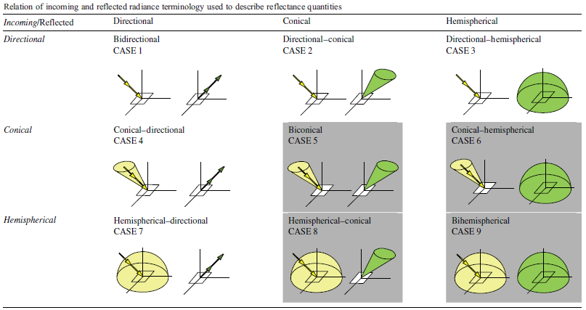
Figure 1: Conceptual and measurable reflectance quantities [15]

Some of the key reflectance quantities from [15] are given below:
Bidirectional reflectance distribution function (BRDF): “The BRDF describes the scattering of a parallel beam of incident light from one direction in the hemisphere into another direction in the hemisphere.” This quantity can’t be directly measured because it is expressed as the ratio of infinitesimal quantities, but its definition is useful to derive other quantities and to describe the intrinsic reflectance properties of a surface. This is given by the equation below:
$f_{r} \left( ϑ_{i},φ_{i},ϑ_{r},φ_{r}\right)= \frac{dL_{r} \left( ϑ_{i},φ_{i},ϑ_{r},φ_{r}\right)}{dE_{i} \left( ϑ_{i},φ_{i}\right)}$ [sr⁻¹]
Where L is the radiance and E is the irradiance.
Bidirectional reflectance factor (BRF): is given by the ratio of the reflected radiant flux from the surface to the reflected radiant flux from Lambertian surface of the same area under identical viewing geometry and single direction illumination. This is given by the equation below:
$BRF=$ $R \left( ϑ_{i},φ_{i},ϑ_{r},φ_{r}\right)= π f_{r} \left( ϑ_{i},φ_{i},ϑ_{r},φ_{r}\right)$
Where R is the reflectance factor.
Hemispherical-directional reflectance factor (HDRF): while similar to the definition of the BRF, this instead includes irradiance from the entire hemisphere. This makes the quantity dependent on the actual, simulated or assumed atmospheric conditions and the reflectance of the surrounding terrain.
$HDRF=$ $R \left( ϑ_{i},φ_{i},2 π, ϑ_{r},φ_{r}\right)= \frac{dΦ_{r} \left( ϑ_{i},φ_{i},2 π, ϑ_{r},φ_{r}\right)}{d{Φ_{r}}_{r}^{id}\left( ϑ_{i},φ_{i},2 π\right)}$
Where $Φ$is the radiant flux, the subscript r indicates the reflected and the subscripts id indicates the ideal surface.
Hemispherical-conical reflectance factor (HCRF): is similar to the HDRF but rather than the reflected component exiting into an infinitesimally small angle, instead it is reflected into a defined cone. This is a common measurable quantity. The HCRF is described by:
$HCRF=$ $R \left( ϑ_{i},φ_{i},2 π, ϑ_{r},φ_{r}, ω_{r}\right)$

Principles of Surface Reflectance Measurement

In general, it is necessary to perform several processes in order to derive the different surface reflectance quantities, e.g. it is not possible to measure the BRDF, but it can be estimated using BRDF models. The different quantities are derived considering some necessary approximations; among them, the atmospheric contribution plays an important role. Radiative transfer models, which are used to correct for atmospheric perturbations, consider the downwelling and upwelling radiation in the observed reflectance and the different components of direct, diffuse or combined direct and diffuse irradiance. From this, and by removing specific components, various measurable and unmeasurable quantities can be derived [15].
HCRF corresponds to the most likely setup for imaging instruments contained on aerial- or space-borne platforms [15]. Due to the small pixel instantaneous field of view of space-based instruments, the HCRF can generally be seen to approximate the HDRF [15].
From the surface, measurements of the total irradiance and estimates of the diffuse fraction of that irradiance can be made with dedicated sensors. These, along with reference panels that approximate ideal Lambertian surfaces, can be used to derive bidirectional reflectance properties [15] such as HCRF, CCRF and DCR, and if the illumination entering or exiting the cones is assumed to be constant across the cone then the HDRF and BRF can be retrieved also. The ability to derive multiple surface reflectance quantities allows users to validate multiple surface reflectance product definitions using the same instrumentation.

Surface Reflectance Measurement Instrumentation

The following sections provide a brief technical description of the instruments that can be used to measure surface reflectance in the field. Recommendations on the instruments that should be employed for campaign or permanent measurements will be discussed in Section 5. Further details on the manufacturer’s specifications and theory of operation of the instruments can be found in the associated ‘Technical Handbooks of FRM4VEG Instrumentation’.

Instrument configurations for in situ observations

The in situ (manual ground-based) measurement of spectral surface reflectance quantities involves the use of a minimum of 3 key pieces of equipment:
- A field spectroradiometer to measure the radiance from the surface
- An instrument to measure the irradiance from the source of illumination
- A reference panel
A directional reflectance measurement is enabled using a bare fibre, or collimating lens that limits the instantaneous field of view. Only a small fraction of the total energy reflected from the surface is measured by the sensor. The measurement direction is critical because all-natural surfaces reflect light in some directions slightly or dramatically more than other directions. It is important to ensure the chosen measurement direction is appropriate for the research question.
Depending on the quantity required, the resources available and the instruments that are used in the field (including single, multiple spectroradiometer and reference panels), different measurement configurations may be adopted. Some of the main approaches are given in [16]:
- Single-Field-Of-View (SFOV) mode: measurements are first taken over a reference standard, and they are immediately followed by a measurement of the target surface. Relative reflectance at each band is computed by dividing target radiance by reference radiance. Only one instrument with a single fiber is needed, although it is clear that to acquire a sequence of target-white reference measurements, a moving part is needed. An issue to be addressed regarding the SFOV is that, due to the non-simultaneous measurements of the target and the white reference – in unstable weather conditions - the changing illumination can lead to significant errors in the obtained reflectance values [16].
- Dual-Field-Of-View (DFOV), where measurements of radiance and irradiance are performed simultaneously from the same position. It requires either a dual fibre spectrometer or a pair of spectrometers, and for this reason it tends to be more complex and expensive, although no moving part it is generally needed. The DFOV can be used in the bi-conical and in the cos-conical mode. The main limitation of this technique is the requirement for two spectroradiometers. This is not only a resource limitation in terms of the instrument provision and calibration required, but also because the environmental conditions (e.g. temperature) experienced by each may differ and lead to different radiometric responses [16].
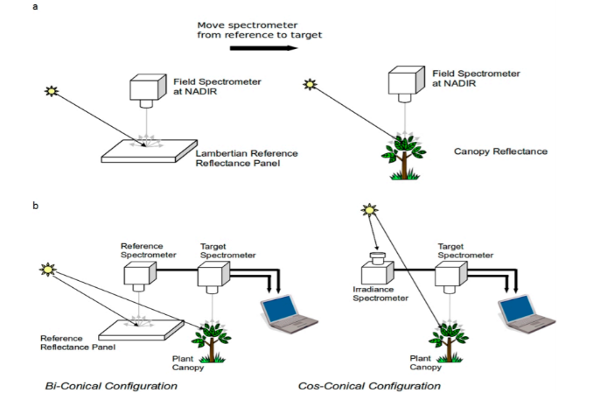
Figure 2: SFOV scheme and DFOV scheme systems [16]

With a single spectroradiometer, the dual FOV approach can be mimicked with an optic that rotates between upward and downward viewing, for example making use of an optical switch [17], effectively providing the hemispherical-conical reflectance in a quasi-simultaneous fashion. This approach also benefits from environmental conditions being the same for measurements in both directions.

Analytical Spectral Devices FieldSpec Spectroradiometer

The FieldSpec instruments are a series of portable spectroradiometers specifically designed for field environment remote sensing to acquire VNIR and SWIR spectra. This type of spectroradiometer is a compact, field portable instrument with a spectral range of 350-2500 nm and a data collection time of 0.1 second per spectrum. It measures the optical energy that is reflected/emitted by a surface. In its most basic configuration, the spectroradiometer views and detects the form of radiant energy defined as radiance. With accessories, various set-ups, and built-in processing of the radiance signal, [18] states that the FieldSpec spectroradiometer can measure:
- Spectral reflectance
- Spectral transmittance
- Spectral absorbance
- Spectral radiance
- Spectral irradiance
The technical characteristics of the FieldSpec 4 Standard-Res (Figure 3) provided by the manufacturer are detailed in the FieldSpec User Manual provided by [18] and in the ‘Technical Handbook of FRM4VEG Instrumentation: Analytical Spectral Devices FieldSpec Spectroradiometers’.
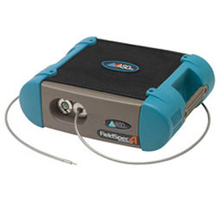
Figure 3: ASD FieldSpec 4 Standard-Res [18]

Solar Light Company Microtops II Sunphotometer

The Microtops II Sun photometer manufactured by the Solar Light Company, Philadelphia, USA, is relatively affordable, portable and easy to operate. The sun photometer measures solar radiance in five spectral bands (that may be specified while ordering the instrument) from which it automatically derives AOT. The aerosol optical thickness (AOT) and precipitable water vapor amount (W) are two important physical parameters that must be taken into account to model the impact of the atmosphere when reflectance is observed by a satellite. These two components of the atmosphere modulate the intensity of ultraviolet radiation at the surface of the Earth and they are an enigmatic yet indispensable component in global climate studies and modelling.
The description of the MICROTOPS II can be found in [19]. It is a hand-held multi-band sun photometer capable of measuring the total ozone column and water vapor column as well as aerosol optical thickness at 1020 nm.
Features and advantages of the instrument (listed in[19]):
- High accuracy
- Easy to use
- Portable
- Low cost
The instrument has an internal temperature and pressure meter. It should be removed from its case and allowed to equilibrate to the ambient conditions before use. It should not be left in the sun for prolonged periods of time. Technical characteristics of the instrument provided by the manufacturer are detailed in the User’s guide MICROTOPS II [19] and in the ‘Technical Handbook of FRM4VEG Instrumentation: Solar Light Company Microtops II Sunphotometer’.
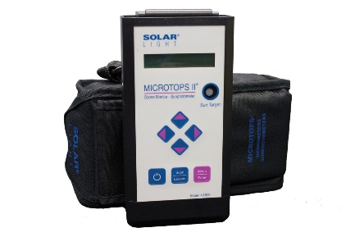
Figure 4: Solar Light Company Microtops II sunphotometer [19]

Delta-T Devices BF3 Sunshine Sensor

The BF3 (Figure 5) is a multi-purpose instrument capable of measuring incident radiation. A unique shade pattern and an array of 7 cosine-corrected photodiodes enable the measurement of total and diffuse irradiance without the need for shade rings, or any adjustment or repositioning of the sensor. From this, the direct irradiance component can also be derived. The BF3 Sunshine Sensor is one sensor with three main outputs[20]:
- Total solar radiation
- Diffuse radiation
- Sunshine status
The direct beam component of solar radiation can be calculated from the total minus the diffuse component. It is possible to set up the two radiation outputs to give millivolt signals scaled to the radiation units of choice (for example for Energy, in W m⁻²). The radiation outputs have a cosine-corrected response.
Features and advantages [20] :
- It doesn’t need a shadow band
- There are no moving parts
- It does not need to be adjusted or repositioned to track the sun
- It does not need to be oriented towards North
- It does not require knowledge of the latitude or longitude, and can be used at any latitude or longitude
The technical characteristics of the instrument provided by the manufacturer are detailed in [20] and in the ‘Technical Handbook of FRM4VEG Instrumentation: Delta-T Devices BF3 Sunshine Sensor’
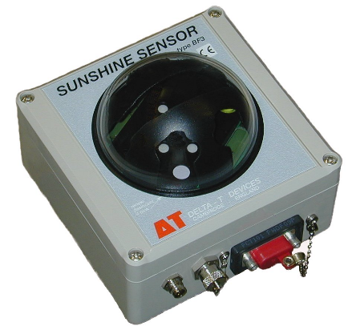
Figure 5: Delta-T Devices BF3 Sunshine Sensor [20]

Spectralon Panel

A white reference panel is required to calculate the reflectance of a material without an estimate of the irradiance (Figure 6). This panel must have a calibrated reflectance, which is used to convert the raw digital numbers (DNs) from an instrument measuring radiance to retrieve the reflectance for other surfaces illuminated under the same conditions. Spectralon is a thermoplastic resin with a hardness roughly equal to that of high-density polyethylene and it is thermally stable to >350 ° C. Spectralon reflectance material gives the highest diffuse reflectance of any known material or coating over the UV-VIS-NIR region of the spectrum. The reflectance is generally >99% over a range from 400 to 1500 nm and >95% from 1500 to 2500 nm. The material is also highly Lambertian (it is important to note that the panel is not a perfect Lambertian scatterer) at wavelengths from 0.257 µm to 10.6 µm, although it exhibits much lower reflectance at 10.6 µm due to absorbance by the material. To maintain its Lambertian characteristics, the material should be kept free from contaminants such as solvents, greases, oils and dirt[21]. Further, the spectralon technical guide [22] emphasises the importance of remeasuring the reflectance characteristics of the panel if it has been in use for a long period of time.

Figure 6: Spectralon Diffuse Reflectance Targets produced by Labsphere

Traditionally, Spectralon panels from Labsphere have a piece screwed on to the bottom to allow the panel to be mounted vertically. This can be used as the marker for orientation towards the sun. The panel needs to be mounted so that it is orientated towards the sun and is completely level (horizontal). The mounting must be stable in order to avoid the panel from tipping over and sustaining damage. A bracket can be manufactured which allows the stable deployment and easy adjustment of the panel on a sturdy tripod. The bracket should incorporate a bubble level to ensure it is horizontal and a short pin to maintain orientation with respect to the sun. A panel should not be placed at ground level, due to the increased likelihood of contamination from dust and debris from footsteps and the prevailing wind. However, even a panel placed on a high platform may not prevent wind-blown material affecting it if the wind is strong enough. Measurements of the panel should be conducted with the operator facing the sun and standing alongside the panel. The description of the material is outlined in [21] and the technical guide of the panel is given in [22].

Combination of Field Spectroscopy with Unmanned Aerial Vehicles

An increasingly adopted approach for measuring surface reflectance over larger areas more efficiently is the use of Unmanned Aerial Vehicles (UAVs). Using hand-held instruments has many limitations, such as the collection of top-canopy spectral measurements over high forest trees or in areas that are difficult to access as well as the inability to cover large spatial areas coincident with the satellite overpass that are representative of the pixel size. Errors may also arise by moving the instruments between locations, trampling the field site, as well as characterising the spatial distribution of some parameters in heterogeneous areas [23].
The combination of field spectroscopy with UAVs can improve the understanding and analysis of different phenomena and the upscaling from in-field to airborne and satellite measurements. UAVs provide improvements to the size of the measurement area as well as allowing it to become more heterogeneous. Likewise, it is possible to fly and record data autonomously, according to a pre-defined plan, and this can improve the consistency of data collected in surveys repeated over time [23].

Headwall Airborne Integrated Solution with DJI Matrice 600 PRO

Many hyperspectral cameras are push broom systems that utilize a diffraction grating to split monochromatic light into various wavelengths. This approach mimics that of Landsat or other satellite sensors in which a beam of light is split and subsequently filtered such that each array of light sensitive photoreceptors receives radiance independent of other wavelengths.
The Headwall Hyperspectral Co-Aligned VNIR/SWIR sensor, described in [24], is designed for airborne or ground based hyperspectral imaging. The imager is designed for use on a DJI Matrice 600 Pro UAV and can be used on its own, with a LiDAR instrument or as a ground-based hyperspectral imaging system. Combining visible and near infrared (VNIR) and shortwave infrared (SWIR) sensors into one package, the VNIR-SWIR camera from Headwall Photonics can collect hyperspectral data from 400-2500 nm using one instrument. Pixels from each sensor are co-registered through software, making the collected data truly aligned during post-processing [24].
Key features of the Headwall Hyperspectral Co-Aligned VNIR/SWIR Sensor with DJI Matrice 600 PRO [24]:
    - 400 – 2500 nm wavelength range
    - Dual VNIR & SWIR sensors with co-aligned pixels
    - 640 spatial pixels / 270 VNIR and 260 SWIR spectral pixels
    - Integrated high performance GPS/IMU
    - 16-channel LiDAR
Additional technical information is given in the ‘Technical Handbook of FRM4VEG Instrumentation: Headwall UAV’.
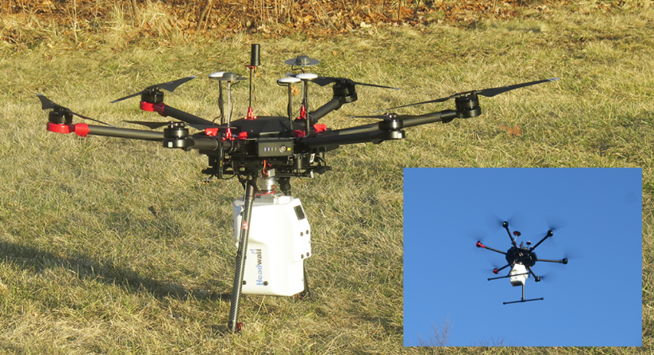
Figure 7: Headwall VNIW-SWIR Co-Aligned + Internal Data Storage + GPS/IMU + LiDAR [24]

Instrument calibration

To calibrate an instrument means to compare it against a more accurate reference in order to provide traceability of the measure by following ISO standards and to ensure global consistency [25]. Calibration is essential for: ensuring an instrument is fit for purpose; quantifying its reliability; and allowing instrument drift to be monitored (through repeated calibrations). When combined with uncertainty analysis, calibration information allows assessment of the uncertainty that an instrument contributes to a measurement. Initial calibration is usually performed by the manufacturer, but it must be performed regularly at appropriate intervals depending on the frequency of usage, susceptibility to drift and to ensure the measurement meets international reporting requirements (i.e. GCOS). When an instrument is calibrated, bias (a constant or predictable difference between the instrument readings) and drift (differences in an instrument’s readings through time) can be accounted for.

Calibration of field instruments

In order to guarantee precise and reliable measurements, calibration and characterisation accuracy of the ground-based imaging spectrometers are necessary. The calibration of a ground based spectroradiometer is sensor dependent: each sensor must be spectrally, radiometrically and geometrically calibrated to ensure the credibility of its products, whilst also considering that all the measurements should be traceable to SI [26]. The accuracy of the calibration must be performed to the user requirements by following a proper measurement plan where step by step traceability must be documented.
A generalized measurement plan is proposed in [27] for the calibration of a spectroradiometers for radiance measurements. This is shown in Table 1.
Table 1: Measurement plan for spectroradiometer calibration [27].
Major Measurement Plan | Considerations
Detailed description of the quantity to be measured including the accuracy desired | - Quantity to be measured  - Wavelengths to be measured  - Measurement accuracy desired  - Geometry of quantity  - Relative spectral distribution  - Approximate magnitude  - Stability  - Polarization
Identification of potential error sources and estimation of their magnitude (can also be according to specifications or literature search) | - Signal to noise  - Non-linearity  - Directional effects  - Spectral scattering  - Spectral distortion  - Polarization effects  - Size-of-source effect  - Wavelength instability  - Detector instability  - Uncertainty of the standards  - Instability of the standard  - Instability of the quantity being measured  - Noise in the measurement data
Selection of the radiance standard | - Source standard
Selection of the spectroradiometer | - Selecting the fore optics  - Selecting the system setup
Select the wavelength standard | - Line irradiance or radiance  - Separation from neighbouring lines  - Number and distribution of lines
Instrument assembly and preliminary checks | - Establishing the optical axis  - Setting up the fore optics  - Checking the output signal  - Checking the wavelength readout
Characterize the spectroradiometer for all potential errors | - SNR and dark current  - Wavelength characterization  - Non-linearity characterization  - Directional and positional characterization  - Spectral scattering characterization  - FOV  - Polarization characterization  - Size of source characterization  - Temperature characterization
Select and characterize the measurement setup | - Selection  - Characterization
Select the measurement design | - Design
Acquire the data and calculate the quantity desired | - Carrying out the measurements
Prepare the uncertainty report | - All sources of uncertainty  - Error “Type A” or “Type B”  - Degrees of freedom  - Combined uncertainty  - Expanded uncertainty  - Unidentified sources of uncertainty

Spectroradiometer: Radiometric Calibration

Radiometric calibration has been defined as the “conversion of raw digital numbers (DNs) recorded by detectors into the physical quantities of sensor spectral radiance or reflectance” by the Working Group on Calibration and Validation (WGCV) of the Committee on Earth Observation Satellites (CEOS) [26]. A large number of radiometric calibration methods have been explored based on the assumption of a linear sensor response, and they can be largely grouped into three stages: 1) pre-flight calibration; 2) onboard calibration; and 3) vicarious calibration [26].
Radiometric calibration is essential if the dual FOV measurement configuration is to be adopted but is not strictly required if a single spectroradiometer is used with a reference panel, provided its detectors have a linear response. However, if a spectroradiometer is not radiometrically calibrated, SI traceability can only be achieved through the reference panel. Therefore, a radiometrically calibrated spectroradiometer is desirable in both cases. Radiometric calibration should be carried out before deployment of the spectroradiometer in a field campaign. It may be achieved using an SI traceable radiance source, or, alternatively, an SI traceable irradiance source and a calibrated reference panel [28]. If multiple FOV-limiting foreoptics are to be used, separate radiometric calibration coefficients must be derived for each. If a traceable radiance source is required, an integrating sphere may be used in order to spatially integrate radiant flux.
[26] proposes an operational radiometric calibration model using a field imaging spectrometer system that accounts for different sensor’s settings, then evaluated by experimental calibration results from the integrating-sphere data and vegetation data, considering the formula:
$$DN=Gain×L+Offset$$
Where Gain and Offset are functions of cooling temperature, integration time and aperture. Each combination of these parameters is used at a varied radiance levels to obtain the radiometric gain and offset matrices, and then carrying out the sensitivity analysis of the radiometric calibration coefficients to system settings.

Spectroradiometer: Spectral Calibration

A spectral calibration is usually provided by the manufacturer of the spectroradiometer, and verification of this spectral calibration should be carried out before and after deployment in a field campaign. Verification may be conducted in the laboratory, making use of:
- Spectral line lamps (e.g. mercury-argon): gas discharge lamps which emit light at certain standard spectral lines as required mostly for spectral calibration purposes. The generated optical lines can be in the visible, infrared or ultraviolet spectral region. Typical emitting species are noble gases and the light emission is nearly always from single atoms or ions, not from molecules[29].
- Integrating sphere to ensure that the field-of-view (FOV) of the spectroradiometer is filled: An integrating sphere is a hollow sphere which has its interior coated with a substance that is nearly perfectly diffuse or Lambertian [30]. The light exiting the exit port of the integrating sphere is circular and spatially uniform.
Alternatively, verification may be conducted in the field, for example using doped reference panels (e.g. erbium, holmium and dysprosium oxide) or other materials with known spectral absorption features (e.g. mylar and acetate sheets), coupled with contact probe accessories. Field standards are reference materials that should exhibit a highly Lambertian reflectance over the whole spectral range of interest. The reflectance calibration of spectroradiometric measurements in the field requires a Spectralon panel as a reference standard [31]. The spectral calibration should be verified to lie within the manufacturers quoted wavelength accuracy specifications (Table 2). Recalibration should only be conducted after exhaustive tests and if there is a substantial error.
Table 2: Quoted wavelength accuracies for two widely used models of spectroradiometer.
Manufacturer | Model | Wavelength accuracy (nm)
Analytical Spectral Devices (ASD) | FieldSpec 3 | 1
 | FieldSpec 4 | 0.5

Within the FRM4VEG project, characterisation of the wavelength scale and bandwidth was achieved at the National Physical Laboratory (NPL) through the measurement of sources with defined spectral features to determine their location and width respectively. The specific lamps required depend on the characterisation specifications but can include Xenon, Krypton and Mercury lamps in the optical region. The procedure involved measuring the lamps in the standard configuration (Figure 8). The subsequent data related the expected wavelength location (i.e. that given by the spectroradiometer software) to the theoretical peak to determine the wavelength error.
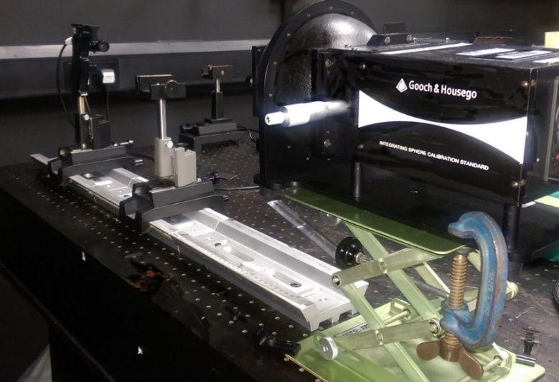
Figure 8: Wavelength characterisation setup, with an integrating sphere used to provide a radiance source

Reference Panel Calibration

Reference panels may be provided with a reflectance calibration from the manufacturer (Figure 9). They are typically manufactured from highly reflective materials such as sintered polytetrafluoroethylene (PTFE), or more traditionally, barium sulphate (BaSO₄). Given the delicate nature of these materials, they are particularly prone to contamination when used in the field, and also suffer from degradation by ultraviolet light. Thus, periodic cleaning and recalibration is required, ideally before deployment in any field campaign. If the surface is only lightly soiled, dust and other contaminants may be air brushed from the surface. For heavier contamination, the recommended procedure for cleaning sintered PTFE reference panels (e.g. Labsphere Spectralon) involves the use of 220 to 240 grit wet and dry sandpaper under running water. The surface is considered clean and free of contaminants when water beads off the surface [32]. When cleaning a reference panel, great care must be taken, as it is possible to sand the surface unevenly, compromising its Lambertian properties [28]. Before use, the reference panel should be visually inspected to ensure that contamination will not compromise its calibration.
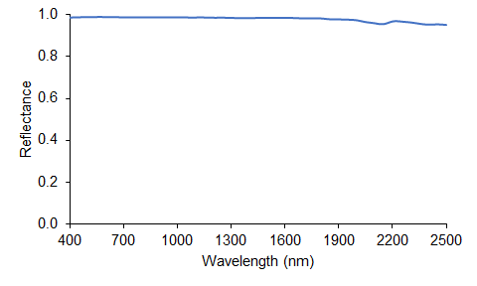
Figure 9:Illumination/total hemispherical reflectance calibration for a Labsphere Spectralon 99% reference panel

Calibration is achieved by inter-comparison with a master reference panel, which itself should have an SI traceable calibration, and should be carefully stored in the laboratory with minimal exposure to ensure this calibration is maintained [19]. It should be noted that the calibration provided by reference panel manufacturers typically corresponds to 8° illumination/total hemispherical reflectance measurement configuration, which corresponds to case 6 of the classification presented by [15]. This configuration removes any information on reference panel anisotropy, and the reference panel is then assumed to be Lambertian. Alternative measurement configurations are required to characterise reference panel anisotropy.
The reference panel calibration procedure adopted at NPL and utilised in the FRM4VEG project involved using a spectroradiometer to compare measurements of the sample reference panel against a master reference target. The 0° illumination/45° viewing geometrical configuration was used for the measurement procedure. The spectrometer views a small area (equating to around 8 mm x 8 mm) around 150 mm from the centre of the panel. Due to the size of the panel, four separate measurements were performed on each of the sides, rather than the centre, since the middle of the panel cannot be measured. These were averaged to obtain the spectral radiance factor.

Sun photometer calibration

A sun photometer is an electronic device used to measure direct sun irradiance within a narrow spectral band. Single beam and double beam are the two major classes of spectrophotometers. In single beam spectrophotometers, all the light passes through the sample. To measure the intensity of the incident light the sample must be removed so that all the light can pass through. This type of spectrometer is usually less expensive and less complicated. In a double beam spectrophotometer before it reaches the sample, the light source is split into two separate beams. One beam passes through the sample and the second one is used for reference. This gives an advantage because the reference reading and sample reading can take place at the same time. Spectrophotometers must be calibrated before they start to analyse the sample and the procedure for calibrating spectrophotometer is known an “zeroing”[33].
One way to calibrate the sun photometer is using the Langley method, based on the principle of spectral extinction, it relies on the Beer-Lambert-Bouguer law and it is described in [34]. The Langley method is based on the calibration constant that can be determined by extrapolating to an air mass of zero, which equates to the signal at the top of the atmosphere, from voltage measurements at different solar zenith angles (and therefore different atmospheric depths [35]). The direct solar beam at one location over a range of solar elevation angles is measured, providing measurements at different relative depths of atmosphere, or airmass e.g. Figure 10. The critical assumption of such Langley measurements is that the aerosol optical extinction remains constant throughout the period of measurement. This requires the atmosphere to be temporally invariant during the several hours required for the measurement sequence to be obtained, and horizontally homogeneous over a distance of about 50 km. Both assumptions are only likely to be valid at high-altitude locations, where the aerosol component in any case is small. Ideally, measurements should be performed during the morning, before the break down of atmospheric inversion layers in the afternoon due to heating and convection [35].
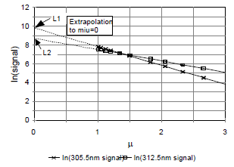
Figure 10: Example Langley plot, in which the instrument voltage is determined at different depths of atmosphere[19]

If access to a suitable high-altitude location is not feasible, an alternative method of calibration can be adopted, involving intercomparing a second instrument to facilitate calibration transfer. This method relaxes the requirement for a high altitude location, but it is then vital to ensure any differences in spectral bandwidth and/or response are accounted for [35].

Measurement of Atmospheric Properties

An alternative approach to surface reflectance validation is proposed by [36] that overcomes some of the difficulties in obtaining in situ measurements representative of the product spatial resolution. This approach relies on the fact that uncertainty in satellite-derived surface reflectance products is related to errors in the retrieval of atmospheric properties such as aerosol optical thickness (AOT) and water vapour. In order to enable the atmospheric correction of the satellite data of interest, atmospheric radiative transfer models (RTM) can be parameterised by using in situ measurements available from sun photometers. These models retrieve surface reflectance using the atmospheric conditions observed during image acquisition.
The resulting reference data set can then be compared with the standard surface reflectance product, providing information on product performance. Such an approach was adopted in the recent Atmospheric Correction Inter-comparison Exercise (ACIX) [37].
Figure 11 [38] shows how the surface reflectance images are retrieved by using atmospheric functions with associated calibration coefficients and how the effects are corrected step by step. An initial surface reflectance image can be obtained, taking into account the multi-angular information needed in order to characterize properly the directional effects in the target. In the case of platforms with multi-angular viewing capabilities, such as Compact High Resolution Imaging Spectrometer (CHRIS) PROBA, accounting for the directional effects in the target reflectance is feasible [38].
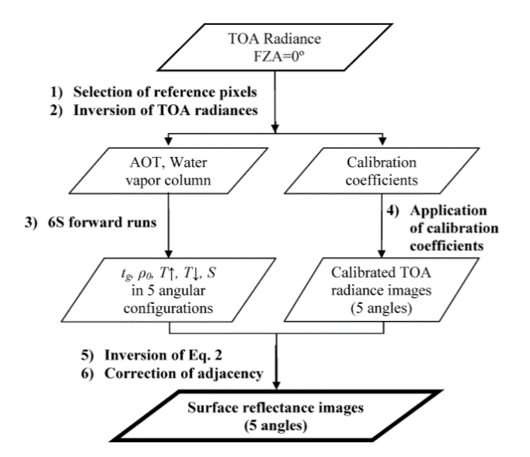
Figure 11: Flowchart describing the main steps for the SR retrieval [38]

Calibration of the UAV-based hyperspectral systems

As already stated in the previous sections, the integration of hyperspectral measurements with UAVs allows measurement campaigns to be extended to a greater number of land cover types without disturbing the surface, as well as creating a bridge between in situ measurements and airborne observations. A fully operational UAV hyperspectral system requires a UAV platform that can support the hyperspectral sensor, a GPS and an IMU. Moreover, since the scanner records hundreds of adjacent lines in the forward direction of travel, the system is highly sensitive to the sensor’s motion in the 3-axes representing roll, pitch and yaw. Therefore, in order to produce usable geo-corrected imagery, these systems require, besides the airframe and hyperspectral sensor, a differential GPS and IMU capable of capturing the motion at very high temporal intervals. Finally, UAV require ground targets to improve the georeferenced products as well as known reflectance targets to produce (or validate) radiometrically corrected data [39].
A simplified schematic of hyperspectral processing is presented in[40]:
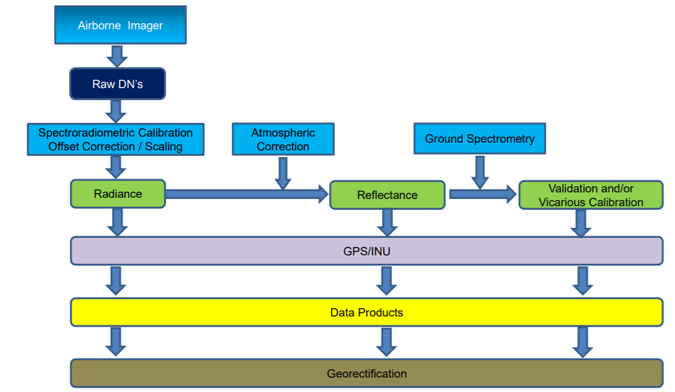
Figure 12: Example of a hyperspectral processing chain [40]

Criteria for FRMs

Field Campaigns

The selection of sites for field campaigns and validation exercises has to be carefully planned to ensure the results are of sufficient quality. In order to achieve this goal, in this section some criteria are listed together with other pragmatic tips to be taken into account to minimise cost, effort and logistical issues.

Selection of field sites

The following criteria can be considered in the selection of sites for field campaigns:
- Vegetation type
  - Between them, the selected sites should cover a wide range of structural, biophysical, and biochemical characteristics, as the considered satellite-derived products must be able to perform well over a range of environments and conditions.
- Representativeness
  - The sites should be representative of their respective biomes.
- Homogeneity
  - To enable validation of products derived from moderate spatial resolution instruments (i.e. 300 m in the case of Sentinel-3 OLCI), the sites should provide areas of vegetation large enough to encompass multiple moderate spatial resolution product pixels, particularly given positional errors and uncertainties related to the instrument’s point spread function (PSF) [41], [42]. An area of at least 3 x 3 pixels will enable misregistration errors between the moderate spatial resolution product and high spatial resolution imagery used in upscaling to be accounted for.
- Extent
  - The extent of the site should be on the order of several square kilometres to balance the need to validate multiple moderate spatial resolution product pixels with efficient in situ sampling [41].
- Topography
  - The sites should be located in areas of flat relief to minimise terrain effects [41].
- Accessibility
  - The sites should be easily accessible by road to enable access with relevant field equipment.
  - Permission for working at the site should be sought.
- Maturity
  - Established and well-characterised sites with a legacy of scientific activity are preferred, particularly where research facilities are available and/or permanent instrumentation is installed, such as flux towers which collect measurements of biophysical variables over extended periods of time.
- Weather
  - To maximise data collection and validation opportunities, the sites should have a good probability of clear skies during the timing of the proposed campaigns.
- Sampling strategy
The sampling design implemented for ground-based measurements is driven by two main factors: (a) the footprint of the field measurements and (b) up-scaling process used to integrate the field measurements and high-resolution imagery.

Field sampling strategies

[43] underlines that appropriate sampling strategies planned for field campaigns should follow particular constraints, in order to assure the quality of the validation datasets, the traceability of the operations and the uncertainties associated with the process. General sampling strategies are available in literature, but in general it is convenient to adapt the requirements of a specific campaign to the precise site, in order to take into account, the variability of the area. For example, [43] states that the uncertainty associated with the validation dataset may be reduced (if certain conditions are met) proportionally to the number of samples taken.
The sampling strategy to implement (random, stratified or systematic) should be chosen by taking into consideration several factors such as:
- The area to be covered (to capture mean reflectance of the area and provide an idea of the variations around this mean with respect to the satellite spatial resolution).
- The timeliness of measurements (with respect to the satellite overpass to minimise changing atmospheric conditions).
- The density of measurements required for statistical robustness.
Other operational considerations include:
- Consistent operator for the duration of the measurements
- Consistent operator clothing for the duration of the measurements
- Consistent measurement height
Whilst sampling based on experience introduces bias, unlike a random sampling approach, it can lead to better informed selection of measurement locations to ensure a representative sample of each type within an area of interest. [43]. [44] proposes three different sampling strategies that can be considered as measurement methodologies:
• Spaced out sampling, averaging several measurements at the one point
A regular grid is planned with spaced out sampling points (Figure 13). At each point of the grid, several measurements are averaged. Thus, the variation of the reflectance between the different points is a combination of the variation at small scale and at the scale of the sampling grid.
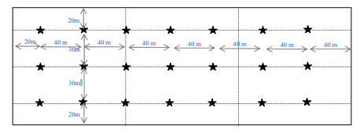
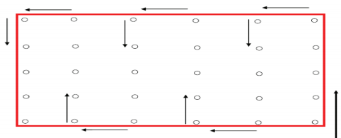
Figure 13: Example of sampling strategy for one 300m x 100 m area [44]

• Spaced out sampling with estimation of the very local spatial variability
This sampling strategy is similar to the previous one, except that for each measurement point, several measurements are locally recorded over different points near the nominal location. This sampling approach allows an evaluation of both local and overall spatial variability of the site reflectance. However, it turned out to be a relatively time-consuming method, strongly limiting the number of transects to be finished within the foreseen timeframe of one hour.
• In-motion sampling
The philosophy of this sampling technique is to keep the ASD spectrometer operator moving continuously (Figure 14). The methodology developed out of the need to characterize a site quickly to keep the impacts of BRDF and changing atmospheric effects to a minimum. The site is broken up into equally spaced transects with the number dependent on size and time, preferentially oriented north/south which helps to minimize problems due to operator shadowing of the target. The aim is to record as many measurements as possible, but to complete the field characterization in less than one hour.
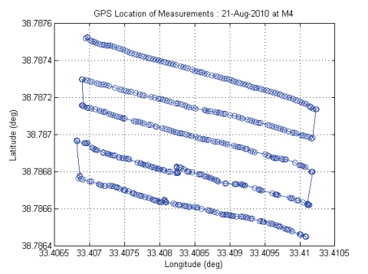
Figure 14: Example of motion sampling strategy [44]

All of the above strategies relate to taking measurements that correspond to a uniform surface type within a satellite pixel.

Timing of field data collection

A tailored sampling strategy is required to estimate surface reflectance at scales suitable for validating the products from satellites, due to the changeability of the illumination conditions across the course of a day. As a result, in situ measurements must take place within 30 minutes of the satellite overpass, during which the change in solar zenith angle (SZA) is dependent on the latitude of the site. To ensure coincidence of in situ measurements, overpass times must be forecasted for the campaign.
Several tools exist for the calculation and production of Sentinel overpass times, such as those suggested in [22]:
- https://www.n2yo.com/
- http://www.heavens-above.com/
The likelihood of cloud cover is another important factor that must be considered to decide if it is possible to do the field campaign. [22] suggests a number of online resources providing cloud observations and cloud predictions, with the intent to target days where the potential for adverse effects of cloud are minimised:
- https://www.windy.com/: A well-designed intuitive interface supports real time displays of projected winds, cloud and rainfall out to 7 days ahead. Clicking on a location gives summary statistics for that locality. Forecasts of airflow and percentage cloud cover have proved reliable in recent uses of the tool to assess the potential for field visits.
- https://darksky.net/: This site provides detailed cloud prediction maps and tables. Users can also interact with the site using the Dark Sky API to access one week of hourly forecast data programmatically.
However, it is difficult to specify a definitive threshold value for predicted cloud cover that should be applied. [22] specifies other factors that must be considered: the extent of the cloud cover prior to the satellite overpass, the expected duration of cloud or clear sky, and the predicted cloud cover in the vicinity are all factors that need to be considered. Also, rainfall is often associated with cloud, so the likelihood of rainfall affecting the surface measurements is important. Damp soil may not be an issue, but waterlogged patches or puddles may severely change the spatial variability in surface reflectance. Long term experience with a site helps inform this decision [22].

Permanent field sites

This section is pending further development during the course of FRM4Veg Phase 2…

Traceability, Uncertainty Sources and Propagation

When a physical quantity is measured, it is mandatory to indicate the quality of the results in order to compare different measurements either among themselves or with reference values or standards. [4] states that the ideal method for expressing uncertainty is based on three characteristics: universality, consistency and transferability. Considering this method, it is possible to evaluate the uncertainty, defined in [4] as “a parameter, associated with the results of a measurement, that describes the dispersion of the values that could reasonably be attributed to the measurand”.
Definitions and procedures from [4] about uncertainty in measurements may be found in the FRM4Veg Overview document.
Uncertainties related to field activities are generally related to: the equipment performance, the methodology of measurement, the sampling strategy, the properties of the surface and the environmental conditions [45].
All the uncertainties associated with the measurement process are then taken into account thanks to the SI traceability, defined as “the property of the result of a measurement or the value of a standard whereby it can be related to stated references, usually national or international standards, through an unbroken chain of comparisons all having stated uncertainties”[46]. The unbroken chain of comparisons is called traceability chain.
The measured quantity retrieved by the ASD and the imaging spectrometer mounted in the UAV is HCRF. The measurement equation for hemispherical-conical reflectance factor (${HCRF}_{ground}\left(θ_{sun}\right))$ is based on [15] and adapted for in situ measurements at nadir-viewing by [47]:
$${HCRF}_{ground}\left(θ_{sun}\right)=\frac{\left({BRF}_{ref}\left(θ_{sun}\right)d+{TDR}_{ref}(1-d)\right){DN}_{ground}\left(t_{2}\right)}{\frac{1}{2}\left({DN}_{ref}\left(t_{1}\right)+{DN}_{ref}\left(t_{3}\right)\right)}$$
where ${BRF}_{ref}\left(θ_{sun}\right)$ gives the reference panel BRF at the solar zenith angle (SZA) (predetermined in laboratory calibration), $d$ gives the direct/diffuse radiant flux ratio, ${TDR}_{ref}$ is the total diffuse reflectance i.e. only from diffuse input (defined by [14], [49] as HCRF), ${DN}_{ground}$ gives the digital number recorded by the sensor over the target of interest, and ${DN}_{ref}$ gives the digital number recorded over the Spectralon panel. Table 3 indicates a number of uncertainty sources associated with in situ HCRF measurements performed using a spectroradiometer and reference panel. Once quantified using either ‘Type A’ or ‘Type B’ evaluation, these uncertainties can be propagated through the above measurement equation to derive the resulting combined standard uncertainty in HCRF.
Table 3: Uncertainty sources associated with in situ HCRF measurements.
Source | Symbol | Affected terms | Type | Description
Levelling of optics | $u(θ_{v})$, $u(φ_{v})$ | $$DN$$ | Random
Levelling of panel | $u(θ_{pref})$, $u(φ_{pref})$ | $${BRF}_{ref}\left(θ_{sun}\right)$$ | Random across samples; systematic at each sample point
Panel degradation | $$u(a_{pref})$$ | $${BRF}_{ref}\left(θ_{sun}\right)$$ | Partially systematic; changes through time
Surface BRDF | $$u({BRDF}_{sf})$$ | $${HCRF}_{ground}\left(θ_{sun}\right)$$ | Random | Combines with the difference between the satellite sensor viewing angle and nadir
Panel BRDF | $$u({BRDF}_{pref})$$ | $${BRF}_{ref}\left(θ_{sun}\right)$$ | Systematic and random | Combines with the sensor viewing angle uncertainty
Wavelength scale | $$u(λ_{sc})$$ | $${HCRF}_{ground}\left(θ_{sun}\right)$$ | Systematic | Turns ${HCRF}_{ground}\left(θ_{sun}\right)$ into ${HCRF}_{ground}\left(θ_{sun},λ\right)$
Stray light | $$u(sl)$$ | $$DN$$ | Systematic
Bandwidth | $$u(bw)$$ | $$DN$$ | Partially systematic | Refers to the effect of the bandwidth being able to  resolve the spectra of interest
Dark current | $$u({DN}_{dc})$$ | $$DN$$ | Usually random | Can depend on temperature
Diffuse/direct ratio | $$u(d)$$ | $$d$$ | To be broken down

Although the presented measurement equation goes some way to defining the uncertainty sources present in the measurement procedure, a more complete measurement equation would seek to represent the effects that are assumed (e.g. exact nadir viewing). Doing this in a clear manner is often difficult due to the large number of terms present. As such, breaking each term down into its constituents and creating a measurement equation for each is recommended by the Fidelity and Uncertainty in Climate Data Records from Earth Observations (FIDUCEO) project[48] (Figure 15).
`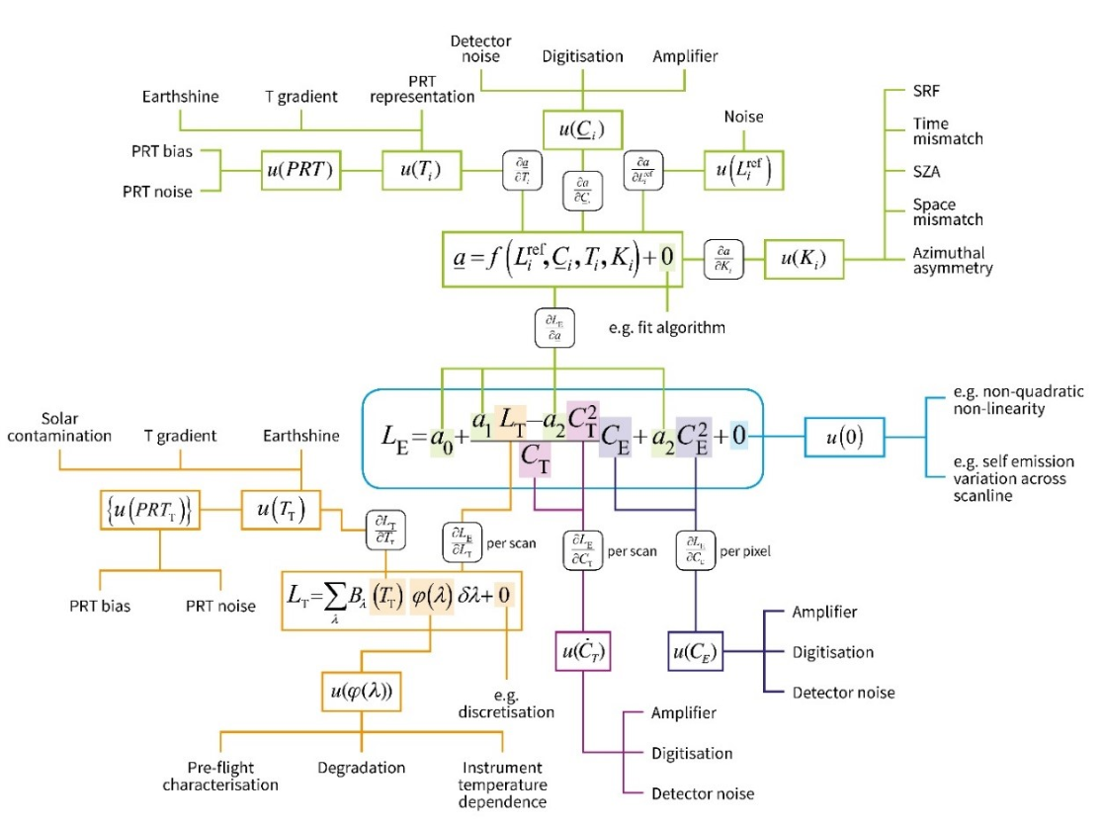
Figure 15: Subset of an uncertainty analysis tree for in situ measurements of HCRF, developed based on the recommendations of the FIDUCEO project [48]

This diagram is designed to show the sources of uncertainty from their origin through to the uncertainty in the measurand. On the outside of the tree are the effects leading to uncertainty. Moving clockwise from the top of the diagram [48]:
- The green branch details effects that lead to uncertainty in the calibration parameters $a_{0}, a_{1}$,$a_{2}$ .
- The blue branch details effects that lead to uncertainty in how well the measurement function describes the true physical state of the measurement process. These effects contribute to the uncertainty in $u\left(0\right).$ The main assumption here is that the quadratic equation fully represents the instrument response and there is no higher nonlinearity.
- The dark purple branch shows effects that contribute to the uncertainty in counts seen when looking at the Earth, $u{(C}_{E}).$ These are sources of noise in the detector and amplified and in the digitisation of the signal for transmission purposes and they will create an independent error from pixel to pixel.
- The light purple branch details the effects that lead to uncertainty $u{(C}_{T}),$ in the counts seen when looking at the calibration target.
- The orange branch shows the effects that lead to uncertainty $u{(L}_{T}),$ in the calibration-target radiance. This comes predominantly from the measurement of the target temperature and thermal gradients across the target.
Once the effects that contribute to the uncertainty on each term in the measurement function are identified, the effects must be combined considering the standard uncertainty associated with the effect, the sensitivity coefficient and the correlation structure over spatial, temporal and spectral scales for errors from this effect. FIDUCEO [48] provides the effects table that represents a common approach to documenting and combine uncertainty effects.

References

[1] J. L. Widlowski et al., “The fourth phase of the radiative transfer model intercomparison (RAMI) exercise: Actual canopy scenarios and conformity testing,” Remote Sens. Environ., vol. 169, pp. 418–437, 2015, doi: 10.1016/j.rse.2015.08.016.
[2] E. Theocharous and N. P. Fox, “NPL REPORT OP 4 CEOS comparison of IR brightness temperature measurements in support of satellite validation. Part II: Laboratory comparison of the brightness temperature of blackbodies,” 2010.
[3] N. Fox, “QA4EO: A guide to comparisons – organisation, operation and analysis to establish measurement equivalence to underpin the Quality Assurance requirements of GEO (QA4EO-QAEO-GEN-DQK-004) Version 4.0,” 2010.
[4] Joint Committee For Guides In Metrology, “Evaluation of measurement data — Guide to the expression of uncertainty in measurement,” Int. Organ. Stand. Geneva ISBN, vol. 50, no. September, p. 134, 2008, doi: 10.1373/clinchem.2003.030528.
[5] ESA, “Fiducial Reference Measurements: FRM,” 2019. https://earth.esa.int/web/sppa/activities/frm (accessed Mar. 08, 2019).
[6] ESA, “FRM4VEG – Fiducial Reference Measurements for Vegetation.” https://frm4veg.org/ (accessed Apr. 15, 2020).
[7] ESA, “FRM4SOC - Fiducial Reference Measurements for Satellite Ocean Colour.” https://frm4soc.org/ (accessed Jun. 01, 2020).
[8] ESA, “FRM4ALT - Fiducial Reference Measurements for altimetry.” https://www.frm4alt.eu/ (accessed Jun. 01, 2020).
[9] ESA, “BOUSSOLE.” http://www.obs-vlfr.fr/Boussole/html/project/strategy.php (accessed Jun. 01, 2020).
[10] ESA, “FRM4DOAS - Fiducial Reference Measurements for Ground-Based DOAS Air-Quality Observations.” https://frm4doas.aeronomie.be/ (accessed Jun. 01, 2020).
[11] ESA, “FRM4GHG - Reference Measurements for Ground-Based FTIR Greenhouse Gas Observations.” http://frm4ghg.aeronomie.be/ (accessed Jun. 01, 2020).
[12] ESA, “FRM4STS - Fiducial Reference Measurements for validation of Surface Temperatures from Satellites.” http://www.frm4sts.org/ (accessed Jun. 01, 2020).
[13] ESA, “Pandonia Global Network – Reference Measurements of Atmospheric Composition.” https://www.pandonia-global-network.org/ (accessed Jun. 01, 2020).
[14] F. E. Nicodemus, J. C. Richmond, and J. J. Hsia, Geometrical considerations and nomenclature for reflectance. Washington D.C., United States: Department of Commerce National Bureau of Standards, 1977.
[15] G. Schaepman-Strub, M. E. Schaepman, T. H. Painter, S. Dangel, and J. V. Martonchik, “Reflectance quantities in optical remote sensing-definitions and case studies,” Remote Sens. Environ., 2006, doi: 10.1016/j.rse.2006.03.002.
[16] K. Sakowska et al., “WhiteRef: A new tower-based hyperspectral system for continuous reflectance measurements,” Sensors (Switzerland), vol. 15, no. 1, pp. 1088–1105, 2015, doi: 10.3390/s150101088.
[17] C. J. MacLellan and T. J. Malthus, “High performance dual field of view spectroradiometer with novel input optics for, autonomous reflectance measurements over an extended spectral range,” in Proceedings of the 2009 International Geoscience and Remote Sensing Symposium, 2009, doi: 10.1109/IGARSS.2009.5417905.
[18] ASD, “FieldSpec ® 3 User Manual,” ASD Document 600540 Rev. J. Boulder, Colorado, United States, 2010.
[19] Solar Light Company, “User’s Guide Microtops-II, Ozone Monitor & Sunphotometer Version 2.43.” Solar Light Company, Glenside, PA, USA, 2011.
[20] J. Wood and E. Potter, User Manual for the Sunhine Sensor: Type BF3, 1.0. Burwell, United Kingdom: Delta-T Devices, 2002.
[21] Labsphere, “Technical guide: Reflectance Materials and Coatings.” North Sutton, New Hampshire, United States, [Online]. Available: http://www.labsphere.com.
[22] T. Malthus et al., “A community approach to the standardised validation of surface reflectance data.,” 2019.
[23] R. Garzonio, B. di Mauro, R. Colombo, and S. Cogliati, “Surface reflectance and sun-induced fluorescence spectroscopy measurements using a small hyperspectral UAS,” Remote Sens., vol. 9, no. 5, pp. 1–24, 2017, doi: 10.3390/rs9050472.
[24] Headwall Photonics, “Hyperspec Co-Aligned VNIR / SWIR Airborne Sensor with DJI Matrice 600 Pro: Product Data Sheet.” Bolton, Massachusetts, 2019.
[25] C. D. Ehrlich and S. D. Rasberry, “Metrological timelines in traceability,” Metrologia, vol. 34, no. 6, pp. 503–514, 1997, doi: 10.1088/0026-1394/34/6/6.
[26] C. Huang, L. Zhang, J. Fang, and Q. Tong, “A radiometric calibration model for the field imaging spectrometer system,” IEEE Trans. Geosci. Remote Sens., vol. 51, no. 4, pp. 2465–2475, 2013, doi: 10.1109/TGRS.2012.2211026.
[27] E. J. Milton, M. E. Schaepman, K. Anderson, M. Kneubühler, and N. Fox, “Progress in field spectroscopy,” Remote Sens. Environ., vol. 113, no. SUPPL. 1, pp. S92–S109, 2009, doi: 10.1016/j.rse.2007.08.001.
[28] I. Lau and N. Thapar, Laboratory Spectroscopy Calibration Procedures. Canberra, Australia: Commonwealth Scientific and Industrial Research Organisation, 2014.
[29] R. Photonics, “RP Photonics Encyclopedia: spectral lamps.” https://www.rp-photonics.com/spectral_lamps.html (accessed May 01, 2020).
[30] M. E. Schaepman, S. Dangel, M. Kneubühler, and D. Schläpfer, “Quantitative Field Spectroscopic Measurement Instrumentation and Techniques,” Spectroscopy, pp. 1–12.
[31] M. E. Schaepman, “Calibration of a Field Spectroradiometer - Calibration and Characterization of a Non-Imaging Field Spectroradiometer Supporting Imaging Spectrometer Validation and Hyperspectral Sensor Modelling,” Remote Sens. Ser., vol. 31, p. 146, 1998, [Online]. Available: http://www.geo.unizh.ch.
[32] Labsphere, Spectralon Reflectance Material Care and Handling Guidelines. North Sutton, New Hampshire, United States: Labsphere, 2017.
[33] AMRITA, “Spectrophotometry (Theory).” https://vlab.amrita.edu/?sub=2&brch=190&sim=338&cnt=1 (accessed May 01, 2020).
[34] J. H. W. Chang, N. H. N. Maizan, F. P. Chee, and J. Dayou, “Langley calibration of sunphotometer using perez’s clearness index at tropical climate,” Aerosol Air Qual. Res., vol. 18, no. 5, pp. 1103–1117, 2018, doi: 10.4209/aaqr.2016.10.0455.
[35] G. E. Shaw, “Sun Photometry,” Bull. Am. Meteorol. Soc., vol. 64, no. 1, pp. 4–10, 1983, doi: 10.1175/1520-0477(1983)064<0004:SP>2.0.CO;2.
[36] E. Vermote, C. Justice, M. Claverie, and B. Franch, “Preliminary analysis of the performance of the Landsat 8/OLI land surface reflectance product,” Remote Sens. Environ., vol. 185, pp. 46–56, 2016, doi: 10.1016/j.rse.2016.04.008.
[37] G. Doxani et al., “Atmospheric Correction Inter-Comparison Exercise,” Remote Sens., vol. 10, no. 352, pp. 1–18, 2018, doi: 10.3390/rs10020352.
[38] L. Guanter, L. Alonso, and J. Moreno, “A method for the surface reflectance retrieval from PROBA/CHRIS data over land: Application to ESA SPARC campaigns,” IEEE Trans. Geosci. Remote Sens., vol. 43, no. 12, pp. 2908–2917, 2005, doi: 10.1109/TGRS.2005.857915.
[39] J. Arroyo-Mora et al., “Implementation of a UAV–Hyperspectral Pushbroom Imager for Ecological Monitoring,” Drones, vol. 3, no. 1, p. 12, 2019, doi: 10.3390/drones3010012.
[40] R. Soffer, G. Leblanc, and M. Kalacska, “Airborne Hyperspectral Activities at the NRC Flight Research Laboratory.” Davos, Switzerland, 2015.
[41] F. Baret et al., VALERI: a network of sites and a methodology for the validation of medium spatial resolution land satellite products. Avignon, France: Institut National de la Recherche Agronomique, 2005.
[42] J. T. Morisette et al., “Validation of global moderate-resolution LAI products: A framework proposed within the CEOS land product validation subgroup,” IEEE Trans. Geosci. Remote Sens., vol. 44, no. 7, pp. 1804–1814, Jul. 2006, doi: 10.1109/TGRS.2006.872529.
[43] A. Barker, J. Nightingale, A. Banks, and T. Scanlon, “NPL REPORT ENV 5 Quality Assurance for FOREST data products: Recommendations for Future Improvements,” 2015.
[44] Y. Boucher et al., “Spectral reflectance measurement methodologies for Tuz Golu field campaign,” in 2011 IEEE International Geoscience and Remote Sensing Symposium, 2011, pp. 3875–3878, doi: 10.1109/IGARSS.2011.6050077.
[45] M. J. Michavilla and O. Gutierrez, “Towards a complete spectral reflectance uncertainty model for Field Spectroscopy,” no. September. 2017.
[46] Z. Grkov, “International Vocabulary of Basic and General Terms in Metrology ( VIM ),” Bur. Stand. Metrol., no. March, pp. 15–19, 1998.
[47] A. Bialek, C. Greenwell, M. Lamare, S. Marcq, S. Lacherade, and A. Meygret, Namibia Field Campaign Technical Note. Teddington, United Kingdom: National Physical Laboratory, 2016.
[48] FIDUCEO, “Example Uncertainty Analysis Tree.” http://www.fiduceo.eu/tutorial/example-uncertainty-analysis-tree (accessed Feb. 22, 2019).
[49] N. Origo, J. Gorroño, J. Ryder, J. Nightingale, and A. Bialek, “Fiducial Reference Measurements for validation of Sentinel-2 and Proba-V surface reflectance products,” Remote Sens. Environ., vol. 241, no. November 2019, p. 111690, 2020, doi: 10.1016/j.rse.2020.111690.
[50] C. J. Merchant, G. Holl, J. P. D. Mittaz, and E. R. Woolliams, “Radiance uncertainty characterisation to facilitate climate data record creation,” Remote Sens., vol. 11, no. 5, 2019, doi: 10.3390/rs11050474.

APPENDIX 1

FRM4VEG Phase 1, Surface Reflectance Campaign at Barrax, Spain

[49] describes a field campaign that took place on the 2nd August 2018 at Las Tiesas, Barrax, Spain, to validate the Sentinel-2 L2A and Proba-V S1-TOC surface reflectance products, together with a description of the FRM methods, a description of the field instruments used and of the field measurement protocols.

Measurement Instrumentation for the field campaign

The instruments used to collect data for the validation were:
- ASD FieldSpec 4 spectroradiometer: to collect the in-situ reflectance values in raw digital number (DN) mode with the 8° fore-optic attachment. The spectrometer has a 400 nm-2500 nm wavelength range with a variable bandwidth of 3 nm at 700 nm and 10 nm at 1400/2100 nm.
- A Spectralon panel: a 99% reflectivity panel produced by Labsphere was used (size: 0.4572 m²).
- A Microtops Sun photometer: used to retrieve the aerosol optical thickness (AOT) by measuring the direct solar irradiance in five spectral bands (440 nm, 675 nm, 870 nm, 936 nm and 1020 nm).
- GPS: a GPS was used to measure the position of each of the sample locations.

Instrument calibration

Before beginning the measurements at each sample location, a white reference measurement was taken of the panel. This tunes the spectrometer settings to the ambient conditions and ensured that saturation cannot happen while the illumination was constant. By using the Spectralon panel as the calibration source, measurements made using the spectrometer could be done in relative mode. This means the absolute calibration of the spectrometer was not required as long as instrument changes between the test and reference measurements were minimal.
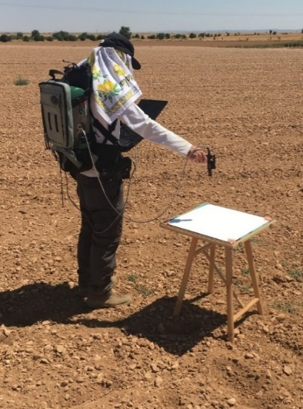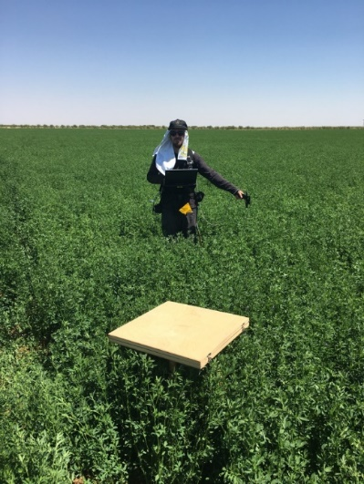
Figure 16: Measurements were taken at the alfafa and bare soil sites by Niall Origo, using the portable Analytical Spectral Devices (ASD) FieldSpec 4 instrument. The Spectralon panel is shown in the foreground (left with cover on; right off).[6]

Characterisation of the panel was conducted at multiple angles to account for its anisotropic properties. This was combined with the calibration of the BRF to provide information on the panel’s diffuse calibration coefficient as well as calibration coefficients specific to the illumination angle. The BRF was characterised using a Perkin-Elmer Lambda 900 spectrophotometer at NPL with an illumination angle of 0° and a viewing angle of 45°, conducted over the 340 nm-1055 nm at 5 nm wavelength interval. The remaining wavelengths were extrapolated using a linear interpolation of the calibration data from 700 nm-800 nm. During this procedure, four locations were measured in the centre of each of the four sides of the panel [49].

Field campaign

Selection of the field site

Las Tiesas is an experimental farm located close to the village of Barrax in the Castilla-La-Mancha, Spain, around 20 km far from the city of Albacete. It was chosen for the field campaign for its desirable features: large and homogeneous crop surfaces, low summer cloud cover likelihoods, flat terrain, easy access to individual fields and a long history of remote sensing validation.
Table 4: Geographic coordinates and altitude of Barrax – Las Tiesas
Barrax – Las Tiesas Site
Latitude (WGS84 degrees) | 39.054371 N
Longitude (WGS84 degrees) | 2.100677 W
Altitude | 700 m

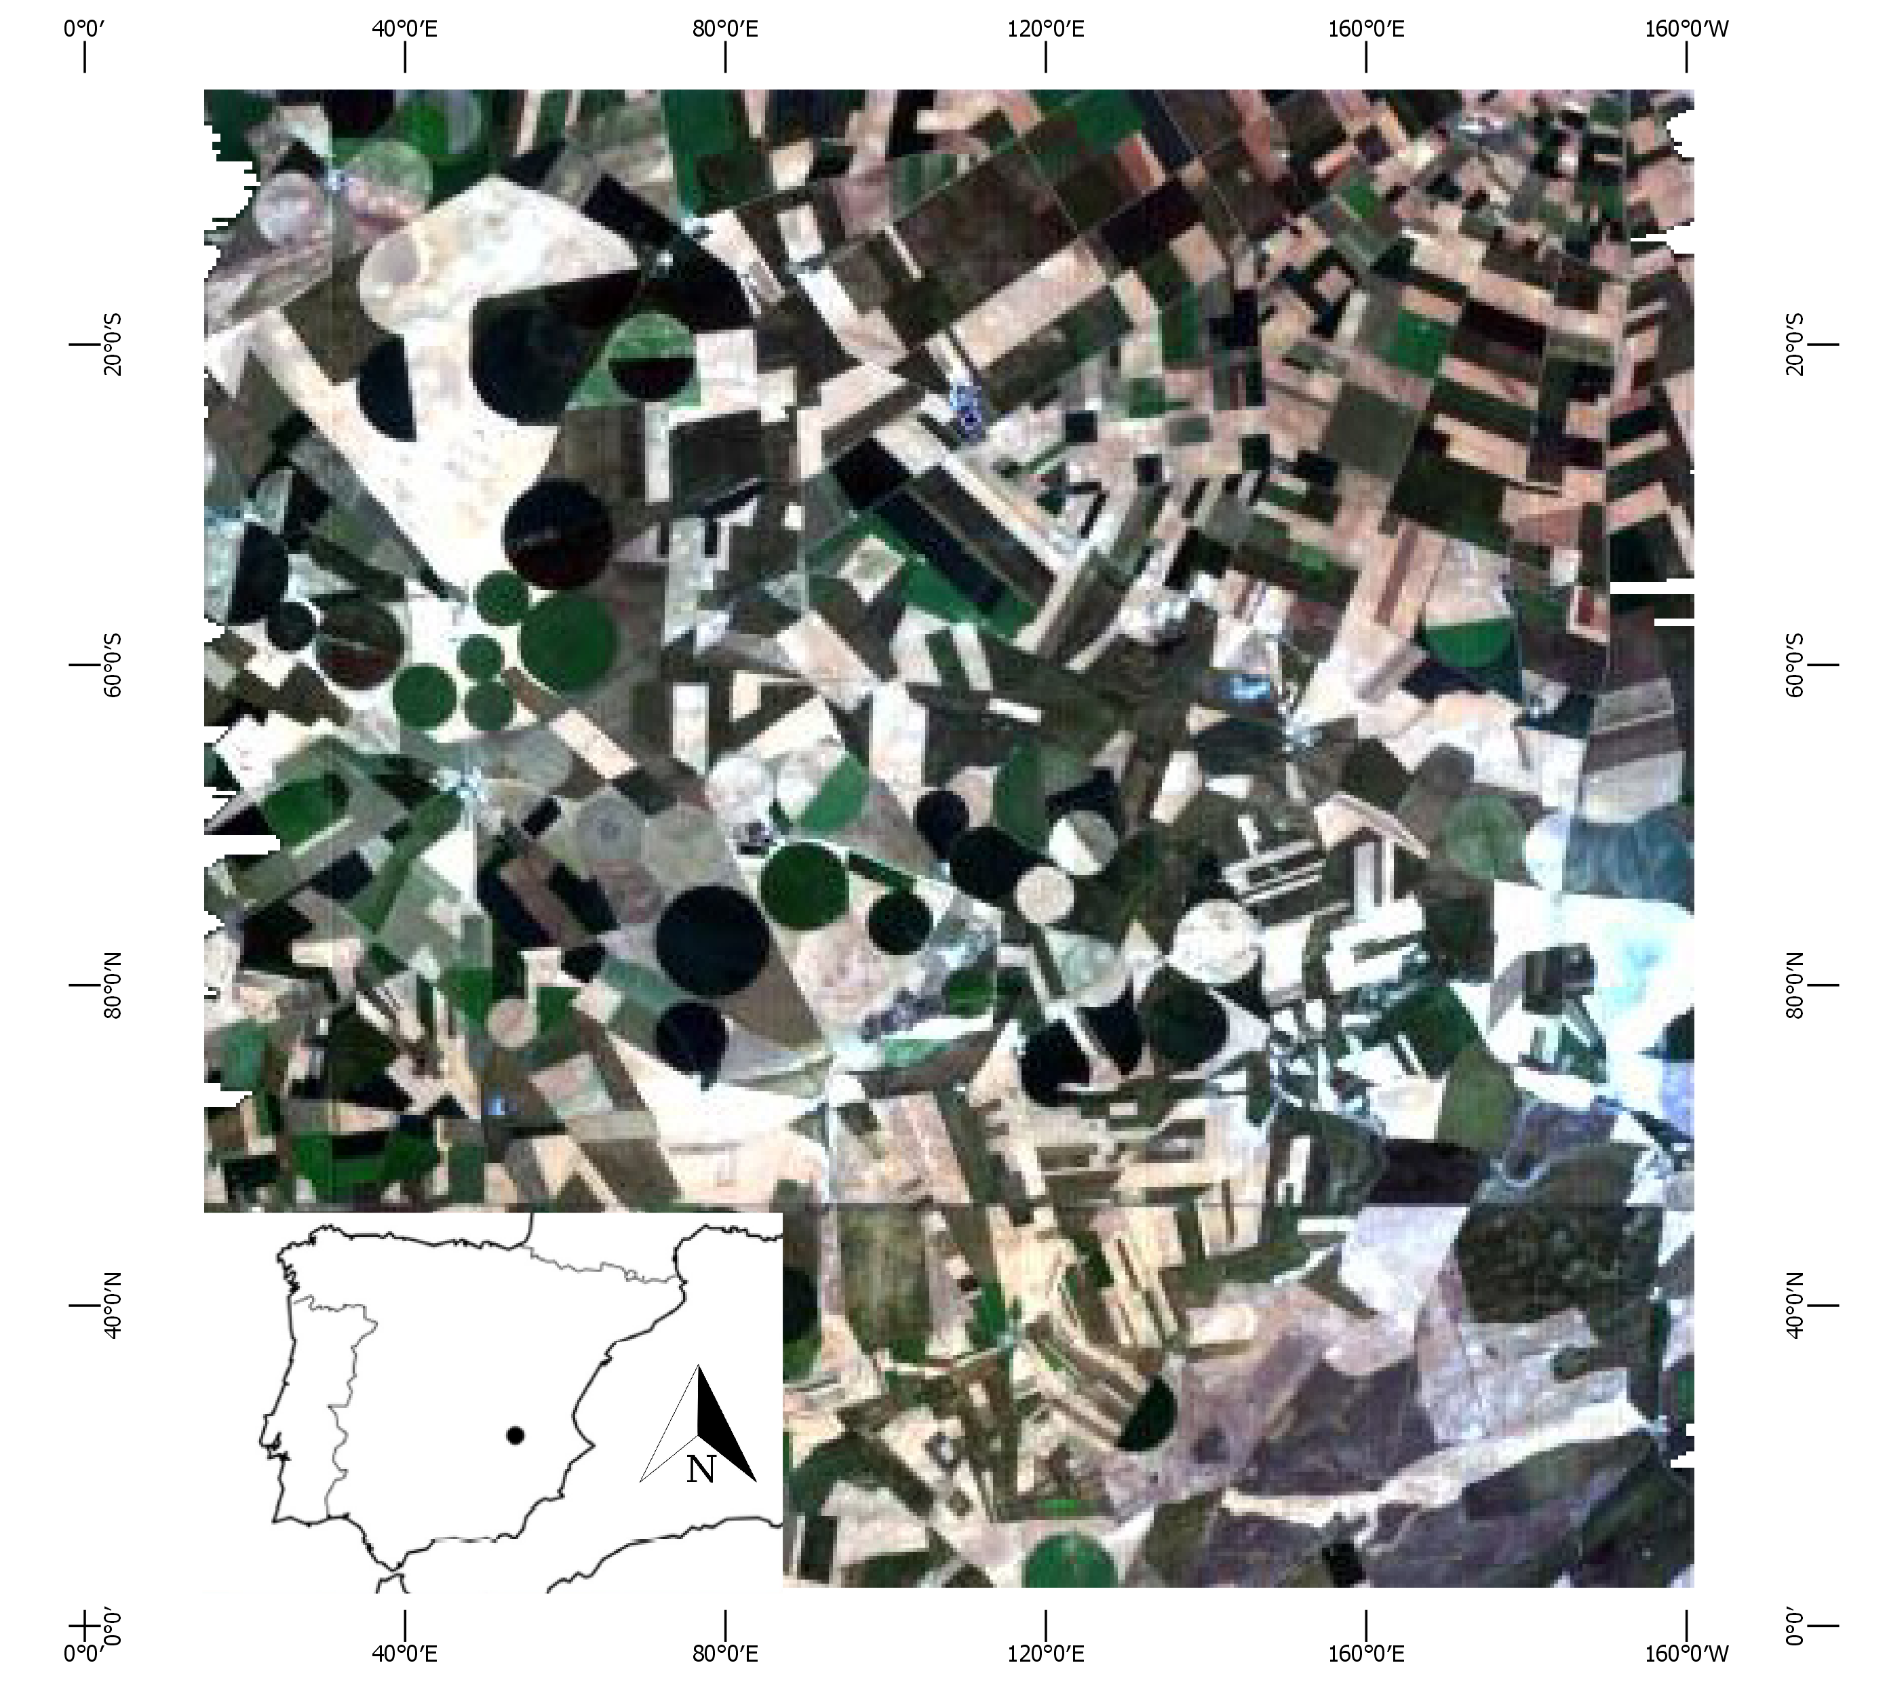
Figure 17: Location of Las Tiesas site in Barrax, Spain

The site is characterised by a flat morphology and large uniform land use units, surrounded by large areas of cereal crops. There is only a 2 m difference in elevation across the entire site. The climate is typical of the Mediterranean environment: high precipitation in spring and autumn, and minimal precipitation it the summer. The mean annual precipitation is approximately 400 mm. The region has high thermal oscillations during all seasons. Castilla-La-Mancha represents one of the driest regions in Europe, consisting of approximately 65% dry and 35% irrigated land. The site has good accessibility, reducing difficulties that could arise during the logistical stages of the campaign.
The Alfalfa field was selected for a number of reasons: its wide diameter (1 km), allowing sufficient samples and coverage for Sentinel-2 and Proba-V; for its homogeneity; and for the moderate canopy height (less than about 1 m).

Field sampling strategy

An initial analysis of the alfalfa field was conducted using Sentinel-2 MSI images acquired during the campaign dates in the previous year (2017), and it indicated that within this field, a minimum area of 200 m x 200 m had to be covered. For this reason the sampling strategy involved allocating ten sampling locations to that area of interest according to the pattern shown in Figure 18: four sampling locations covered the corners, a further four sampling locations form a smaller box inside, the remaining two sampling locations were equidistant inside that and all the locations were at least 50 m from the edges in order to minimise edge effects.
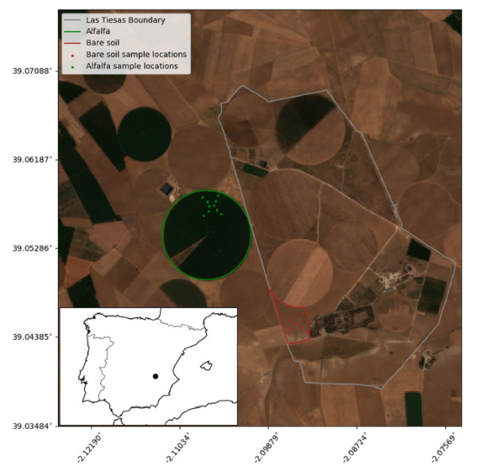
Figure 18: The location of the field campaign with sample points shown. Las Tiesas farm boundary shown in grey, with the boundaries and sample points of the Alfalfa and bare soil shown in green and red, respectively [49]
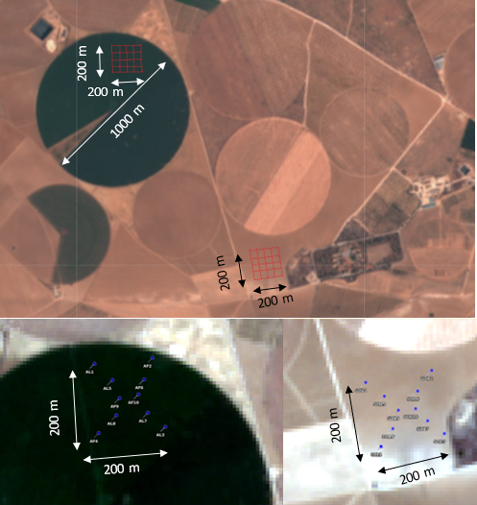
Figure 19: Distribution of sampling locations for surface reflectance measurements within the selected alfalfa (top and bottom left) and bare soil fields (lower and bottom right) at Barrax – Las Tiesas[6]

In order to minimise the change in solar zenith angle the measurement window covered a temporal range of no more than 30 minutes either side of the Sentinel-2A overpass [49].
The measurement sequence at each location involved a sequence of six individual measurements (one of the reference panel, four of the surface, and another of the reference panel). Each individual measurement was made up of ten scans which provides ten spectra. In total, sixty scans were collected per location [49].

Timing of field data collection

A meeting was proposed to discuss forecasts some days prior to the departure date to take into account the short-term forecasts from a) an ensemble of models and b) from the national weather forecaster (e.g. the Met Office in the United Kingdom), together with a more general assessment of the medium-term conditions (such as the movement and likely projection of low- and high-pressure systems). Table 5 provides a summary of the cloud-free Sentinel-2 MSI imagery available for Las Tiesas, which was used in order to assess the suitability of the site.
Table 5: Cloud-free availability of Sentinel-2 MSI data over the site (green colour scale represents the minimum to maximum number of available scenes)
 | Number of scenes with <10% cloud cover over a 3 km x 3 km area
 | 2017 |  |  |  |  |  | 2018
Site | A | S | O | N | D |  | J | F | M | A | M | J | J
Barrax - Las Tiesas | 10 | 11 | 7 | 11 | 8 |  | 8 | 8 | 4 | 6 | 8 | 10 | 12

Field data uncertainty propagation

The field data processing combined several data sources including the ASD binary files, multi-angular/spectral panel characterisation data, hyperspectral panel calibration and spectral/diffuse direct ratios. Therefore, an uncertainty propagation methodology was chosen, following the approach proposed by [50], which allowed the final in situ surface reflectance uncertainty to be produced. This involved producing a measurement function that accounts for as many sources of uncertainty as is feasible, as well as correlation. It attempts to explicitly account for all processes that influence the output value. General descriptions about field data uncertainty and uncertainty propagation may be found in the FRM4Veg Validation Methodology SR document and in the FRM4Veg Overview document.

