|  |  |
| --- | --- |
|  | **Technical Handbooks of FRM4VEG Instrumentation**  **(TR-1): Konica Minolta SPAD-502 Chlorophyll Meter**  version 1.0  National Physical Laboratory  University of Southampton  EOLAB  28 May 2020 |
| [Related image](https://www.google.co.uk/url?sa=i&rct=j&q=&esrc=s&source=images&cd=&cad=rja&uact=8&ved=0ahUKEwjRx6alu5PYAhXL1xQKHcWbBx4QjRwIBw&url=https://www.bodet.co.uk/news/269-the-national-physical-laboratory-selects-bodet-to-provide-a-wireless-time-solution.html&psig=AOvVaw3HTJAk3pVRL7SYyC5vdX23&ust=1513683146214264) | This document was produced as part of the ESA-funded project “Fiducial Reference Measurements for Vegetation Phase 2 (FRM4VEG 2)” under ESA contract number: 4000129823/20/I-NS |

##### Authors

|  |  |  |  |
| --- | --- | --- | --- |
|  | **Name** | **Organisation** | **Date** |
| **Written by** | Luke Brown | University of Southampton | 28/05/2020 |
|  | Niall Origo | NPL |  |
|  | Rosalinda Morrone | NPL |  |
|  | Joanne Nightingale | NPL |  |
| **Reviewed by (consortium)** |  |  |  |
| **Approved by (ESA)** |  |  |  |

##### Version History

|  |  |  |
| --- | --- | --- |
| **Version** | **Date** | **Publicly available or private to consortium** |
| 1.0 | 28/05/2020 | Private Consortium |

##### Table of Contents

Authors 1

Version History 1

Table of Contents 2

List of Figures 2

List of Tables 2

Acronyms 3

1 Introduction 4

1.1 Purpose and Scope 4

2 Technical Description 5

2.1 Overview 5

2.2 Theory of Operation 6

3 Calibration History and Uncertainty Budget 8

3.1 Uncertainty Budget 8

4 Instrument Operation 9

4.1 Calibration 9

4.2 Performing a Measurement 9

4.3 Using the Depth Stop 10

4.4 Sampling Strategy 10

5 Care and Storage 12

6 Troubleshooting 13

A Appendix 14

A.1 Log Sheet 14

7 Applicable and Reference Documents 15

##### List of Figures

Figure 1: Breakdown of parts of the SPAD-502 [1]. 6

Figure 2: Performing a measurement of a garlic leaf with the SPAD-502. 10

##### List of Tables

Table 1: Technical characteristics of the Konica Minolta SPAD-502 chlorophyll meter [1]. 5

Table 2: SPAD-502 uncertainty budget. 8

Table 3: Reasons and solutions to common problems with the SPAD-502 chlorophyll meter [1]. 13

##### Acronyms

|  |  |
| --- | --- |
| **Abbreviation** | **Stands for** |
| DMF | Dimethyl-formamide |
| DMSO | Dimethyl-sulphoxide |
| ESA | European Space Agency |
| FRM4VEG | Fiducial Reference Measurements for Vegetation |
| LCD | Liquid crystal display |
| LED | Light emitting diode |
| SPAD | Special Products Analysis Division |

# Introduction

## Purpose and Scope

This document forms part of deliverable D-60 of the European Space Agency (ESA) project ‘Fiducial Reference Measurements for Vegetation (FRM4VEG)’ and it should be used as a guide to operating the Konica-Minolta SPAD-502 chlorophyll meter. Its purpose is to provide an instrument technical description, together with information about maintenance and calibration history, pre-deployment uncertainties estimates, and steps required to achieve the FRM status.

The document is organized into 7 key sections:

* **Section 1** provides a summary of the document.
* **Section 2** overviews the technical characteristics of the instrument together with a description of its functioning.
* **Section 3** provides the uncertainty budget as provided by the manufacturer.
* **Section 4** describes all the procedures that need to be followed when using the instrument, together with the calibration that is required each time the instrument is switched on.
* **Section 5** lists useful advices for care and storage of the camera as provided by the manufacturer.
* **Section 6** lists the reasons for and solutions to common problems with the use of the instrument.
* **Appendix A:** provides the log sheet for recording the measurements in the field.

# Technical Description

## Overview

The Konica-Minolta SPAD-502 is a compact handheld instrument designed by the Special Products Analysis Division (SPAD) to quickly and non-destructively provide a relative measure of leaf chlorophyll concentration (LCC). The instrument is water resistant and can be used in a variety of environmental conditions, and its measurement area of 2 mm x 3 mm enables even small leaves to be measured. Technical characteristics of the instrument provided by the manufacturer are detailed in Table 1.

Table 1: Technical characteristics of the Konica Minolta SPAD-502 chlorophyll meter [1].

|  |  |
| --- | --- |
| **Characteristic** | **Details** |
| Type | Handheld meter for measuring chlorophyll |
| Measurement sample | Plant leaves |
| Measurement principle | Optical density difference at two wavelengths |
| Measurement area | 2 mm x 3 mm |
| Maximum sample thickness | 1.2 mm |
| Insertion depth | 12 mm maximum, depth stop adjustable to depths between 0 mm and 6 mm |
| Light source | 2 light emitting diodes (LEDs) |
| Receptor | 1 silicone photodiode |
| Display | Liquid crystal display (LCD) panel showing 3-digit measurement value (-9.9 to 9.99 in 0.1-unit steps; 100 to 199 in 1-unit steps) and 2-digit data number |
| Data memory | Space for 30 samples |
| Controls | Power switch  AVERAGE key: calculates average of all data in memory  ALL DATA CLEAR key: deletes all data in memory  DATA RECALL key: recalls data for previous data number  1 DATA DELETE key: deletes displayed data  Measurements automatically taken when measuring head is closed |
| Power source | 2 AA-size 1.5 V alkaline-manganese or carbon-zinc batteries |
|  | More than 20,000 measurements per set of 2 alkaline-manganese batteries |
|  | Less than 2 seconds |
| Accuracy | Within ± 1 SPAD unit (at room temperature for SPAD values between 0 and 50.0; SPAD values of greater than 50.0 may be less accurate and will cause decimal point of display to blink; for SPAD values more than 99.9, no decimal point will appear). |
| Repeatability | Within ± 0.3 SPAD units (for SPAD values of between 0 and 50.0) |
| Reproducibility | Within ± 0.5 SPAD units (for SPAD values of between 0 and 50.0) |
| Temperature drift | Less than ± 0.04 SPAD units per ° C |
| Other | Buzzer (single beep for measurement complete, series of beeps for error); function for inputting compensation value |
| Dimensions (L x W x D) | 164 mm x 78 mm x 49 mm |
| Weight | 225 g (without batteries) |
| Standard accessories | Sliding depth stop; carrying strap; soft case; 2 AA-size batteries; reading checker |

## Theory of Operation

The SPAD-502 consists of a measuring head containing a photodiode detector and two light emitting diodes (LEDs) with peak wavelengths of 650 nm and 940 nm. When the measuring head is closed on a leaf, electromagnetic radiation is emitted from each of the two LED in sequence, passing from the emitting window, through the leaf and onto the photodiode detector within the receiving window (Figure 1).

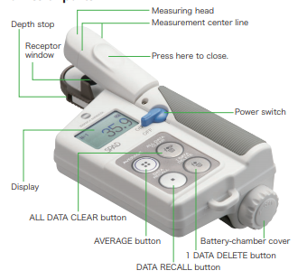

Figure 1: Breakdown of parts of the SPAD-502 [1].

From measurements of transmittance at 650 nm and 940 nm, a relative value proportional to LCC is calculated as

$$M=k\log{\frac{I_{0\left(650\right)}I_{(940)}}{I_{(650)}I_{0(940)}}}+C$$

where $I_{(650)}$, $I_{(940)}$, $I_{0\left(650\right)}$ and $I_{0(940)}$ are the incident and transmitted electromagnetic radiation at 650 nm and 940 nm respectively, and $k$ and $C$ are confidential slope and offset coefficients undisclosed by the manufacturer [2].

LCC can be derived from the relative values provided by the SPAD-502 using species-specific calibration functions, which are established by placing a portion of the leaf in a solvent such as acetone, methanol, chloroform, dimethyl-ether, dimethyl-formamide (DMF) or dimethyl-sulphoxide (DMSO), facilitating pigment extraction. Once extracted, the concentrations of chlorophyll-a and –b can be determined spectrophotometrically [3] and related to those values provided by the instrument.

# Calibration History and Uncertainty Budget

## Uncertainty Budget

The instrument uncertainty budget was assembled by ‘Type B’ evaluation, based on information provided by the manufacturer, and is detailed in Table 2.

Table 2: SPAD-502 uncertainty budget.

|  |  |  |  |  |
| --- | --- | --- | --- | --- |
| **Source** | **U value** | **Unit** | **Distribution type** | **Divisor** |
| Accuracy | 1 | SPAD | Gaussian | 1 |
| Repeatability | 0.3 | SPAD | Gaussian | 1 |
| Reproducibility | 0.5 | SPAD | Gaussian | 1 |
| Resolution | 0.1 | SPAD | Rectangular | 1.73205081 |
| Temperature drift1 | 0.04 | SPAD | Gaussian | 1 |
| Total (Total) | 1.17615192 | SPAD |  |  |
| Total k=2 (Total) | 2.35230384 | SPAD |  |  |

1Per ° C.

# Instrument Operation

The following instrument operation instructions are adapted from those provided by the manufacturer [1]:

## Calibration

Calibration is required each time the instrument is switched on.

1. Turn the instrument on. The display will show ‘CAL’.
2. With no sample in the sample slot, press down the finger rest to close the measuring head. Keep it closed until a beep sounds and the display shows ‘---‘ to indicate successful calibration.
   1. If a series of beeps sound and the display shows ‘CAL’ blinking, calibration was not successful. Repeat step 2, making sure to keep the measuring head completely closed until calibration is finished.
   2. If ‘EU’ appears at the top of the display, the emitting and/or receiving windows may be dirty. Clean the windows as described in Section 5 and repeat step 2.

## Performing a Measurement

1. Insert the sample to be measured into the sample slot of the measuring head (Figure 1).
   1. The sample should completely cover the receiving window, and extremely thick parts of the leaf such as veins should be avoided.
   2. When using the instrument in direct sunlight, shade it with your body to prevent the sunlight from affecting the measurement.
2. Press on the finger rest to close the measuring head, and keep it closed until a beep sounds and the measured value appears on the display. The measurement will be stored in memory (Figure 2).
   1. If a series of beeps sound and the display shows ‘---‘ blinking, the measurement was not successful. Repeat step 2, making sure to keep the measuring head completely closed until the measurement is finished.
   2. If the issue persists, the sample may be too thick or thin.
3. Record the measurement in the corresponding cell of the log sheet (Appendix A.1).
   1. Up to 30 measurements can be made and subsequently recalled, using the ‘DATA RECALL’ button.
   2. Although measurements from a given sampling location may be averaged on the instrument using the ‘AVERAGE’ button, it is preferable to record each individual measurement to enable sample statistics to be calculated and outlier removal procedure to be adopted at a later date.
   3. If a measurement was taken in error, it may be removed from memory using the ‘1 DATA DELETE’ button.

## Using the Depth Stop

A depth stop is included with the SPAD-502 to enable a consistent measurement position (Figure 1). It is particularly useful when measuring several points along small oblate leaves such as wheat or barley leaves.

1. The position of the depth stop is adjusted by pressing on both sides and sliding to the required position. It may be moved within 0 mm to 6 mm of the centre line.
   1. If not using the depth stop, it can be stored upside down on the measuring head, with the tabs facing downwards.

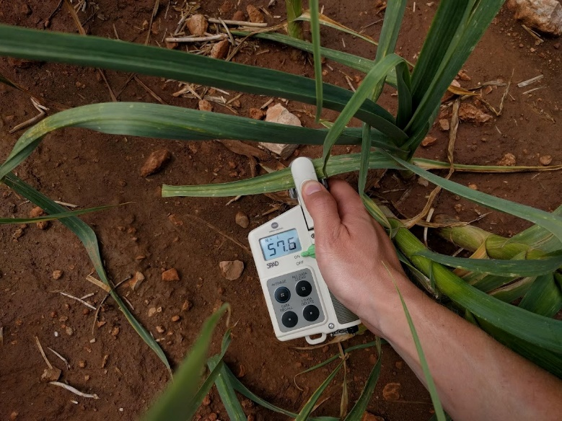

Figure 2: Performing a measurement of a garlic leaf with the SPAD-502.

## Sampling Strategy

To adequately represent LCC, multiple measurements should be taken to characterise its variability, both across the surface of individual leaves, and within the vertical profile of the canopy. The following sampling strategy is adopted within the FRM4VEG project:

1. At a given sampling location, three leaves should be measured. These should be from the top, middle and bottom of the canopy to represent vertical variations in LCC.
   1. For each leaf, six measurements should be made, each at a different location to represent variations in LCC across the leaf surface.

# Care and Storage

The following care and storage advice is adapted from that provided by the manufacturer [1]:

* The measuring head should be kept clean and dry at all times. The rubber seal should be examined periodically. It should be in good condition to ensure external illumination cannot enter the receiving window and influence the measurement.
* When dirty, the instrument may be wiped with a soft, clean, dry cloth. If extremely dirty, a damp cloth may be used to remove most of the dirt. Again, the instrument should then be wiped dry with a soft, clean, dry cloth.
* Alcohol or other chemicals should not be allowed to contact the instrument. Although the SPAD-502 is water resistant, it should not be immersed in or washed with water. If the instrument does get wet, it should be wiped dry.
* The instrument should not be subjected to strong shocks or vibrations, or left in direct sunlight or near other sources of heat. It should be stored at temperatures between - 20° C and 55° C, and should not be subjected to high humidity.
* If the instrument will be stored for more than two weeks, the batteries should be removed to prevent them from leaking and causing damage. A dehumidifying agent such as silica gel should be stored with the instrument.

# Troubleshooting

Reasons for and solutions to common problems with the SPAD-502 chlorophyll meter are provided by the manufacturer [1], and are listed in Table 3.

Table 3: Reasons and solutions to common problems with the SPAD-502 chlorophyll meter [1].

|  |  |  |
| --- | --- | --- |
| **Problem** | **Reason** | **Solution** |
| Power switch is on, but display is blank | Batteries are incorrectly installed | Install batteries correctly |
|  | Batteries are dead | Replace batteries with fresh ones |
| Measurements cannot be taken even if the measuring head is closed | Calibration has not been performed by closing the measuring head with no sample in the sample slot | Perform calibration |
| Measured values disappeared from memory | The instrument has been turned off | The memory is erased when the power switch is turned off |
| The measured value varies even though the same area of the leaf is measured | There is a drop of water or stain on or near the emitting or receiving windows of the measuring head | Wipe the emitting and receiving windows of the measuring head with a clean, soft, dry cloth |
|  | The sample leaf is positioned incorrectly | Position the leaf so that it is under the centre line and completely covers the receiving window |
|  | The leaf has many veins | When measuring leaves with many veins, the measured value may vary due to the veins; for best results, measure several areas of the same leaf and use the average value of these measurements |
|  | The measuring head has not been closed correctly or has been opened before the measurement is complete | Close the measuring head correctly and keep it completely closed until the measurement is complete (a beep will sound and the measured value will appear on the display) |
|  | Measurements are being made under direct sunlight | When measuring in direct sunlight, shade the instrument with your body to prevent the sunlight from affecting the measurements |

###### Appendix

Log Sheet



# Applicable and Reference Documents

[1] Minolta, *Chlorophyll Meter SPAD-502*. Osaka, Japan: Minolta.

[2] C. Parry, J. M. Blonquist, and B. Bugbee, “In situ measurement of leaf chlorophyll concentration: analysis of the optical/absolute relationship,” *Plant. Cell Environ.*, vol. 37, no. 11, pp. 2508–2520, Nov. 2014.

[3] A. R. Wellburn, “The Spectral Determination of Chlorophylls a and b, as well as Total Carotenoids, Using Various Solvents with Spectrophotometers of Different Resolution,” *J. Plant Physiol.*, vol. 144, no. 3, pp. 307–313, Sep. 1994.