Technical Handbooks of FRM4VEG Instrumentation
(TR-1): Headwall UAV

version 1.0

National Physical Laboratory
University of Southampton
EOLAB

28 May 2020
This document was produced as part of the ESA-funded project “Fiducial Reference Measurements for Vegetation Phase 2 (FRM4VEG 2)” under ESA contract number: 4000129823/20/I-NS

Authors

 | Name | Organisation | Date
Written by | Niall Origo | NPL | 28/05/2020
 | Rosalinda Morrone | NPL
 | Joanne Nightingale | NPL
Reviewed by (consortium)
Approved by (ESA)

Version History

Version | Date | Publicly available or private to consortium
1.0 | 28/05/2020 | Private Consortium

Table of Contents

Authors 1
Version History 1
Table of Contents 2
List of figures 3
List of tables 3
Acronyms 3
1 Introduction 4
1.2 Purpose and Scope 4
2 Technical Description 5
2.1 Overview 5
2.2 Theory of Operation 9
3 Calibration History and Uncertainty Budget 11
3.1 Calibration History 11
3.2 Uncertainty Budget 11
4 Instrument Operation 11
4.1 Instrument Setup 11
4.2 Performing a Measurement 11
5 Care and Storage 12
A Appendix 13
A.1 Calibration Report 13
6 Applicable and Reference Documents 13

List of figures

Figure 1: Headwall VNIW-SWIR Co-Aligned + Internal Data Storage + GPS/IMU + LiDAR [1] 9
Figure 2: Trimble AP15 GNSS-inertial system circuit board [3] 10
Figure 3: Puck Lite Velodyne LiDAR [2] 11

List of tables

Table 1: Technical characteristics of the Hyperspectral Co-Aligned VNIR/SWIR Airborne Sensor with DJI Matrice 600 Pro [1] 6
Table 2: Technical characteristics of Light weight Real-Time 3D LiDAR Sensor [2] 6
Table 3: Technical characteristics of the Trimble AP15 GNSS-Inertial System [3] 7

Acronyms

Abbreviation | Stands For
CMOS | Complementary metal-oxide semiconductor
DEM | Digital Elevation Model
ESA | European Space Agency
FRM4VEG | Fiducial Reference Measurements for Vegetation
GNSS | Global Navigation Satellite System
GPS | Global positioning system
IMU | Inertial Measurement Unit
LIDAR | Light detection and ranging
MEMS | Micro Electro-Mechanical Systems
MCT | Mercury Cadmium Telluride
OEM | Original Equipment Manufacturer
SWIR | Short Wave Infrared
UAV | Unmanned Aerial Vehicle
VNIR | Visible and Near Infrared

Introduction

Purpose and Scope

This document forms part of deliverable D-60 of the European Space Agency (ESA) project ‘Fiducial Reference Measurements for Vegetation (FRM4VEG)’ and it should be used as a guide to operate the Headwall UAV. Its purpose is to provide an instrument technical description, together with information about maintenance and calibration history, pre-deployment uncertainties estimates, and steps required to achieve the FRM status.
The document is organized into …. key sections:
- Section 1 provides a summary of the document.
- Section 2 overviews the technical characteristics of the UAV together with a description of its functioning.
- Section 3 …..
- Section 4 ….
- Section 5 ….
- Section 6 …

Technical Description

Overview

The Headwall Hyperspectral Co-Aligned VNIR/SWIR Sensor is designed for airborne or ground based hyperspectral imaging. As the smallest and lightest instrument in its class, the sensor can be purchased as part of a flight-tested, integrated turnkey system with a DJI Matrice 600 Pro UAV and combined with two other instruments that can play crucial roles in ensuring the quality of the collected data[1]:
- A global-positioning system combined with an inertial measurement unit (GPS/IMU), that keeps track of the geographical coordinates during flight and is a key source of data during post-processing of the images.
- A LiDAR, which uses pulsed lasers to measure the distance from the UAV to the ground
Key features of the Headwall Hyperspectral Co-Aligned VNIR/SWIR Sensor with DJI Matrice 600 PRO[1]:
    - Smallest and lightest instrument in its class
    - 400 – 2500 nm wavelength range
    - Dual VNIR & SWIR sensors with co-aligned pixels
    - 640 spatial pixels / 270 VNIR and 260 SWIR spectral pixels
    - Factory data tested and flight ready
    - Integrated high performance GPS/IMU
    - Solid state internal data storage
    - 16-channel LiDAR

Table 1: Technical characteristics of the Hyperspectral Co-Aligned VNIR/SWIR Airborne Sensor with DJI Matrice 600 Pro [1]
Characteristic | Details
Spectral range (nm) | VNIR (400-1000) SWIR (900-2500)
Spectrograph design | High throughput aberration-corrected concentric imager
Spectral pixels | 270 267
Spatial pixels | 640
Detector pixel pitch (μ) | 7.4 15
Dispersion per Pixel (nm/pixel) | 2.2 6
FWHM Slit Image (nm) | 6 10
F/# | 2.5
Slit width (μ) | 20
Slit length (mm) | 6 10.4
Camera technology | CMOS Stirling-cooled MCT
Max frame rate (Hz) | 350 200
Bit depth | 12 16
Size (inches / mm) | 10.7 x 8.3 x 6.5 / 272 x 211 x 154
Weight / Weight including LiDAR (kg) | 2.83 / 3.63
Data storage | Internal solid-state drive: 480 GB per sensor
IO connectivity | GigE
GPS/IMU | Integrated High-Performance model
Mounting Options | UAV hard mount / Field Rotary Kit (sold separately)
LiDAR (16-channel) | Optional for UAV configurations
Power requirement Typical / Max (W) | 26 / 30
Operational temperature range (ºC) | 0- 40
Storage temperature range (ºC) | -30-60

Table 2: Technical characteristics of Light weight Real-Time 3D LiDAR Sensor [2]
Characteristic | Details
Sensor  Time of Flight Distance Measurement with Calibrated Reflectivities  Channels  Measurement Range  Accuracy  Returns (Strongest, Last)  Field of View (Vertical)  Angular Resolution (Vertical)  Field of View (Horizontal)  Angular Resolution (Horizontal/Azimuth)  Rotation Rate  Integrated Web Server for Easy Monitoring and Configuration  Laser  Laser Product Classification  Wavelength  Beam Size @ Screen  Beam Divergence Horizontal  Mechanical/Electrical/Operational  Power Consumption  Operating Voltage  Weight  Dimensions  Shock  Vibration  Environmental Protection  Operating Temperature  Storage Temperature  Output  3D LiDAR Data Points Generated:  100 Mbps Ethernet Connection  UDP Packets C  GPS | 16  Up to 100 m  ±3 cm (Typical)  Single and Dual  +15.0° to -15.0° (30°)  2.0°  360°  0.1° – 0.4°  5 Hz – 20 Hz  Class 1 Eye-safe per IEC 60825-1:2007 & 2014  903 nm  12.7 mm (Horizontal) x 9.5 mm (Vertical)  0.18° (3.0 mrad); Vertical: 0.07° (1.2 mrad)  8W  9 V – 18 V  590 g (without Cabling and Interface Box)  103 mm Diameter x 72 mm Height  500 m/s² Amplitude, 11 ms Duration  5 Hz to 2,000 Hz, 3 G_{rms}  IP67  -10°C to +60°C  -40°C to +105°C  - Single Return Mode: ~300,000 points per second  - Dual Return Mode: ~600,000 points per second  - Time of Flight Distance Measurement  - Calibrated Reflectivity Measurement  - Rotation Angles  - Synchronized Time Stamps (μs resolution)  GPRMC NMEA Sentence from GPS Receiver (GPS not included)

Table 3: Technical characteristics of the Trimble AP15 GNSS-Inertial System [3]
Characteristic | Details
Advanced Applainix In-Fusion GNSS-Inertial integration  Solid-State MEMS IMU with Applanix SmartCall  Advanced Trimble Maxwell 6 Custom GNSS survey (two chipsets)  220 channels per chipsets | GPS: simultaneous L1 C/A, L2C, L2E, L5  GLONASS: simultaneous L1 C/A, L2 C/A, L2 P, L3 CDMA  BeiDou: B1, B2  Galileo: simultaneous L1 BOC, E5A, E5B, E5AItBOC  TZSS: L1 C/A, L1 SAIF, L2C, L5  SBAS: simultaneous L1 C/A, L5  L-Band: OmniSTAR VBS, HP, XP and G2, Trimble CenterPoint RTX
High precision multiple correlator for GNSS pseudo range measurements  Unfiltered, unsmoothed pseudo range measurements data for low noise, low multipath error, low time domain correlation and high dynamic response  Very low noise GNSS carrier phase measurements with <1 mm precision in a 1 Hz bandwidth  Proven Trimble low elevation tracking technology  Two antenna heading aiding (GNSS Azimuth Measurement System)  Support for optional Distance Measurement Indicator Input  Support for optional POSPac Mobile Mapping Suite post-processing software  No export permit required  Size  Weight  Power  Connectors (with connector board)  Connectors (with connector board) | 130 L x 100 W x 39 H mm (nominal)  130 L x 100 W x 43 H mm (with optional connector board)  0.28 (nominal), 0.38 kg (with optional connector board)  10-28 Volts DC, 20 Watts (max, with GAMS Option)  I/O: Samtec QSH/060-01-L-D-DP-A-RT1  Power: Samtec IPBT-103-H2-X-D-3
Temperature  IMU  Range  Temperature  Power  Size  Weight | -40 degC to +75 degC(Operational)  -55 degC +86 degC (Storage)  +/- 6g, +/- 350 dps  -20 / +55 C  +4.5 / -16Vdc, 1 W (max)  43L x 47 W x 12 H mm  0.015 kg

Theory of Operation

Combining visible, near infrared (VNIR) and shortwave infrared (SWIR) sensors into one package, the VNIR-SWIR camera from Headwall Photonics can collect wideband hyperspectral data from 400-2500 nm using one instrument. The VNIR sensor is a CMOS image sensor sensitive in the 400 – 1000 nm range, while featuring a pixel pitch of 7.4 µm and a maximum frame rate of 330 fps. The SWIR sensor is a Stirling-cooled MCT detector that is sensitive in the 900-2500 nm range and features a pixel pitch of 15 µm while being able to reach >100 fps. Pixels from each sensor are co-registered through software, making the collected data truly aligned during post-processing. [1]
Headwall’s VNIR-SWIR imaging sensor leverages a patented aberration-corrected design that provides very high spectral and spatial resolution with stable measurement accuracy. The dual hyperspectral sensors do not exhibit image aberrations such as stray light, optical distortions or thermal instabilities. Along with aberration-corrected imaging, the Hyperspectral VNIR-SWIR Sensor package offers a wide field of view and high signal-to-noise performance.

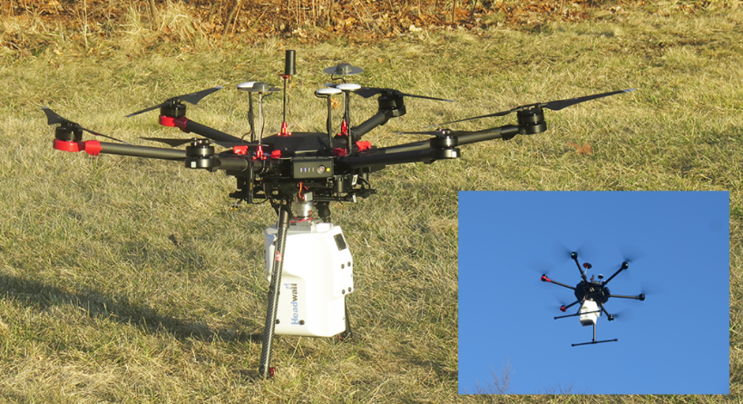
Figure 1: Headwall VNIW-SWIR Co-Aligned + Internal Data Storage + GPS/IMU + LiDAR [1]

The GPS keeps track of the UAV’s location while the IMU accounts for the effects of roll, pitch and yaw experienced during the flight. The GPS collects data on latitude, longitude, and altitude of the craft while aloft. To accurately calculate the size of each pixel in the image as projected on the ground, elevation of the ground relative to the centre of the earth is needed as well. Elevation as function of latitude and longitude can be stored in a Digital Elevation Model (DEM), while LiDAR data can be used to create an accurate DEM. The quality of the point-cloud data captured from the integrated LiDAR

systems differ depending on whether you are using theStandard or High-performance GPS/IMU. In addition to affecting LiDAR data, inaccuracies in GPS/IMU data result in image distortions that impact the ortho-mosaicking of flight-swath images.
Trimble AP15 GNSS-Inertial Sytems[3] is an embedded GNSS-Inertial OEM board set plus Inertial Measurement Uni, in a compact form factor. It is designed to give system integrators the ability to harness the best in GNSS multi-frequency positioning technology, with the superior capabilities of inertial data of continuous mobile positioning in poor signal environments, and for the orientation of imaging sensors.
GNSS key features[3]:
- Centimetre level mobile positioning accuracy
- Industry leading continuous positioning performance in GNSS denied environments
- Full position and orientation solution for direct georeferencing of remote sensing instruments
- High performance GNSS two antenna heading aiding from single receiver
- Solid-state, purpose built-compact MEMS IMU featuring Applanix SmartCall compensation technology.
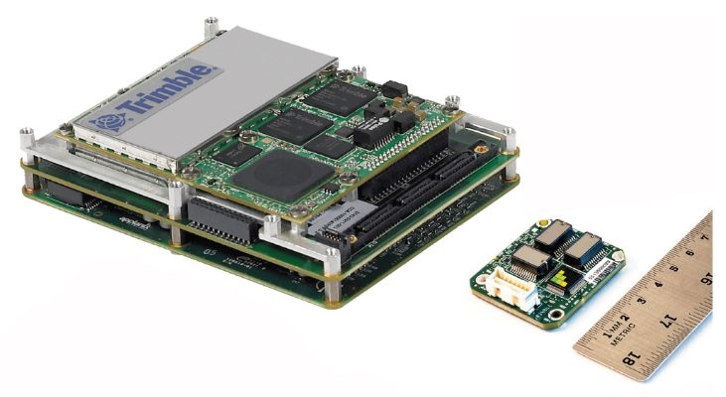
Figure 2: Trimble AP15 GNSS-inertial system circuit board [3]

Velodyane LiDAR’s Puck LITE [2] is a lighter weight version of the VLP-16 Puck for applications that have lower weight requirements. It has a 360° surround view to capture real-time 3D LiDAR data that includes distance and calibrated reflectivity measurements. It has a range of 100 m width dual return mode to capture greater detail in the 3D image while the power consumption is approximately 8W. A compact footprint and an industry leading weight of 590 g for LiDAR sensor with high resolution makes it ideal for UAV/drone and mobile applications in the areas of 3D mapping/imaging, inspection and navigation.

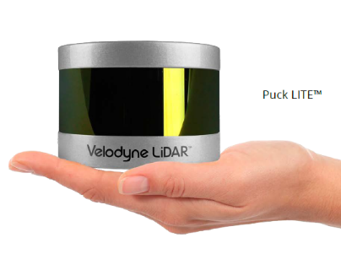
Figure 3: Puck Lite Velodyne LiDAR [2]

Calibration History and Uncertainty Budget

Calibration History

Uncertainty Budget

Instrument Operation

Instrument Setup

Performing a Measurement

Care and Storage

Appendix

Calibration Report

Applicable and Reference Documents

[1] Headwall Photonics, “Hyperspec Co-Aligned VNIR / SWIR Airborne Sensor with DJI Matrice 600 Pro: Product Data Sheet”, Bolton, Massachusetts, 2019.
[2] Velodyne LiDAR, “Puck LITE, Light Weight Real-Time 3D LiDAR Sensor”, Morgan Hill, CA, 2016.
[3] Trimble Applanix, “Trimble AP15 Datasheet”, Richmond Hill, Ontario, 2016.

