Technical Handbooks of FRM4VEG Instrumentation
(TR-1): AccuPAR PAR/LAI Ceptometer LP-80
version 1.0

National Physical Laboratory
University of Southampton
EOLAB

28 May 2020
This document was produced as part of the ESA-funded project “Fiducial Reference Measurements for Vegetation Phase 2 (FRM4VEG 2)” under ESA contract number: 4000129823/20/I-NS

Authors

 | Name | Organisation | Date
Written by | Niall Origo | NPL | 28/05/2020
 | Rosalinda Morrone | NPL
 | Joanne Nightingale | NPL
Reviewed by (consortium)
Approved by (ESA)

Version History

Version | Date | Publicly available or private to consortium
1.0 | 28/05/2020 | Private Consortium

Table of Contents

Authors 1
Version History 1
Table of Contents 2
List of Figures 3
List of Tables 3
2 Acronyms 3
1 Introduction 4
1.1 Purpose and Scope 4
2 Technical Description 4
2.1 Overview 4
2.2 Theory of Operation 5
3 Calibration History and Uncertainty Budget 6
4 Instrument Operation 6
4.1 Turning on the instrument 6
4.2 Taking Measurements 7
4.3 Download 8
4.4 Calibration 9
5 Care and Storage 10
6 Troubleshooting 11
A Appendix 14
7 Applicable and Reference Documents 14

List of Figures

Figure 1: AccuPAR LP-80 Features [1] 6
Figure 2: PAR data return screenshot [1] 7
Figure 3: PAR display [1] 7

List of Tables

Table 1: Technical Characteristics of the AccuPAR LP-8[1] 5
Table 2: : Reasons and solutions to common problems with the AccuPAR LP-80 [1] 11

Acronyms

Abbreviation | Stands for
ESA | European Space Agency
FRM4VEG | Fiducial Reference Measurements for Vegetation
LAI | Leaf Area Index
LCD | Liquid-crystal Display
PAR | Photosynthetically Active Radiation

Introduction

Purpose and Scope

This document forms part of deliverable D-60 of the European Space Agency (ESA) project ‘Fiducial Reference Measurements for Vegetation (FRM4VEG)’ and it should be used as a guide to operating the Decagon AccuPAR LP-80. Its purpose is to provide an instrument technical description, together with information about maintenance and calibration history, pre-deployment uncertainties estimates, and steps required to achieve the FRM status.
The document is organized into 7 key sections:
- Section 1 provides a summary of the document.
- Section 2 overviews the technical characteristics of the instrument together with a description of its functioning.
- Section 3 ….
- Section 4 describes the procedures that need to be followed when using the instrument.
- Section 5 lists useful advices for care and storage of the camera as provided by the manufacturer.
- Section 6 lists the reasons for and solutions to common problems with the use of the instrument.
- Appendix A: …

Technical Description

Overview

The AccuPAR model LP-80 PAR/LAI Ceptometer measures Photosynthetically Active Radiation (PAR). It is a menu-driven, battery-operated linear PAR ceptometer, used to measure light interception in plant canopies, and to calculate Leaf Area Index (LAI) by inverting the PAR readings [1].

Table 1: Technical Characteristics of the AccuPAR LP-8[1]
Characteristic | Details
Operating Environment  Probe length  Number of sensors  Overall length  Probe cross-section  Micro Controller Dimensions  Par Range  Resolution  Minimum spatial resolution  Data storage capacity  Unattended logging interval  Instrument weight (w/batteries)  Data retrieval  Keypad  Clock  Interface cable  Power  External PAR sensor connector | 0 ◦ to 50◦ C (32◦ − 122◦ F) 0 to 100% relative humidity  86.5 cm  80  102 cm (40.25 in)  19 cm x 9.5 cm (.75 x .375 in)  15.8 x 9.5 x 3.3 cm (6.2 x 3.75 x 1.3 in)  0 to 2,500 µmol m−2 s −1  1 µmol m−2 s −1  1 cm  1 MB Flash  User selectable, between 1 and 60 min  0.55 kg (1.21 lbs)  direct via RS-232  7-Key menu-driven  24-hour ±1 minute per month  RS-232 cable  Four AAA Alkaline cells  Locking 5-pin sealed circular connector

Theory of Operation

The instrument consists of an integrated microprocessor-driven data logger and probe. The probe contains 80 independent sensors, spaced 1 cm apart. The photosensors measure PAR in the 400 to 700 nm waveband. The AccuPAR displays PAR in units of micromoles per meter squared per second. The instrument is capable of hand-held or unattended measurement.
It can be operated in environments with temperatures from 0 to 50 ◦ C, and in relative humidities of up to 100%. The instrument ships with an RS-232 interface cable to allow for downloading data to a computer, an external PAR sensor to allow for calibration, and simultaneous above and below canopy PAR measurements. [1]
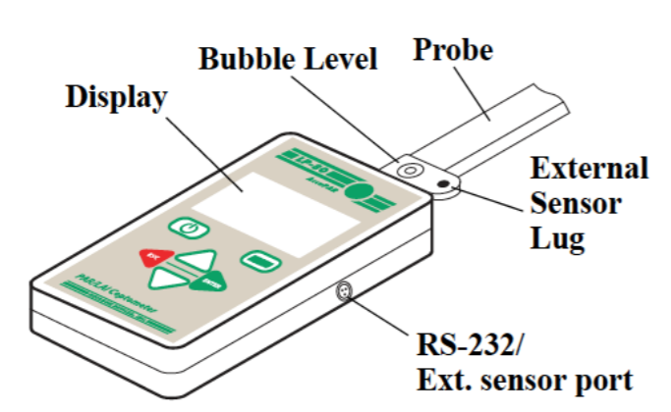
Figure 1: AccuPAR LP-80 Features [1]

Calibration History and Uncertainty Budget

Instrument Operation

The following instrument operation instructions are adapted from those provided by the manufacturer [1].

Turning on the instrument

When first turn on the instrument, it will be in the PAR sampling menu, in which the real-time PAR data is displayed in the center portion of the screen. If the external PAR sensor is connected, its real-time PAR data are showed as well. At any time, it is possible to cycle between the four menus by pressing the MENU key. The menus are indicated by the tabs on the top of the screen, with the active menu in the foreground. If the battery is low, a low battery indicator will appear to the right of the menu tabs.
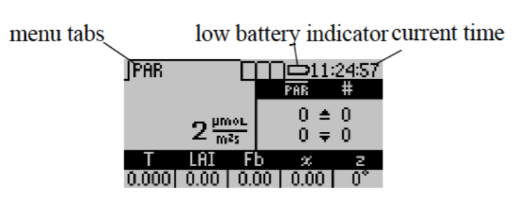
Figure 2: PAR data return screenshot [1]

The menu option showed in figure 2 is used for measurements with the AccuPAR. The screen indicated that the current real-time PAR level is 2 µmols/m² s and that the user did not take any above or below PAR measurements. If the external sensor is attached the real-time PAR value measured by external sensor will be also displayed above the real-time light bar PAR data. [1]

Taking Measurements

To make an above-canopy PAR measurement, press the up-arrow key in this menu. The resulting value will be displayed in the upper right section of the screen. To make measurements below the canopy, press the down-arrow key or the green circular key in the upper right corner of the keypad. An external sensor must be plugged in or an above canopy PAR reading must be taken first before summary data will update. The LP-80 recalculates summary data after each below canopy PAR reading. Other relevant data displays at the bottom of the screen.
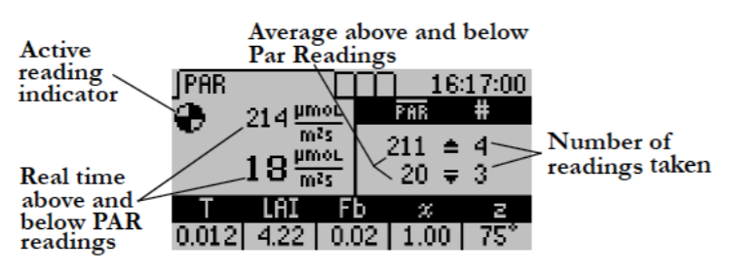
Figure 3: PAR display [1]

LP-80 updates and displays the current calculated Tau (τ ), LAI value, beam fraction (Fb), leaf distribution parameter (χ) and zenith angle (z) values are updated and displayed at the bottom of the screen with each subsequent below canopy PAR measurement. The LP-80 records both above and below canopy readings. Pressing ENTER brings up the Save screen which allows you to save as is, annotate, or discard. Pressing ESC discards the values. Both options clear the screen for new data. The values displayed at the bottom of the screen are dependent on how the instrument in the Setup menu is set up. With each above or below canopy measurement, a number appears to the right of the PAR value that indicates the number of completed measurements. The displayed PAR value reflects the sample average. The LP-80 made four above and three below canopy measurements in the previous PAR screen shot. Therefore, in the above sample screen, four above and three below canopy measurements have been made, so the average of the four above-canopy PAR values is 211 µmols, while the average of the three below-canopy values is 20 µmols.
To save a reading once above and below PAR data are taken, press ENTER. The Save Method screen appears. Three options at the Save Method screen are then available.
- Select “Save” and press ENTER to save the information. Data will be stored with the time and date measurements are taken.
- Select “Discard” and press ENTER to return to the main screen and start over with a new reading.
- Select “Annotate” and press ENTER to give data a file name or description. Selecting “Annotate” will cause the Annotate screen to appear.
Use the arrow keys to select a letter or number and press ENTER to move to the next character. Then keep pressing ENTER until the screen returns to the PAR menu.
The Data menu allows you to view, download, and erase the data that you store with the AccuPAR.

Download

The download option allows to download stored data to the computer via the RS-232 cable that came with the system. It is possible to download the data using the LP-80 Utility (free software included with the system), Windows Hyperterminal or any similar terminal software. If it is possible to use the LP-80 Utility, the terminal software can be used to transfer the data from your LP-80 to the computer.
The AccuPar LP-80 comes with the LP-80 Utility software which allows to download stored data to the computer via the RS-232 cable. Follow steps 1 through 9 to download data.
- Make sure the RS-232 serial cable is properly connected to the LP-80, and to a serial port on the computer, or to a USB-toserial adapter.
- Open the LP-80 Utility Program.
- Select the appropriate COM port from the drop-down menu on the main screen.
- Turn on your LP-80 by pressing the power button.
- Click the “Download” button in the lower left of the screen, or click File > Download Data.
- The “Save LP-80 Data” dialog box will appear.
- Name the file, and choose a format to save it in, and click Save. (For more information, see Data File Formats.)
- A progress bar will appear on the main screen.
- When the download is finished, it is possible to optionally erase the data on the LP-80.
Data files are saved in one of the following file formats:
- Excel (.xls): Saves the file as a workbook that can be directly opened using Microsoft Excel 97 or newer. The Excel format includes column headers by default. These are titles at the top of each column. These can be disabled by using the Preferences Menu.
- Tab Delimited Text (.txt): Saves the file in tab delimited format, where all values are separated with tabs.
- CSV (Comma Delimited) (.csv): Saves the file in comma delimited format, where all values are separated with commas.

Calibration

The LP-80 has a calibrated external PAR sensor that it uses for making simultaneous above and below canopy PAR measurements. The LP-80 also uses this sensor to calibrate the AccuPAR probe, ensuring that the PAR response between the external sensor and the probe are the same. When this option is selected, the Calibration screen appears. For best results, attach the external PAR sensor to the LP-80 by inserting the bolt attached to the external sensor through the hole in the bubble level. This will ensure that the sensor and probe are both level. The directions state to level the probe and sensor, however the AccuPAR can be also calibrated on a flat board or platform at an angle to get more direct light from the sun. The PAR level must be above 600 µmols m−1 s −1.
Values below this will not update the calibration, so check the PAR levels before proceeding with the calibration. In general, a clear day where the sun is visible will be above 600 µmols. Overcast days are typically less than 600 µmols. When you have the instrument ready to calibrate, move out of the probe area to minimize reflection off your body, and press the ENTER button to perform the calibration (it is important not to affect light levels on the probe through shading or reflection). The current probe calibration displays graphically. If you have no external sensor attached while performing the calibration, the calibration will return an error.

Care and Storage

- Batteries: The AccuPAR uses four standard 1.5 V AAA alkaline batteries. These batteries are easily obtained and should last for at least two years before they have discharged. If a battery icon appears in the upper right corner of the screen (to the left of the time) or a low battery message is displayed, batteries need to be changed. Replacing Batteries If the alkaline batteries require replacement, remove the four screws on the bottom of the AccuPAR case and lift the cover carefully. The batteries are located on both sides of the circuit board. The battery holders indicate which direction they should be placed. After replacing the batteries, press the reset button at the top left corner of the board.
- Cleaning the Probe and Controller: The white probe diffuser should always be clean to ensure accurate readings. To clean the probe, use a small amount of isopropyl alcohol and a soft cloth. Rub the surface until it is clean. To clean the controller, use a soft cloth and water to wash heavy dirt, then use ethyl or isopropyl alcohol to finish cleaning. Make sure to only use a soft cloth when cleaning the LCD window. Tissues made from wood fiber will scratch the surface.
- Recalibration: The AccuPAR calibrates its sensors against the external sensor supplied with the instrument. Therefore, the AccuPAR can be recalibrated in the Config menu as often as it is wished. However, as is the case with all electronic components, shifts in the external sensor sensitivity will occur over time. As a result, it is recommended to periodically send the external sensor in to Decagon’s factory for recalibration. For periodic measurements, one recalibration every two to three years should be adequate.
- General Precautions: The AccuPAR is a low maintenance instrument. There are only a few suggestions to keep in mind. Cautions Keep the probe clean. The accuracy of readings may decline if there is any debris on the probe which prevents light from entering the sensors. Although the AccuPAR is splash-resistant, do not immerse the instrument in water, or leave the it in contact with rain for long periods of time. When transporting the AccuPAR, keep the instrument in its padded hard-sided carrying case to prevent damage.

Troubleshooting

Here is a list of some problems that may occur with a quick reference guide that will direct you to detailed solutions [1]:

Table 2: : Reasons and solutions to common problems with the AccuPAR LP-80 [1]
Problem | Solution
Instrument does not turn on | Make sure that the batteries are inserted correctly, and/or if they have enough power to activate the machine
The display is difficult to see | Turn off the LP-80 and then turn it on again. If this does not fix the problem, the LP-80 features a built-in screen for changing screen contrast. You may be able to fix the contrast manually, which can be done using a terminal port program.
Message on screen displays an error about low readings of the external sensors.  Your LAI output is 0 even though there is a valid above and below canopy PAR reading.  Message on screen displays a warning about low batteries. | The external sensor must be reading a PAR value of 600µmol/m² s in order to calibrate. Make sure that the external is attached and is in full view of the Sun. If the day is overcast, wait to calibration the sensor on a sunny day when PAR levels are above 600µmol/m² s.  Check your zenith angle (Z). If Z is greater than 90 degrees, the time or latitude/longitude are most likely set incorrectly. Return to the set date/time menu and double check that: 1. Time is set in 24 hour format. 2. You have the proper sign in your latitude and longitude positions. Positive is East and negative West for longitude, and positive is North and negative South for latitude. Zenith angle should now be 0 to 90 degrees, as expected for daylight hours, and LAI and Fb should now be calculated correctly  The batteries in the instrument may not be properly inserted in the battery holder or they may need to be replaced. If the batteries are not inserted properly, reseat the batteries into the battery holder and cycle the power on the instrument.
Message on screen displays a warning about updating date and time.  Message on screen display an error: data erase failed.  Message on screen displays an error about missing bootstrap loader.  Message on screen displays an error about corruption of the firmware.  Message on screen displays an error: cannot change settings while logging.  Message on screen displays an alert: one mode can be run at a time.  Message on screen displays an alert: full memory.  Message on screen displays a view: no summary data.  Message on screen displays a warning: by continuing you will lose any custom information.  The LP80 Utility tells me the communication port I want to use is not available for selection.  Downloading data stops in the middle with an error message saying the Utility lost connection with the LP80. | After changing the batteries or loading new firmware onto an instrument, this message may appear. Navigate to the configuration menu and verify that the date and time are set properly.  This screen will only be displayed when you try to erase the data memory when the batteries are critically low. Replace the batteries and then press ENTER when powered back on to exit this screen.  The instrument cannot download new firmware updates. To download new firmware to the LP-80, or to stop this message from displaying, the instrument must be serviced by Decagon.  This screen means that your firmware was not loaded properly, and that an update is needed. (The firmware for the LP80 is userupgradeable.) To obtain this, visit Decagon’s website to see if new updates are available; if not, contact Decagon for the newest firmware version.  Anytime a reading or logging mode is activated (indicated by a busy icon in the upper left hand corner of the PAR or Log menu), configuration settings are locked to prevent inconsistent data from being saved. To change settings, navigate to the PAR or Log menu and escape out of the active reading.  Only one mode may be running at a time. If you are logging, this message will appear on the PAR screen. If you are taking a reading. on the PAR screen, a message similar to this will appear in the Log menu. Press ENTER to stop the currently running mode or press MENU to proceed to the next menu without changing the mode.#  You may continue to view the real-time PAR values, configuration settings, and previously stored data while the memory is full. No more data records can be saved until the data records stored in memory are downloaded to the computer and erased from the LP-80.  The view menu only allows you to view summary records. If you have not saved any records or if you only have saved above and below records, this message will appear when trying to view or download data.  If you are trying to change a country or city location and you have custom configured the longitude, latitude or UTC offset, this message will appear. If you continue it will reset the location information to the default settings for that city. If you press ESC, your custom location settings will be preserved.  Disconnect any other applications that may be using the desired communications port. Additionally, some PDA synchronization software monitors serial communication ports. Disable Microsoft’s ActiveSync or Palm’s HotSync system software while using the serial port with the LP80 Utility.  A noisy serial connection can disrupt the connection between the Utility and the LP80. If this error happens regularly, you can try setting your baud rate lower or increasing the number of times a command is sent to the LP80. Choose the “Communications” tab in Preferences to alter this.

Appendix

Applicable and Reference Documents

[1] Meter Group, "AccuPAR PAR / LAI Ceptometer Model LP-80", Pullman, Washington, USA, Decagon Devices, Inc, 2013.

