|  |  |
| --- | --- |
|  | **Technical Handbooks of FRM4VEG Instrumentation**  **(TR-1): Analytical Spectral Devices FieldSpec Spectroradiometers**  version 1.0  National Physical Laboratory  University of Southampton  EOLAB  28 May 2020 |
| [Related image](https://www.google.co.uk/url?sa=i&rct=j&q=&esrc=s&source=images&cd=&cad=rja&uact=8&ved=0ahUKEwjRx6alu5PYAhXL1xQKHcWbBx4QjRwIBw&url=https://www.bodet.co.uk/news/269-the-national-physical-laboratory-selects-bodet-to-provide-a-wireless-time-solution.html&psig=AOvVaw3HTJAk3pVRL7SYyC5vdX23&ust=1513683146214264) | This document was produced as part of the ESA-funded project “Fiducial Reference Measurements for Vegetation Phase 2 (FRM4VEG 2)” under ESA contract number: 4000129823/20/I-NS |

##### Authors

|  |  |  |  |
| --- | --- | --- | --- |
|  | **Name** | **Organisation** | **Date** |
| **Written by** | Luke Brown | University of Southampton | 28/05/2020 |
|  | Niall Origo | NPL |  |
|  | Rosalinda Morrone | NPL |  |
|  | Joanne Nightingale | NPL |  |
| **Reviewed by (consortium)** |  |  |  |
| **Approved by (ESA)** |  |  |  |

##### Version History

|  |  |  |
| --- | --- | --- |
| **Version** | **Date** | **Publicly available or private to consortium** |
| 1.0 | 28/05/2020 | Private Consortium |

##### Table of Contents

Authors 1

Version History 1

Table of Contents 2

List of Figures 2

List of Tables 2

Acronyms 3

1 Introduction 4

1.1 Purpose and Scope 4

2 Technical Description 5

2.1 Overview 5

2.2 Theory of Operation 5

3 Calibration History 7

4 Instrument Operation 8

4.1 Instrument Setup 8

4.2 Software Setup 9

4.3 Performing a Measurement 9

5 Care and Storage 11

6 Troubleshooting 12

7 Applicable and Reference Documents 13

A Appendix 14

A.1 2018 Calibration Results for Instruments #16130 and #18177 14

A.1.1 Wavelength and Bandwidth 14

A.1.2 Measured and Calibrated Spectral Radiance 15

A.1.3 Stray light 15

A.2 2018 Calibration Certificate for Reference Panel #AM18 17

##### List of Figures

Figure 1: Performing a measurement of a Labsphere Spectralon reference panel with the ASD FieldSpec 4 Standard-Res. 6

# List of Tables

Table 1: Technical characteristics of the ASD FieldSpec 4 Standard-Res spectroradiometer [1]. 5

Table 2: Reasons and solutions to common problems with the FieldSpec spectroradiometers [2]. 12

# Acronyms

|  |  |
| --- | --- |
| **Abbreviation** | **Stands For** |
| ASD | Analytical Spectral Devices |
| DN | Digital Number |
| ESA | European Space Agency |
| FOV | Field-of-view |
| FRM4VEG | Fiducial Reference Measurements for Vegetation |
| HCRF | Hemispherical-conical reflectance factor |
| InGaAs | Indium gallium arsenide |
| NEdL | Noise equivalent radiance |
| NIST | National Institute of Standards and Technology |
| NPL | National Physical Laboratory |
| PTFE | Polytetrafluoroethylene |
| SSID | Service set identifier |
| SWIR | Shortwave-infrared |
| TE | Thermoelectric |
| VNIR | Visible near-infrared |
| WEP | Wired equivalent privacy |

# Introduction

## Purpose and Scope

This document forms part of deliverable D-60 of the European Space Agency (ESA) project ‘Fiducial Reference Measurements for Vegetation (FRM4VEG)’ and it should be used as a guide to operating Analytical Spectral Devices (ASD) FieldSpec spectroradiometers. Its purpose is to provide an instrument technical description, together with information about maintenance and calibration history, pre-deployment uncertainties estimates, and steps required to achieve the FRM status.

The document is organized into 7 key sections:

* **Section 1** provides a summary of the document.
* **Section 2** overviews the technical characteristics of the instrument together with a description of its functioning.
* **Section 3** refers to the pre-deployment calibration carried out at the National Physical Laboratory (NPL).
* **Section 4** describes all the procedures that need to be followed when using the instruments, both in the field and during the data processing.
* **Section 5** lists useful advice for care and storage of the instruments as provided by the manufacturer.
* **Section 6** lists the reasons for and solutions to common problems with the use of the FieldSpec spectroradiometers.
* **Appendix A:** provides the instrument calibration results mentioned in Section 3, together with the calibration certificate of the reference panel.

# Technical Description

## Overview

The ASD FieldSpec instruments are a series of portable spectroradiometers designed for measuring reflectance, transmittance, radiance and irradiance in the visible near-infrared (VNIR) and shortwave-infrared (SWIR) region of the electromagnetic spectrum. In its most basic configuration, the spectroradiometer views and detects the form of radiant energy defined as radiance.

Technical characteristics of the FieldSpec 4 Standard-Res provided by the manufacturer are detailed in Table 1.

Table 1: Technical characteristics of the ASD FieldSpec 4 Standard-Res spectroradiometer [1].

|  |  |
| --- | --- |
| **Characteristic** | **Details** |
| Spectral range | 350 nm to 2500 nm |
| Resolution | 3 nm @ 700 nm  10 nm @ 1400/2100 nm |
| Spectral sampling (bandwidth) | 1.4 nm @ 350 nm to 1000 nm  1.1 nm @ 1001 nm to 2500 nm |
| Scanning time | 100 milliseconds |
| Stray light specification | VNIR: 0.02%, SWIR 1 & 2: 0.01% |
| Wavelength reproducibility | 0.1 nm |
| Wavelength accuracy | 0.5 nm |
| Maximum radiance | VNIR: 2 x solar, SWIR: 10 x solar |
| Channels | 2151 |
| Detectors | VNIR (350 nm to 1000 nm): 512 element silicone array, SWIR 1 (1001 nm to 1800 nm) and SWIR 2 (1801 to 2500 nm): graded index indium gallium arsenide (InGaAs) photodiode, two stage thermoelectric (TE) cooled |
| Input | 1.5 m fibre optic, 25° field-of-view (FOV); optional narrower FOV fore-optics available |
| Noise Equivalent Radiance (NEdL) | VNIR: 1.0 x 10-9 W cm-2 nm-1 sr-1 @ 700 nm  SWIR 1: 1.2 x 10-9 W cm-2 nm-1 sr-1 @ 1400 nm  SWIR 2: 1.9 x 10-9 W cm-2 nm-1 sr-1 @ 2100 nm |
| Weight | 5.44 kg (12 lbs) |
| Calibrations | National Institute of Standard and Technology (NIST) traceable wavelength, absolute reflectance, radiance, irradiance calibrations |
| Computer | Windows 7 64-bit laptop (instrument controller) |

## Theory of Operation

The ASD FieldSpec spectroradiometers consist of a calibrated closed optical path system containing three spectrometers that cover the VNIR and SWIR regions of the electromagnetic spectrum. Light is collected by a bundle of 57 fibre optics, which are distributed across the three spectrometers. In the VNIR, a fixed diffraction grating is used to split the light into its constituent wavelengths, before it strikes a silicone photodiode detector array. In the SWIR spectrometers, an oscillating diffraction grating is adopted along with a single graded index indium gallium arsenide (InGaAS) photodiode detector [1].

By making use of permanently attached fibre optics, a greater signal-to-noise ratio (SNR) and more accurate radiometric calibration can be achieved than would otherwise be the case. The field-of-view (FOV) of the bare fibre optic cable is 25°, but FOV limiting fore-optics may be attached to restrict this. Measurements of the hemispherical-conical reflectance factor (HCRF) can be achieved with one instrument operating in the single FOV configuration. In this configuration, a calibrated diffuse reference panel that approaches Lambertian is used to determine the hemispherical irradiance term, followed by subsequent radiance measurements of the target of interest (Figure 1). Reference panels are typically manufactured from highly reflectance materials such as sintered polytetrafluoroethylene (PTFE), or more traditionally, barium sulphate (BaSO4).

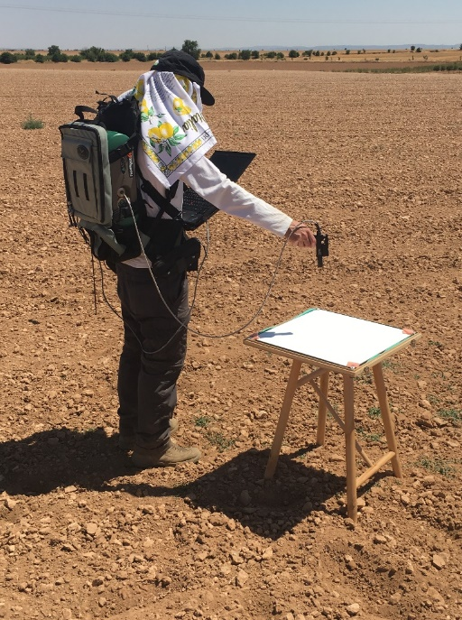

Figure 1: Performing a measurement of a Labsphere Spectralon reference panel with the ASD FieldSpec 4 Standard-Res.

# Calibration History

Pre-deployment calibration of instruments #16130 and #18177 was carried out by the National Physical Laboratory (NPL) at their calibration facility in Teddington. Associated calibration results can be found in Appendix A.1. Pre-deployment calibration of reference panel #AM18 was carried out by NPL between 21/05/18 and 22/05/18. The associated calibration certificate can be found in Appendix A.2.

# Instrument Operation

The following instrument operation instructions are adapted from those provided by the manufacturer [2] and [3]:

## Instrument Setup

1. Ensure all batteries (instrument and instrument controller) are fully charged before setting off to the field site.
2. The instrument should be turned on and allowed to warm up for a minimum of 30 minutes prior to use. The three detectors warm up at different rates, and spectral steps may occur if a sufficient warm up period is not allowed.
   1. The instrument should be turned on using the power switch at its rear.
   2. It is often convenient to turn the instrument on prior to setting off to the field site, so that the warm up period can occur whilst traveling.
   3. If a contact probe is also being used, its lamp should also be turned on and allowed to warm up for the same period of time.
3. Unpack the instrument from its shipping case and into the Ergonomic Pro-Pack, fastening the straps to hold it in place. It is recommended to orient the instrument so that the fibre optic cable is on your non-dominant side, leaving your dominant hand to operate the instrument controller.
   1. Before putting on the Ergonomic Pro-Pack, ensure that all straps are fastened and that the instrument is secure.
   2. Place the NiMH battery into the pouch on the belt on the opposite side to the fibre optic cable. Feed the cable under the cross strap to the power input.
   3. Attach the Ethernet cable to the instrument.
   4. Attach the belly board to the shoulder straps and place the instrument controller onto the belly board.
   5. Attach the other end of the Ethernet cable to the instrument controller.
   6. The fibre optic cable should be inserted to the pistol grip, which can be held by the operator, or mounted on a monopod or tripod. FOV limiting fore-optics may be attached to the pistol grip (e.g. 8°).
4. The reference panel should be set up on a levelled tripod or other stable surface. The lid should be closed whenever measurements are not being performed to prevent contamination and degradation by ultraviolet light. Do not touch the surface of the reference panel.
   1. Before use, visually inspect the panel to ensure that contamination will not compromise its calibration.

## Software Setup

1. With the instrument controller on, start the RS3 software. The ‘high contrast’ version is recommended for field use as it is more legible in bright conditions.
   1. Select the ‘Spectrum Save’ menu. Type in the full path to the location you wish to save data to and enter a suitable base name of up to eight characters. Set the starting spectrum to ‘0’, the number of spectra to be saved to ‘5’.
   2. Select ‘Adjust Configuration’ from the ‘Control’ menu. Select the required fore-optic from the dropdown menu (i.e. ‘Bare Fiber’ or ‘8°’). Under number of samples, type ‘10’. This represents the number of spectra that will be averaged for each spectrum saved.
   3. The selection of the number of spectra and samples is a trade-off between the time taken to perform each measurement and the level of noise reduction achieved through averaging. A good compromise is to save multiple spectra, which can be averaged during data processing and used to calculate other measurement statistics.

## Performing a Measurement

1. Before performing measurements, the instrument needs to be optimised to adjust the integration time to the ambient illumination conditions.
   1. Optimisation is essential to respond to changing illumination conditions and avoid saturation. If the instrument is saturating, a warning will appear on screen and an audible saturation alarm will sound. Re-optimisation will be required.
   2. Optimisation should be achieved by holding the pistol grip over the reference panel at nadir and clicking the ‘Opt’ button on the toolbar.
2. During optimisation, dark current measurements will also be performed. Additional dark current measurements should be performed every 20 minutes by clicking the ‘DC’ button on the toolbar.
   1. During dark current measurements, a shutter will close, enabling the signal generated by electrical components to be isolated and subtracted from the signal generated by incoming photons. Dark current measurements are stored in memory and automatically subtracted from subsequent measurements.
3. Measurements of the reference panel and target of interest can now be performed in raw digital number (DN) mode by holding the pistol grip at nadir and pressing the space bar on the keyboard.
   1. It is recommended to wait for two refreshes of the spectrum on the screen before saving the spectrum.
   2. An audible tone will sound when the measurement is complete.
   3. The reference panel and target measurements should be as close in time as possible to minimise the effects of changes in illumination. The measurement sequence adopted in the FRM4VEG project consists of one measurement of the reference panel, followed by four to eight measurements of the target around the circumference drawn by the movement of the operators’ arm, terminating with another measurement of the reference panel.
   4. Measurements should be performed under clear and stable illumination conditions. If sampling in sub-optimal conditions, measurements should only be performed in clear spells between clouds passing overheard.
   5. Measurements should be performed within 2 hours of solar noon, and within 30 minutes of a satellite overpass.
4. Measurements may also be performed in radiance mode, in which the radiometric calibration is automatically applied to the data by RS3. This can be achieved by pressing the ‘Rad’ button on the toolbar.
   1. Either the raw DN or radiance mode may be selected, as the radiometric calibration can be applied in data processing, and conversely the raw DN values can be recovered from radiance values.

# Care and Storage

The following care and storage advice is adapted from that provided by the manufacturer [2]:

* Handle the fibre optic cable with care and never store it with a bend of less than 5 “diameter.
* Handle the reference panel with care. Its surface is delicate and must not be touched. If insects or dirt land on the reference panel, gently blow them away.
* Ensure the instrument is well ventilated. Insufficient ventilation can result in overheating, corrupted data, and potential physical damage. Do not cover the vents of the instrument or place objects on the instrument or its power supplies. The lower mesh pocket of the Ergonomic Pro-Pack is intended for ventilation only and should not be used to carry clothing or other supplies.
* In the event of bad weather, turn off the instrument and its controller. Place the instrument controller in its compartment and cover the instrument with the rain flap located at the top of the Ergonomic Pro-Pack. Note that rain flap is water resistant but not water proof. Do not try to use the instrument with the rain flap deployed due to the risk of overheating.
* The instrument should be stored in its shipping case for transport. Coil the fibre optic cable loosely and place it in the netting on the top of the instrument. Place the instrument in the Ergonomic Pro-Pack and fasten the straps to hold it in place. Place the instrument controller in its compartment. Fold the left and then right battery pouches in, and place the Ergonomic Pro-Pack into the shipping case using the hand straps at the top and hip belt at the bottom. The shipping case has cut-outs for the fibre optic cable in both the floor and lid.
* To clean the instrument, turn it off and disconnect all power supplies. Allow it to cool before cleaning with a slightly damp cloth and mild soap. Be sure all soap residue is removed and all surfaces are dry before use.

# Troubleshooting

Reasons for and solutions to common problems with the FieldSpec spectroradiometers are provided by the manufacturer [2], and are listed in Table 2.

Table 2: Reasons and solutions to common problems with the FieldSpec spectroradiometers [2].

|  |  |  |
| --- | --- | --- |
| Problem | Reason | Solution |
| The instrument controller does not connect to the instrument | Various | Power cycle the instrument and/or instrument controller |
|  | The Ethernet cable is not connected or the wrong type of Ethernet cable is being used | Check the Ethernet cable is a cross-over cable, and that it is securely inserted into the instrument and instrument controller |
|  | The IP address of the instrument controller is not in the same range or subnet as the instrument | Ensure the IP address of the instrument controller is in the same subnet as the instrument (the first three octets of the IP address should match), the default subnet mask is 255.255.255.0 |
|  |  | Perform a ping test to make sure the instrument in responding (type ‘ping 10.1.1.11’ into the command line for an Ethernet connection and ‘ping 10.1.1.77’ for a wireless connection) |
|  | The wireless adapter is not connected to the instrument | Check the wireless adapter is connected to the instrument and that the correct wired equivalent privacy (WEP) key is being used |
| The instrument does not connect to the access point | Various | Ensure the wireless interface on the instrument is not set to ad hoc, and that the correct service set identifier (SSID) and WEP key is being used |
| The instrument loses its wireless connection | Radio frequency (RF) noise | Try to minimise RF noise, which may be caused by cordless telephones, microwaves, monitors, ceiling fans, lights and security systems |
|  | Obstructions can degrade the signal | Minimise obstructions (walls, ceilings, doors, buildings, hills) between the instrument and instrument controller |
|  |  |  |

# Applicable and Reference Documents

[1] Malvern Panalytical, “ASD FieldSpec 4 Standard-Res Spectroradiometer.” [Online]. Available: https://www.malvernpanalytical.com/en/products/product-range/asd-range/fieldspec-range/fieldspec-4-standard-res-spectroradiometer/index.html. [Accessed: 24-Aug-2018].

[2] ASD, *FieldSpec 3 User Manual*. Boulder, Colorado, United States: Analytical Spectral Devices, 2008.

[3] A. MacArthur, *Field Guide for the ASD FieldSPec Pro - Raw DN Mode*, 2nd ed. Edinburgh, United Kingdom: Natural Environment Research Council Field Spectroscopy Facility, 2007.

###### Appendix

2018 Calibration Results for Instruments #16130 and #18177

Wavelength and Bandwidth



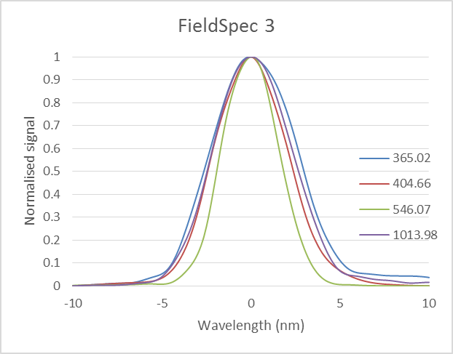 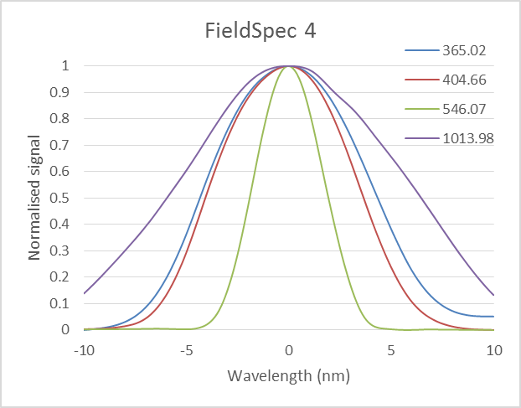

Calculations produced uncertainties that were less than realistic. For wavelength, if the expanded uncertainty is less than 0.1 nm, 0.1 nm is quoted. For bandwidth, if the expanded uncertainty is less than 0.2 nm, then 0.2 nm is quoted.

Results:

* For both instruments, bandwidths are larger than the quoted 3 nm.
* Bandwidths change with wavelength.
* The wavelength error is larger than the expected 0.25 nm for instrument #16130.

Measured and Calibrated Spectral Radiance

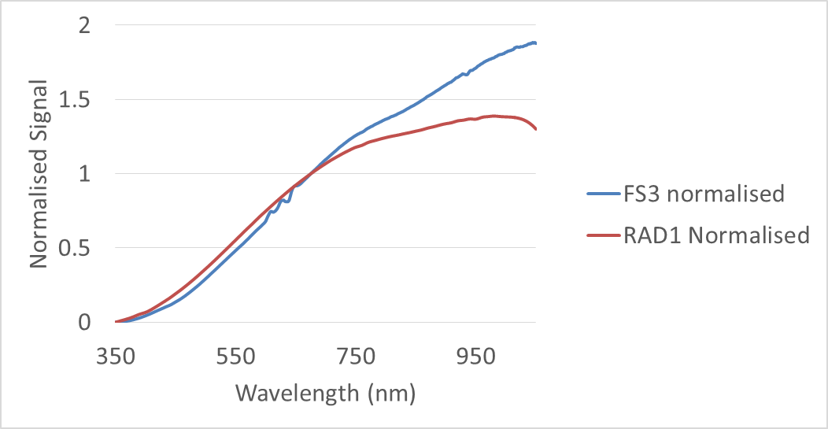 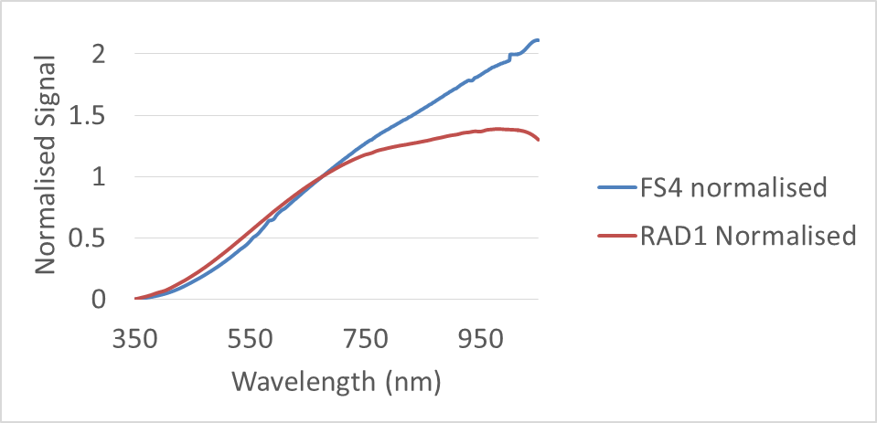

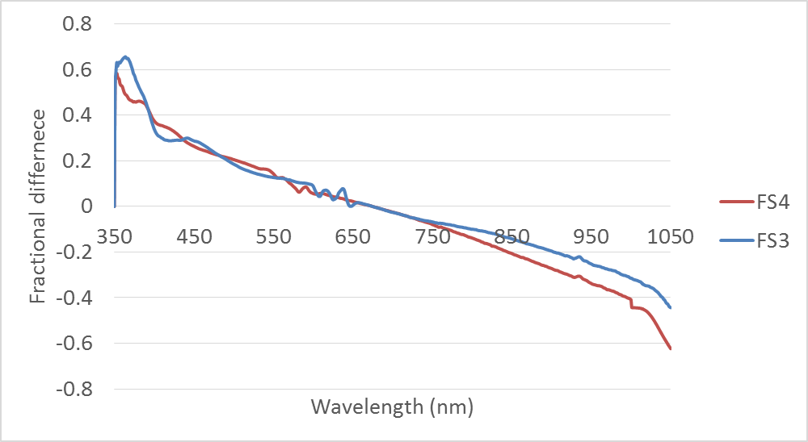

Results:

* The large differences between reference and measured radiance, particularly at longer wavelengths, indicate the internal correction is not good enough. Therefore, it is recommended to perform an absolute radiometric calibration.

Stray light

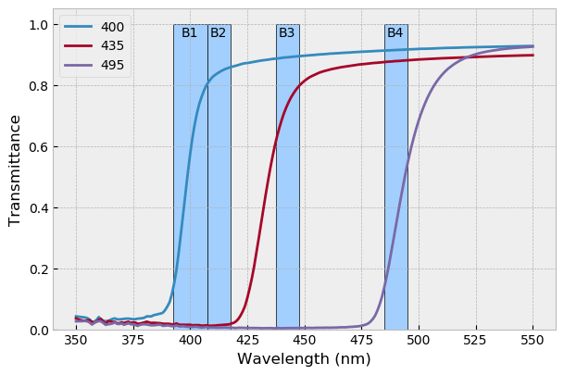 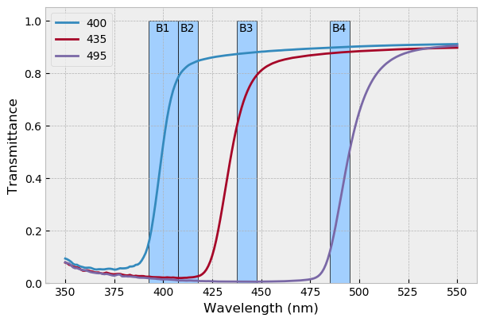



Radiance source filtered with three filters separately. The resulting spectrum is superimposed on the first four Sentinel-3 OLCI bands.

Results:

* Stray light is low in the bands the spectroradiometers will be used in, therefore a correction may not be necessary. However stray light will depend on the source.

2018 Calibration Certificate for Reference Panel #AM18

