Production and Submission of Dissertations (DETSA Students)

Updated Advice for those DETSA Students Submitting - 2014

How many copies are required?

- Two bound copies of your dissertation must be submitted to the Student Administration Office (Building 34 - DETSA Programmes Administrator, Professional Training Team);
- An electronic copy must be submitted via Blackboard

It is your responsibility to ensure that this electronic copy is exactly the same as the two identical hard copies submitted. Both hard and electronic copies of your dissertation are retained by the University. You should keep an additional personal hard copy and store securely an electronic copy.

Your Contact Details

Are your contact details up-to-date?
- Please ensure that you check and update your contact details via the Student Record System Self Service (SUSSED Students (tab)  Your Student Record
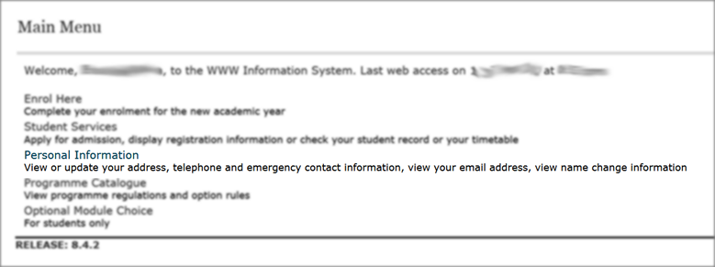
- Please contact the Student Office immediately if there are any mistakes in how your name appears. How your name appears in your student record is how your name will appear on your degree certificate.

This is the only contact information that will be used by the Student Office and University.

What type of Binding should my dissertation have?

- Soft Bound: Acetate Cover, lemon coloured front sheet and Manila/Buff card back cover

How should my dissertation be presented?

Your dissertation should be presented in accordance with the following guidelines, unless the nature of the work makes that impossible, but above all, dissertations should be neat, tidy, easy to read and presented in a consistent manner:

- The main body of your dissertation should be typed on each side of good quality (80-100gsm) A4 paper with one-and-a-half line spacing;
- You should use a type-face of adequate size and legibility:
  - use a sans serif font such as Lucida Sans; Arial; Calibri or Microsoft Sans Serif; font size should be 10pt or 11pt;
  - the font size used within tabulated data may be reduced;
- Each side should have adequate margins all round of at least 15mm plus a ‘binding edge’ (sometimes called the gutter margin) margin of at least 40mm.
  - You should select a ‘Mirrored’ page layout margin setting. Details about how to set mirrored margins are available: Setting Mirrored Margins: http://youtu.be/eoYMIPjv08E
  - All pages should be numbered after the title page.
  - Preliminary pages should be numbered using Roman numerals (i.e. i, ii, iii, iv, v…);
  - The subsequent pages should use Arabic numerals (i.e. 1,2,3,4, 5…);
  - Page number should be centred and in the footer.
- Generally and where appropriate, the anonymity of those persons or organisations who participated in the research should be preserved. The guidance of your supervisor is critical in this respect.
- Figures and Tables should be sequentially numbered, have a title and appear below the figure or Table: http://youtu.be/G2RltLkC7vg
- You should avoid using gender specific text.

Where do I get my dissertation bound?

- Murray Building 58 Room 2011 OR
- Student Services Building 37 Room 1003
  - 1 working day turnaround (Normally)

How much will it cost and how can I pay?

- Cash on collection (as of 2012/13 – £5.00 per copy)
- Cheque or Card (not Diners Club or AmEx) is supported by the Finance Office in Student Services Building 37 – Cheque/Card Payments can only be made when the Finance Office is open IT IS ESSENTIAL if you are NOT paying with cash that you confirm opening hours of the Finance Office see: http://www.southampton.ac.uk/finance/income/income_contact_info.html

How do I submit a hard copy if I am away from campus?

You are responsible for getting in contact with the Copy room for full guidance (copy@soton.ac.uk)
You will probably need to allow more time at least 5 working days. If you choose to submit your dissertation while away from campus it is your responsibility to ensure that you allow sufficient time and liaise in advance with the copy room:
- You may email a PDF version to: copy@soton.ac.uk and at the same time cc your email to the Student Office (sesdetsa@soton.ac.uk)
- Payment can be made over the telephone with Finance Office – Full details of the process are emailed to you from the Copy Room with your invoice.
- There is an additional cost for printing/copying and a delivery charge.

The Contents

Cover. The front cover must be clear acetate.

Title Page. (Printed on ‘Lemon’ coloured paper: for layout see templated versions below)

Statement of authorship. The following authorship statement must signed be bound in your dissertation:

I confirm that the material contained in this dissertation is all my own work and where the work of others has been drawn upon, it has been properly acknowledged according to appropriate academic conventions. No portion of this work has been submitted or is currently being submitted in support of an application for another degree or qualification of this or any other university or institute of learning.

Signed …………………………………………………

Acknowledgements.
Optional and brief but normally includes recognition of help given, copyright, etc.

Contents Page.
This page lists, chapter by chapter, the contents of your dissertation and should include the Abstract, List of References and Appendices (If required you may choose to include a Glossary of vocabulary as an appendix). Each item must have a page reference number in the dissertation. How to use Styles to automatically create a contents page: http://youtu.be/4N8mjfpAd8w

List of Figures
If required with page number references.

List of Tables
If required with page number references.

List of Abbreviations and Acronyms
If required.

Abstract
A précis of your work in about 250 words.

Body of the dissertation.
From this point on your work should be double-sided.
You are obliged to consult your supervisors for guidance on content.
Typically there will be the following chapters:
- Introduction
- Literature Review
- Research Methodology
- Results and/or Findings and/or Data Analysis
- Discussion
- Conclusions
References
- Your referencing and citations should follow the Harvard system, as used for assignments.
- You should use Pears and Shields (2010) Cite Them Right as a guide.
Appendices
Template Title Page – DELETE THIS TEXT as required

University of Southampton, <2014>

FACULTY OF SOCIAL AND HUMAN SCIENCES

<YOUR TITLE HERE>

by <Your Name Here>

A dissertation submitted in partial fulfilment of the degree of
<MSc Education Practice and Innovation>
by taught course.

