Sub project | Lesson title | Resources
Biological Sciences | Why might polar bears become extinct? | Lesson plan  Powerpoint  Work book  Cartoon strip to put in correct order.
Learning objectives
Be able to describe what evolution is
Be able to explain the process of natural selection.
Be able to explain some of the reasons why extinctions happen.
Differentiation?
Lower ability groups could be given the pictures of giraffes in the correct order and asked to match the words.
Lower ability groups could be given simple sentences describing polar bear evolution and asked to draw pictures to illustrate what is happening.
Higher ability groups could discuss mutation and the genetics involved in a more in depth way.
Higher ability groups could also discuss the environmental issues/ human activity involved in global warming.

Activity |  | Timing
Starter: Why might polar bears become extinct? (Illicit ideas that polar bears cannot change as quickly as their environment is, it is therefore likely that they will become extinct as unable to find mates or food. Cubs drown etc.).  Main: Discuss the idea that evolution is a theory and share Lamarck theory. Introduce Darwin.  Give cartoon strip/ text to describe the action of natural selection in the evolution of giraffes. What is happening? Ask them to put it in the right order.  Discuss natural selection briefly and info on brown/polar bears.  Ask them to draw their own cartoon strip in their booklets to apply to the evolution of polar bears.  Plenary: Back to original question. Evolution is a slow process and although extinctions happen naturally we are at a point of crisis due to rapid changes in every ecosystem brought about by human activity. |  | 5/ 10 mins  5 mins  10 mins  5 mins  20/ 30 mins  5 mins

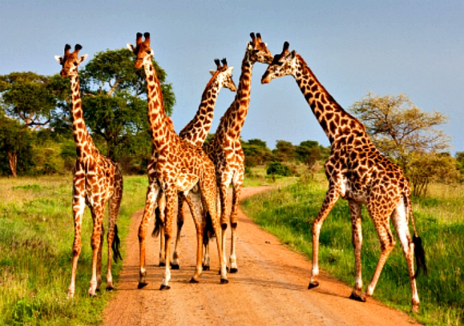
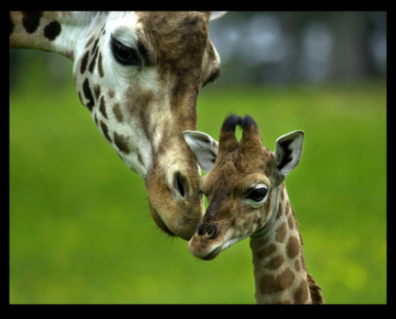
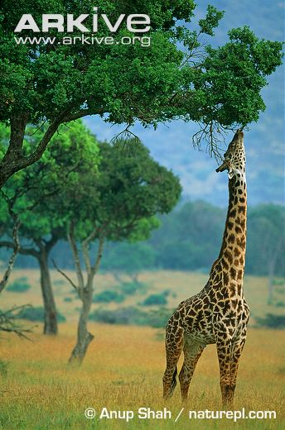
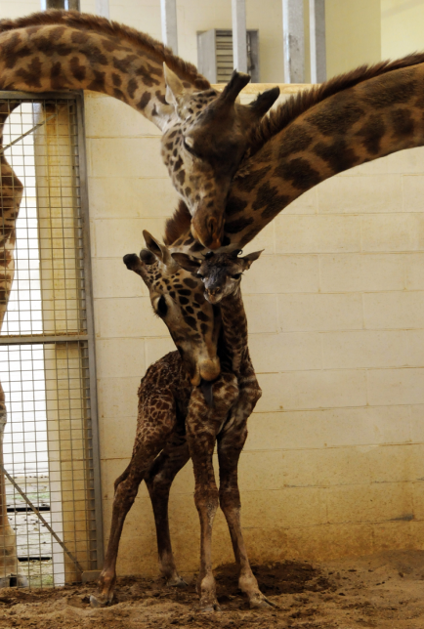
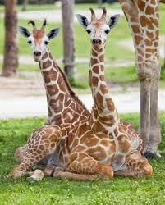
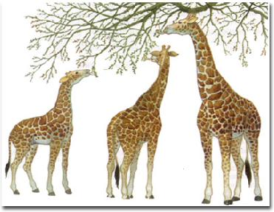

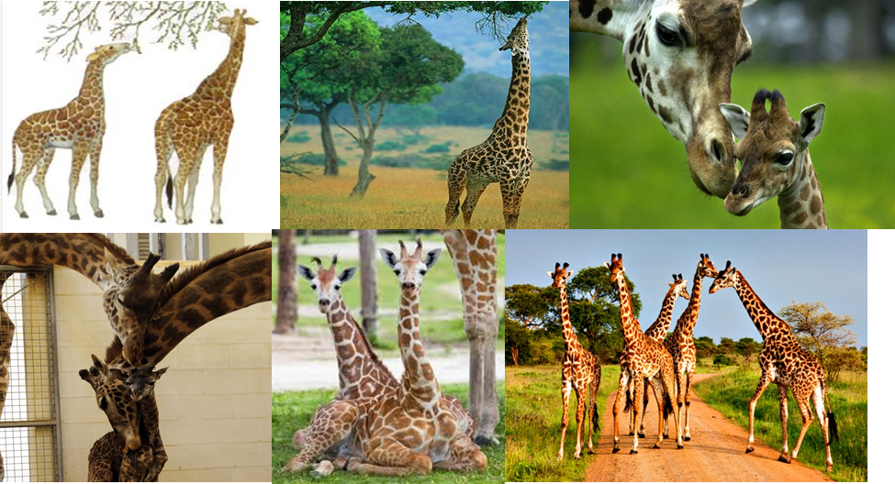

Over thousands of generations the numbers of offspring with longer necks increases.
The offspring of giraffes with longer necks inherit the genes for a long neck from their parents.
Giraffes still have necks of varying lengths but they are longer overall than those of their ancestors.
Giraffes had necks of varying lengths which are shorter overall than those of modern giraffes.
The giraffes with longer necks were more likely to survive to reproduce than those with shorter necks.
The giraffes with the longest necks could reach more leaves than those with shorter necks.
Over thousands of generations the numbers of offspring with longer necks increases.
The offspring of giraffes with longer necks inherit the genes for a long neck from their parents.
Giraffes still have necks of varying lengths but they are longer overall than those of their ancestors.
Giraffes had necks of varying lengths which are shorter overall than those of modern giraffes.
The giraffes with longer necks were more likely to survive to reproduce than those with shorter necks.
The giraffes with the longest necks could reach more leaves than those with shorter necks.

