Habitica

What is it:
Habitica is a to-do list with built in gamification. You start off with an avatar and by doing your chores daily you level up, collect mounts and pets and items that can help you.

Link:
https://habitica.com/static/home
Screenshots
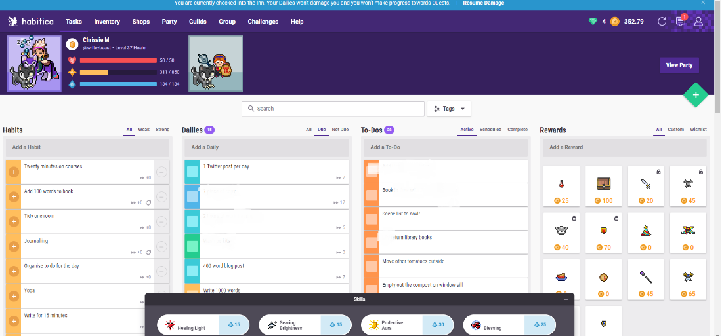

Mobile app
Yes

Cost
Free with in app purchases

Pros
- Working on your tasks gives your character a boost or helps kill a monster
- Work with your friends to complete quests
- Join guilds and chats to cheer on other people and earn bigger rewards
- Can use your Google account to log in

Cons
- Easy to add too many things and end up overloaded and unable to keep up
- Not for everyone – unless you’re into gaming
- The novelty can soon wear off
- Resets when you get to level 100

Todoist

What is it?
A to-do list that allows you to break up your to-dos int o projects. You can set a daily target of tasks to do and earn yourself “Karma”. There is also a premium function which allows you to use labels and to add calendar feeds.

Link:
https://todoist.com/

Mobile app
Yes

Screenshots
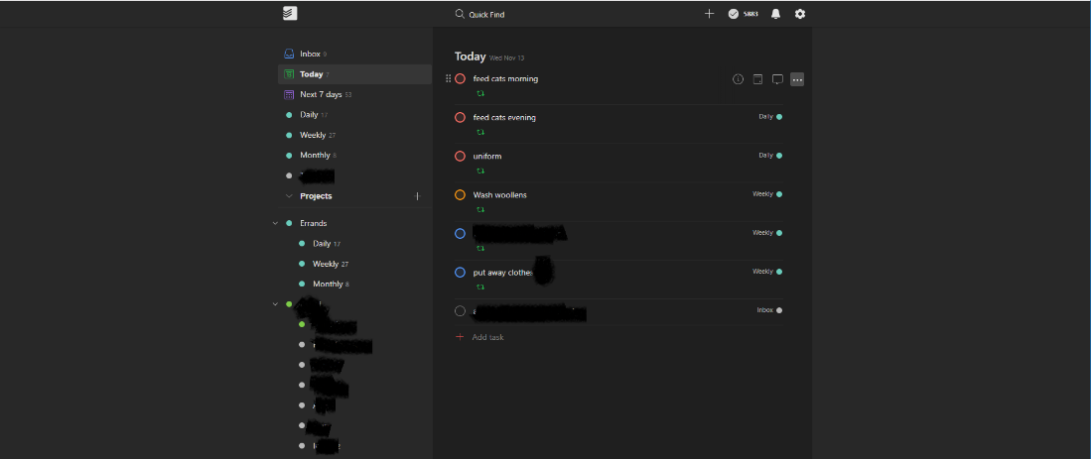

Cost
$3/month

Pros
- Shared projects
- Can choose from light or dark themes
- Divide your tasks into projects
- Today, and Week lists by default
- Up to 80 projects in the free version

Cons

Wunderlist

What is it?
Wunderlist is a to-do list featuring recurring tasks, the ability to add your tasks to a calendar and shared lists. It was purchased by Microsoft in 2015

Link:
https://www.wunderlist.com/

Mobile app:
Yes

Pros:
- Choose your own background
- Sort your lists into groups
- Share your lists

Microsoft To Do

What is it?
Microsoft todo is a task list from Microsoft and is part of Office 365. This means that it integrates with other O365 products.

Link:
https://todo.microsoft.com/tasks/

Mobile app:
Yes

Pros:
- Integrates with other O365 apps and more features are being added
- The My Day function allows you to add what you prioritise that day – good for people who will find themselves overloaded otherwise.
- Custom lists
- Good for keeping your day-to-day personal tasks in order

Cons:
- Integration with Outlook can be a bit flakey – when you flag an email in Outlooks, it can be added to To Do but this feature can sometimes cause duplicate tasks to appear in To Do and Outlook
- Integration with Planner and Project still has some features missing

Microsoft Planner

What is it?
Microsoft Planner is Microsoft’s answer to Kanban, with personalised buckets, the ability to share across groups and full integration with Microsoft Teams.
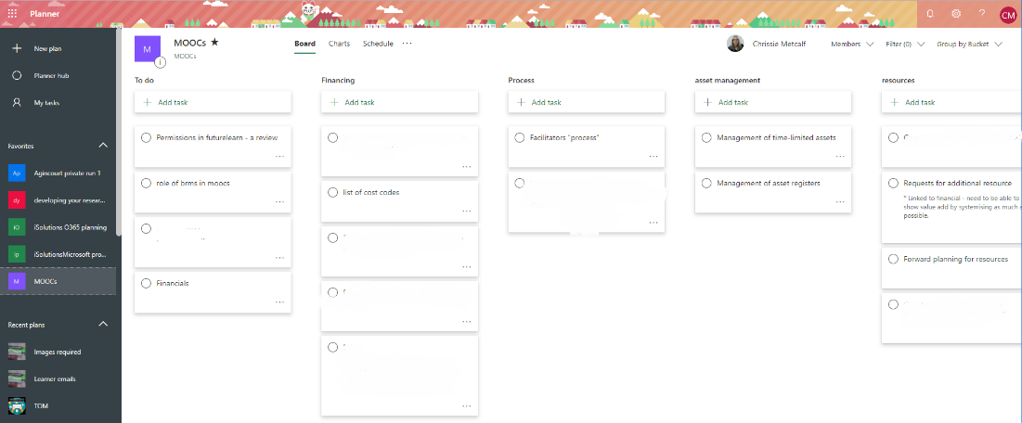

Link:
https://tasks.office.com/

Mobile App
Yes

Pros:
- Full integration with the O365 suite
- Ideal for small, Agile projects where Microsoft Project would betoo much
Cons:
- Designed more for use collaboratively.
- Creation in O365 account creates a group with its own email address – great for teamwork, not so great when you want to use it to keep your personal tasks in order.

Microsoft Project

What is it?
Microsoft Project is a full-on project planning tool. Designed to allow medium and large teams to set milestones, deadlines and see timelines. Usually used by Project Managers
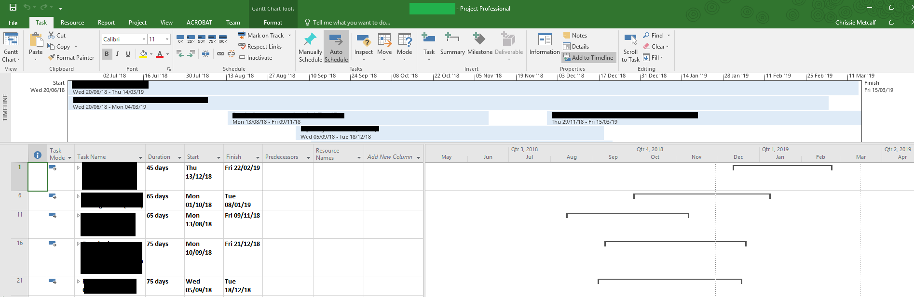

Link:
https://products.office.com/en-gb/project/project-management

Mobile app
?

Pros:
- Enables big projects to be managed appropriately
- Online version has full integration with O365
- Gantt charts!

Cons:
- Not designed for individual use
- Fairly steep learning curve

Trello
What is it?

Asana

What is it?
Asana is a combination of a task list and a full on project management tool. In a paid for version, you can get collaborate with bigger teams, and create Gantt charts. The free version allows you to create 3 projects.
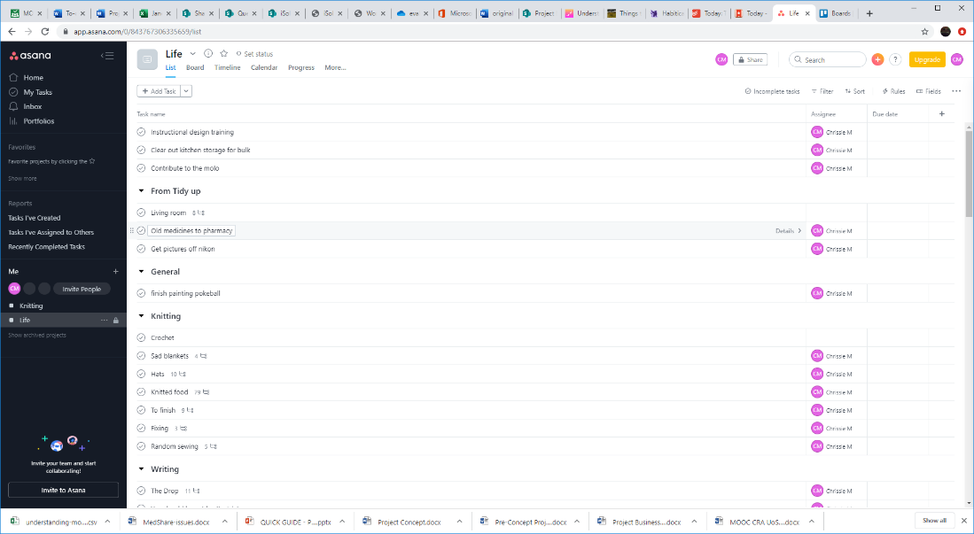

Link:
https://asana.com/

Mobile App:
Yes

Pros:
- Clear interface
- Subtasks
- Collaboration
- Can be integrated into Microsoft Teams if required
- Log on with your Google account

Cons:
- Have to pay for full features (eg Gantt charts etc)
- You need to go into a task to check out its subtasks
- Mobile app lists every task and doesn’t associate tasks with its parent section or task.

Instagantt

What is it?
Create Gantt charts from Asana. Integrates fully with your Asana projects to create a Gantt chart allowing you to see workload. Also allows you to add tasks and time estimations which will then appear in Asana.
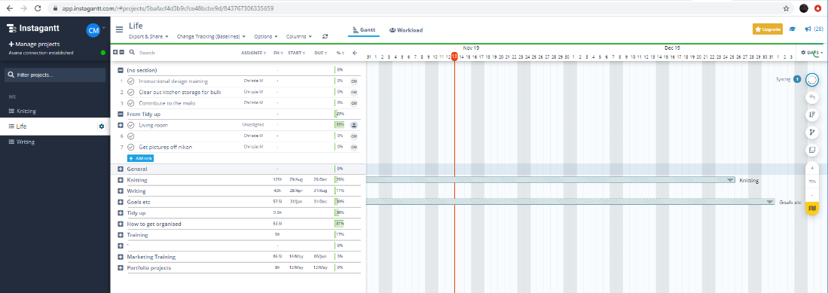

Link:
https://instagantt.com/

Mobile app
No

Pros:
- Full integration with Asana giving full project management capabilities for Asana projects

Cons:
- Web only
- Can be unwieldy for small personal tasks
- Not ideal for day-to-day tasks

