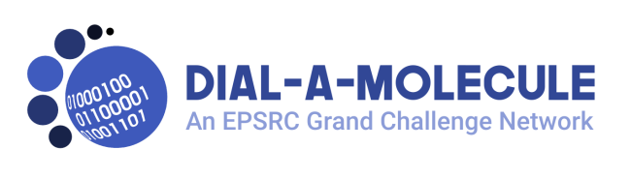
Dial-a-Molecule Annual Meeting 2019 – Sustaining Chemical Synthesis

Day 1 – 3rd July 2019

10:15-10:45 Coffee and registration

10:45–12.40 Opening Session
Chair: Prof. Richard Whitby

10.45–10.55. Welcome, housekeeping etc.

10.55–11.35. Keynote lecture – Simon Yates (AstraZeneca)
Dial-a-Molecule Technologies at the Industrial (Coal) Face

11.35–12.00. Dr. Natalie Fey (University of Bristol)
Data-driven discovery and optimisation of organometallic catalysts

12:00–12.25 Prof. Ian Fairlamb, (University of York)
Approaches to the study of a Pd-catalysed reaction with multiple catalytic cycles delivering many organic products

12:25–12.40 Exhibitor flash talks

12:40-12:45 Introduction to Breakout session

12.45–14.00 Lunch and Exhibition
Tours available to see York Chemspeed

14.00–15.00 Breakouts

Breakout 1 The 21st-Century ‘Well-Found’ Academic Lab

Breakout 2 Training needs for the 21st-Century chemist

Breakout 3 NIH NCATS ASPIRE programme

15.00–15.45 Coffee and Exhibition

15.45–17.30 Celebrating achievements of Dial-a-Molecule
Chair:

15:45-16:05 Prof Richard Whitby (University of Southampton; Dial-a-Molecule PI)
Overview of Dial-a-Molecule achievements

16:05-16:20 Dr. Marc Reid, (University of Strathclyde)
Computer Vision in Chemical Research

16:20-16:35 Dr. Alex Cresswell, (University of Bath)
Dial-an-Amine: New Strategies for Amine Synthesis

16:35-16:50 Dr. Alastair Lennox (University of Bristol)
Electrochemical difluorination of alkenes

16:50-17:15 ROAR – a major Dial-a-Molecule success story; Prof Mimi Hii (Imperial College London)

17.15–19.30 Poster session, Exhibition and Networking
With drinks and pizza – sponsored by Syngenta

Day 2 – 4th July 2019 Morning
9.00–10.00 Celebrating achievements of Dial-a-Molecule (cont)
Chair:
9:00-9:15 Dr. Richard Bourne (University of Leeds)
Cognitive Chemical Manufacturing
9:15-9:30 Prof. Alexei Lapkin (University of Cambridge)
Combining Chemical Robotics and Statistical Methods to Discover Complex Functional Products;
9:30-9:45 Dr. Louis Morrill (Cardiff University)
Developing Continuous Electroorganic Catalysis - It's Got Potential
9:45-10:00 Dr. Bao Nguyen (University of Leeds)
Water as synthetic reaction medium: realising its green chemistry credentials
10:00-10:05 Intro to parallel workshops
10:05-11:10 Coffee + Parallel workshops from partner networks
Learn how you can interact with our partners and help them drive forward the aims of Dial-a-Molecule in the future
AI3SD+
ROAR
SMART
11.10–12.00
Chair: Prof. Mimi Hii
Keynote lecture – Prof. Anita Maguire (University College, Cork)
Taming Diazo Chemistry in Flow

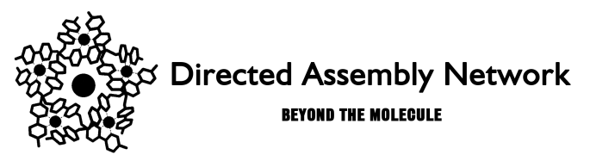

Day 2 – 4th July 2019 Afternoon

Dial-a-Molecule Annual Meeting
Joint session with Dial-a-Molecule/Directed Assembly Networks’ ECR event

12.00–13.00 Lunch and exhibition

13:00-14:45 Annual Meeting joint session with ECR event
Chair: Dr Will Unsworth
13:00-13:10 Welcome to ECRs and Introduction to the afternoon
13:10-14:00 Keynote lecture – Prof. Martin Burke (University of Illinois), sponsored by AstraZeneca
Democratizing Synthesis

14.00–14.45. Prof. Adam Nelson University of Leeds
How Best to Discover Novel Bioactive Small Molecules?

Close of Annual Meeting

14.45–15.15 Coffee and exhibition

Attendees registered for the Annual Meeting are welcome (and encouraged) to stay for the following ECR event session

15.15–17.30 ECR event session 2
Chair: Dr. Jona Foster

15.15–16.45 ECR flash talks.

16.45–17.30. Dr. Sarah Staniland University of Sheffield
Nature's materials: a journey to the nanoscale

