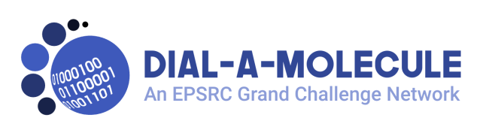
Dial-a-Molecule Annual Meeting 2019 – Sustaining Chemical Synthesis

Outline agenda

Day 1 – 3rd July 2019

10:15-10:45 Coffee and registration

Session 1: 10:45–12.45

10.45–10.55. Welcome, housekeeping etc.

10.55–11.45. Keynote lecture – Prof. Marty Burke (University of Illinois)
Title tbc

11.45–12.10. Dr. Natalie Fey (University of Bristol)
Data-driven discovery and optimisation of organometallic catalysts

12:10–12.35 Prof. Ian Fairlamb, (University of York)
Title tbc

12:35–12.45 Exhibitor flash talks

12.45–14.00 Lunch and Exhibition
Tours available to see York Chemspeed

Session 2: 14.00–15.00

Breakouts.

15.00–15.45 Coffee and Exhibition

Session 3: 15.45–17.30

Celebrating achievements of Dial-a-Molecule; an overview followed by talks from recipients of PoC or Interdisciplinary Mobility funding from Dial-a-Molecule

15:45-16:05 Prof Richard Whitby (University of Southampton; Dial-a-Molecule PI)
Overview of Dial-a-Molecule achievements

16:05-16:20 Dr. Marc Reid, (University of Strathclyde)
Title tbc

16:20-16:35 Dr. Alex Cresswell, (University of Bath)
Dial-an-Amine: New Strategies for Amine Synthesis

16:35-16:50 Dr. Alastair Lennox (University of Bristol)
Title tbc

16:50-17:05 Dr. Nikolay Cherkasov (University of Warwick)
Stirring bars with integrated process sensors

17:05-17:30 ROAR – a major Dial-a-Molecule success story

Poster session, Exhibition and Networking 17.30–19.30
With drinks and pizza – sponsored by Syngenta

Day 2 – 4th July 2019
Session 4: 9.00–10.15
9:00-9:40 Keynote lecture – Dr. Simon Yates (AstraZeneca)
Title tbc
9:40-9:55 tbc
9:55-10:10 Prof. Alexei Lapkin (University of Cambridge)
Combining Chemical Robotics and Statistical Methods to Discover Complex Functional Products;

10:10-10:15 Intro to session 5
Session 5 10:15-11:30
Coffee + Parallel workshops from partner networks

Session 6: 11.30–13.00
11:30-11:45 Dr. Louis Morrill (Cardiff University)
Developing Continuous Electroorganic Catalysis - It's Got Potential
11:45-12:00: Dr. Bao Nguyen (University of Leeds)
Water as synthetic reaction medium: realising its green chemistry credentials
12:00-12:50 Keynote lecture – Prof. Anita Maguire (University College, Cork)
Title tbc
12:50 Closing Remarks
13.00–14.00 Lunch and exhibition

Attendees may also be interested in the Dial-a-Molecule and Directed Assembly Networks’ joint ECR event, which is taking place immediately following this event at the same venue. All attendees are encouraged to attend the first session of this event (14:00-15:30), which will feature flash presentations from ECRs with wide ranging research interests. You may also be interested in attending the second session of the ECR event (16:00-17:30) when Adam Nelson (Leeds) and Sarah Staniland (Sheffield) will be giving plenary lectures.

