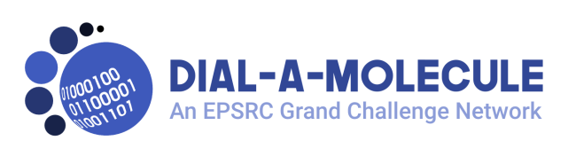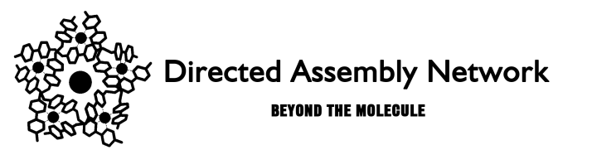
4th Joint Dial-a-Molecule and Directed Assembly Networks’ ECR Event - - Supporting Synthesis and Self-Assembly

Day 1 - 4th July 2019
Note that the second part of the Dial-a-Molecule Annual Meeting 2019 will be taking place on the morning of the 4th July. Delegates at the ECR event are welcome to attend. Directed Assembly focussed participants may be particularly interested to see Prof. Anita Maguire – see the Dial-a-Molecule Annual Meeting webpage for further information.
12.00–13.00 Lunch, exhibition and registration for ECR event
13:00-15:15 Joint session with Dial-a-Molecule Annual Meeting
Chair:
13:00-13:10 Welcome to ECRs and Introduction to the afternoon
13:10-14:00 Keynote lecture – Prof. Martin Burke (University of Illinois), sponsored by AstraZeneca
Democratizing Synthesis

14.00–14.45. Adam Nelson University of Leeds
How Best to Discover Novel Bioactive Small Molecules?

Close of DaM Annual Meeting

14.45–15.15 Coffee and exhibition

15.15–17.30 ECR event session 2
Chair:

15.15–16.45 ECR flash talks.

16.45–17.30 Sarah Staniland University of Sheffield
Nature's materials: a journey to the nanoscale

17.30 Close, check in to accommodation,

19:00 Event dinner, National Railway Museum
Drinks reception sponsored by Astra Zeneca

Day 2 – 5th July 2019
Session 3: 9.30–11.00
Building collaboration session

Session 4: 11.00–12.30
Diversity and Inclusivity in Science session.
11:00-11:20 Anna Slater University of Liverpool
11:20-11:40 Dave Smith University of York
11:40-12:00 Alyssa-Jennifer Avestro University of York
12:00-12:30 Panel Discussion/Q&A

12.30–13.30 Lunch and Exhibition

Session 5: 13.30–15.00
Academia-Industry partnerships session.
13:30-13:50 Allan Watson University of St. Andrew’s
13:50-14:10 Rob Davidson; Dr Reddys,
14:10-14:30 Mei Lee, GSK
14:30-15:00 Panel Discussion/Q&A
15:00-15:15 Closing remarks
15.15 Close of meeting

