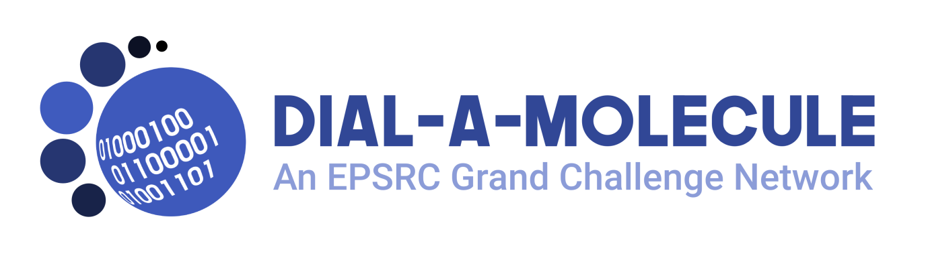
Summer School 30 July-03 August 2018, Loughborough
The Dial-a-Molecule Grand Challenge Network is funded by the EPSRC to promote research aimed at a step change in our ability to deliver molecules quick and efficiently.
How can we make molecules in days not years?
The three main, interlinked themes of Dial-a-Molecule are:
- Data driven Synthesis.
- Enabling Technologies for Synthesis.
- Synthesis College.
More details about our research interests and activities can be found at www.Dial-a-Molecule.org ____________________________________________________________________________________
Our residential Summer School is based on the Enabling Technologies theme and will give PhD students an opportunity to both learn about the technologies and to get hands on experience with commonly used equipment and tools. Topics will include:
- Real-time reaction analytics
- Design of Experiments
- Flow chemistry
- 3D-printing
- Novel reactor technologies
The format will be a mixture of lectures, workshops and practical sessions. Attendees will have the chance to give short presentations on their own research. Course presenters will be in residence, allowing ample opportunity for informal discussions.
Applying for the Summer School
The school is intended for PhD students at the end of their 1st or 2nd year of study. We will also consider other applications e.g. from students further through their studies or from post-docs.
There are 25 places available; we expect demand to be high and we want to make sure we have a good balance of interests amongst our attendees. Therefore we ask interested students to submit a short application on the attached form by the closing date of May 14th^{th}, 5pm. Applications will be assessed and applicants will be notified of the outcome within 4 weeks of submission. Successful applicants will be required to pay a registration fee of £50 to confirm their place.
Accommodation and Costs
The Network will fund 4 nights’ accommodation and all meals for each delegate, plus travel costs up to a maximum of £100. Successful applicants must pay a £50 registration fee.
Accommodation will be in University Lodge, Loughborough University. The Summer School will take place in recently opened STEMLab, Loughborough University.

Application to attend the Dial-a-Molecule Network Summer School, Loughborough, 30thJuly-3rd Aug 2018
Please email this completed application form (with your name in the filename) to the Network Co-ordinator, Gill Smith, Dialamol@soton.ac.uk by 5pm on May 14th.
Name of Applicant:
Email address:
Please confirm that you can attend the entire week of the summer school 30 July-03 August: Yes/No
Department and Institution:
Field of Research:
(e.g. title for your thesis or the research project on which you are supported)

Name of supervisor or line manager:
(you must have the permission of your supervisor or line manager to apply for the summer school. They will be copied in on any correspondence if you are offered a place)
Email address of supervisor or line manager:
Use (no more than) the rest of this page to explain why you would like to attend the Summer School. How will it help your research? How will it help your future career development?

