EPSRC Dial-a-Molecule 3D meeting in York
The Department of Chemistry at the University of York recently hosted a major national conference on Synthetic tools for Exploration of 3D Pharmaceutical Space (17/11/17). The meeting was attended by over 90 delegates, including academics and students from all around the UK and Ireland, as well as several representatives from the pharmaceutical industry, most notably from GSK, Sygnature and Astex. The meeting featured a number of extremely well-received and insightful talks from researchers involved in the synthesis of 3D molecules and their use in drug discovery, expertly delivered by Prof Joe Sweeney (University of Huddersfield), Prof Rob Stockman (University of Nottingham), Dr Liam Cox (University of Birmingham), Prof Peter O’Brien (University of York), Prof Nigel Simpkins (University of Birmingham), Dr Susannah Coote (Lancaster University), Dr James Bull (Imperial College London), Dr Jeff St Denis (Astex), Dr Rob Young (GSK) and Dr Elaine O’Reilly (University of Nottingham). The meeting concluded with a fascinating keynote lecture given by Prof Erick Carreira (ETH Zurich) on his work on ‘Recent Developments in Strategies and Tactics Towards Complex Secondary Metabolites as enabling tools for the Study of Natural Products Biology’. The photo below includes all the external speakers, along with York organisers Dr Will Unsworth and Prof Peter O’Brien and session chair Dr Paul Clarke.
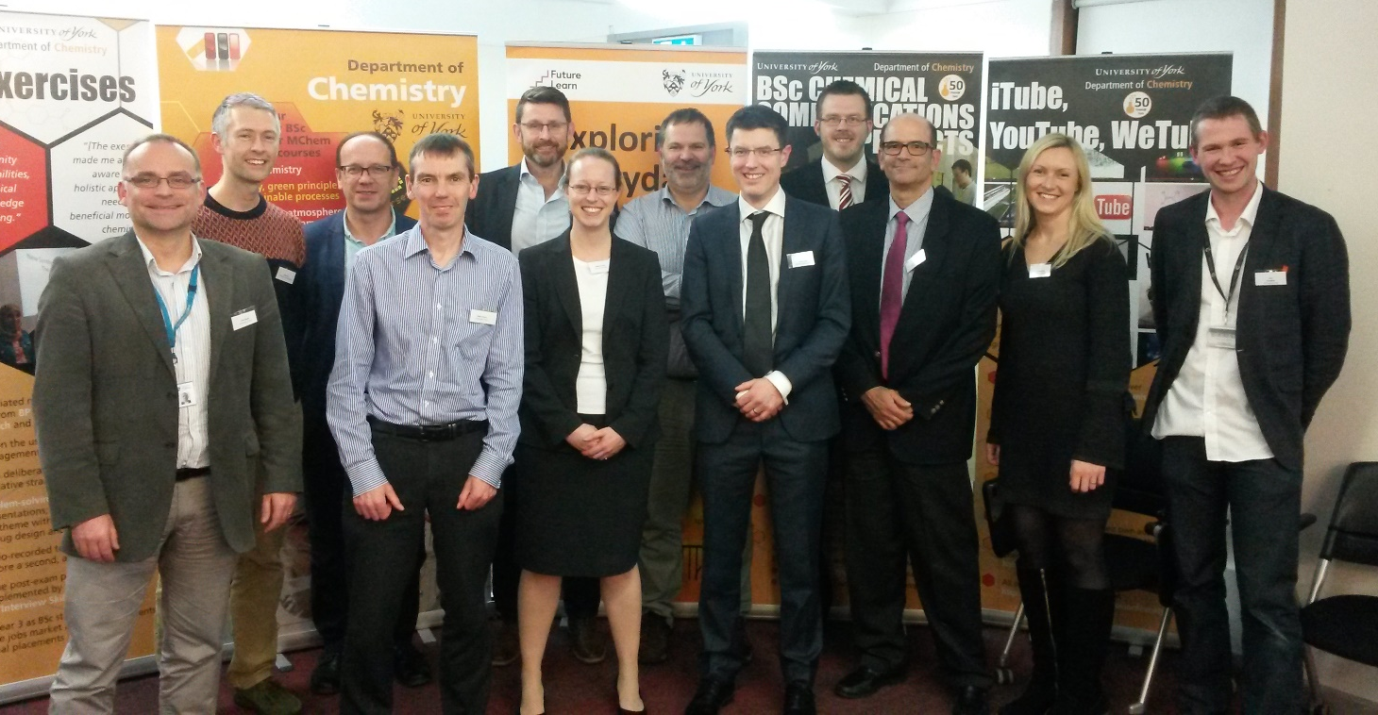
Speakers and Organisers of the Dial-a-Molecule 3D Meeting
The aim of this free-to-attend meeting was to bring together researchers at all career stages, from industry and academia, to learn about and discuss recent developments in the synthesis, analysis and biological evaluation of 3D molecules and their pharmaceutical importance. It was also hoped that the day would inspire new research in the broad area 3D pharmaceutical space and help foster industry-academic collaborations. Based on the excellent feedback on the quality of the talks and the lively discussion throughout the day (which went long into the evening during the drinks reception!) we feel that this goal was well achieved.
The meeting was provided free of charge thanks only to the generous financial support of Dial-a-Molecule and our event sponsors Advion, Astex, Fluorochem, GSK and Radleys. Dial-a-Molecule is a Grand Challenge Network, funded by the EPSRC, with the broad remit of promoting research aimed at a step change in our ability to deliver molecules quickly and efficiently. The network supports various meetings and events, lobbies on behalf of its members to ensure that synthesis remains at the forefront of research and development nationally and also funds original research; for more information, see: researchhttp://generic.wordpress.soton.ac.uk/dial-a-molecule/
Other highlights of the day included a demonstration from Dr James Firth of LLAMA (a free, open-access web interface able to predict the 3D shape and physical properties of molecules) and a lively poster session, in which 23 PhD students, postdoctoral researchers and academics presented their work, with prizes for the best posters awarded to Alexander Boddy (Imperial), Chris Jones (Queen Mary) Joan Mayol Llinas (Leeds) and Sam Griggs (York). We are also grateful to exhibitors from Advion (Andy Baker), Fluorchem (Heather Lambert and Ian Wrigley) and Radleys (Richard Buck) for contributing to a great day!
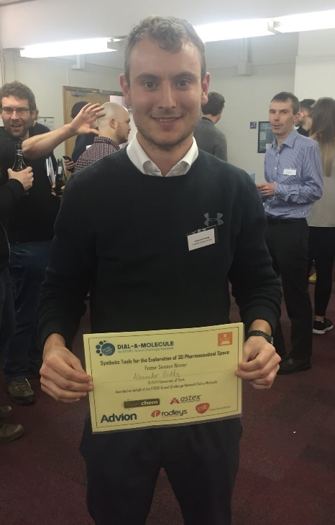
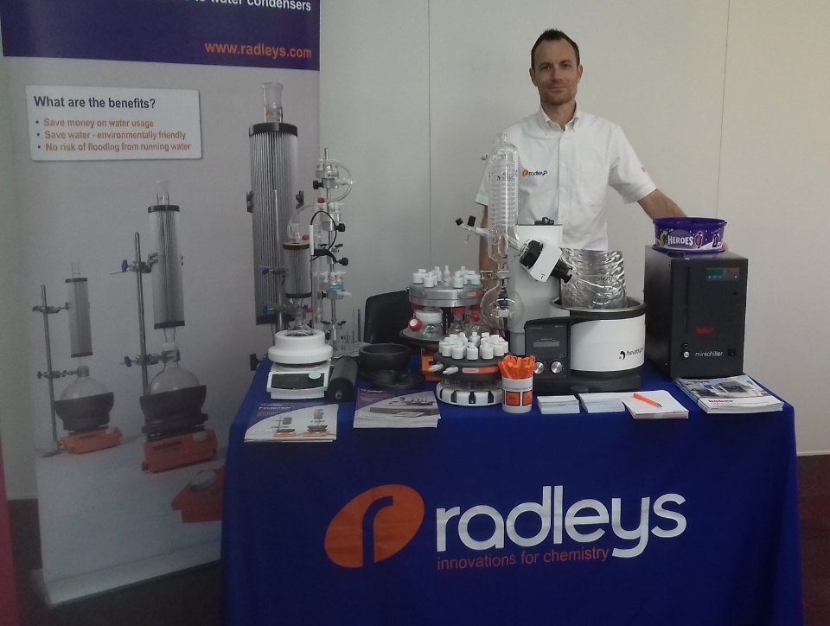

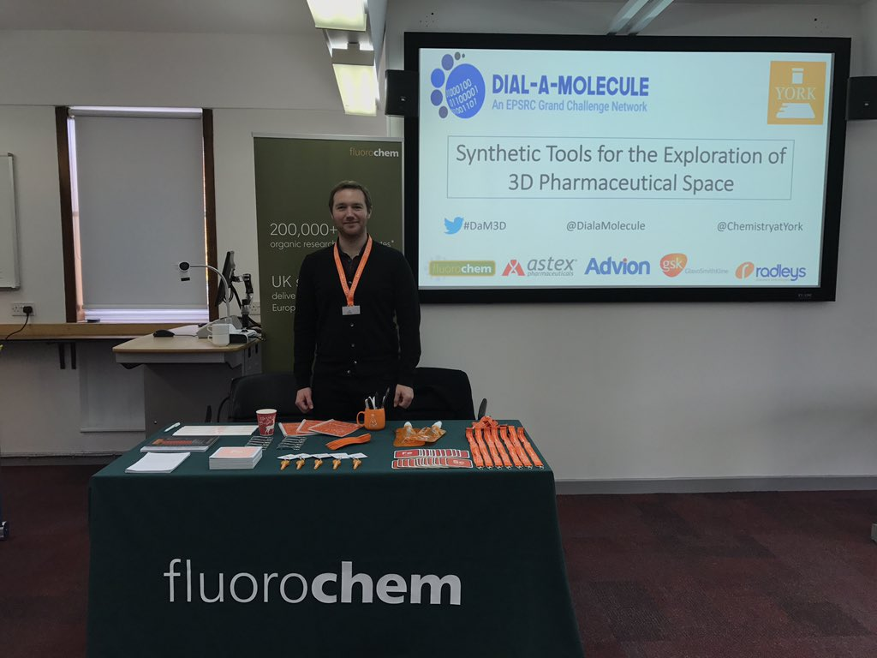
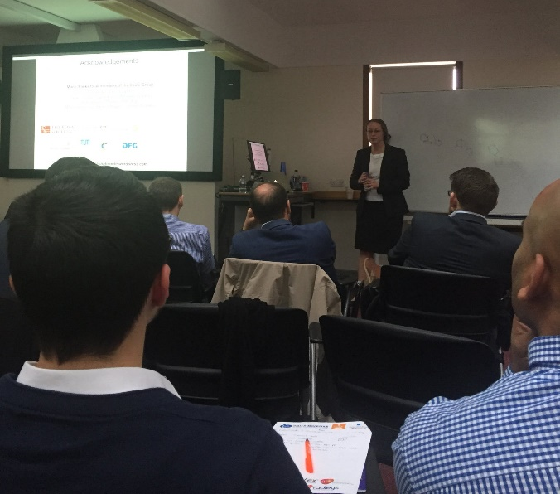

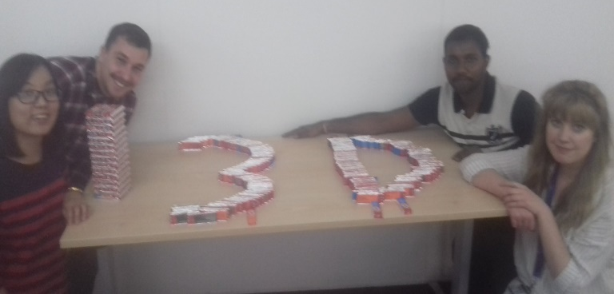

1. Radleys exhibition; 2. Poster winner
Alex Boddy; 3. Susannah Coote
4. Fluorochem exhibition; 5. 3D Kit Kats!

