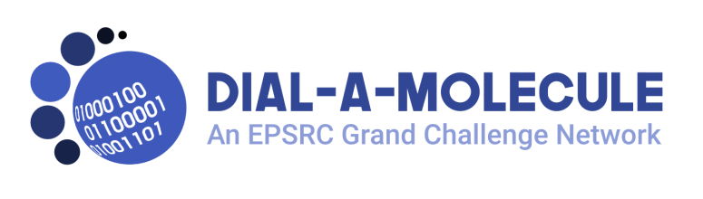

Application for Proof of Concept funding

A flexible competitive grant awarded towards the cost of consumables and small equipment for Proof of Concept studies to support subsequent proposals and/or to produce output of benefit to the Dial-a-Molecule community. Maximum individual awards are likely to be £2000.

The Dial-a-Molecule Steering Group are looking for proposals that will enable the applicant to obtain preliminary results that will enable future grant applications – truly Proof-of-Concept rather than ongoing project.
We encourage applications that are original and adventurous, accepting that there is a risk of failure to achieve the desired outcomes.
Whilst it is not essential that proposals are collaborative, this would be viewed as an advantage. For requests that are predominantly for equipment, applicants should consider if using established facilities at other laboratories (perhaps using an interdisciplinary mobility award) would be more appropriate and the network would be happy to advise/help in finding the right partners.

Title:

Principal applicant name:
Organisation:
Position:
Email:
Phone:
Address:

Proposal
Proposed expenditure – what you are asking for and how much it will cost.

Briefly outline the aims of the project that the funding would support, how it will progress the aims of Dial-a-Molecule and any grant applications you expect it to lead to (up to 1 page A4)

Please note that applications will be reviewed against the following criteria:
- Alignment with Dial-a-Molecule priorities
- Likelihood that the proposal will enable future grant applications
- Level of benefit to the wider DaM community (outside the individual institution)
- Applicants level of engagement with DaM

